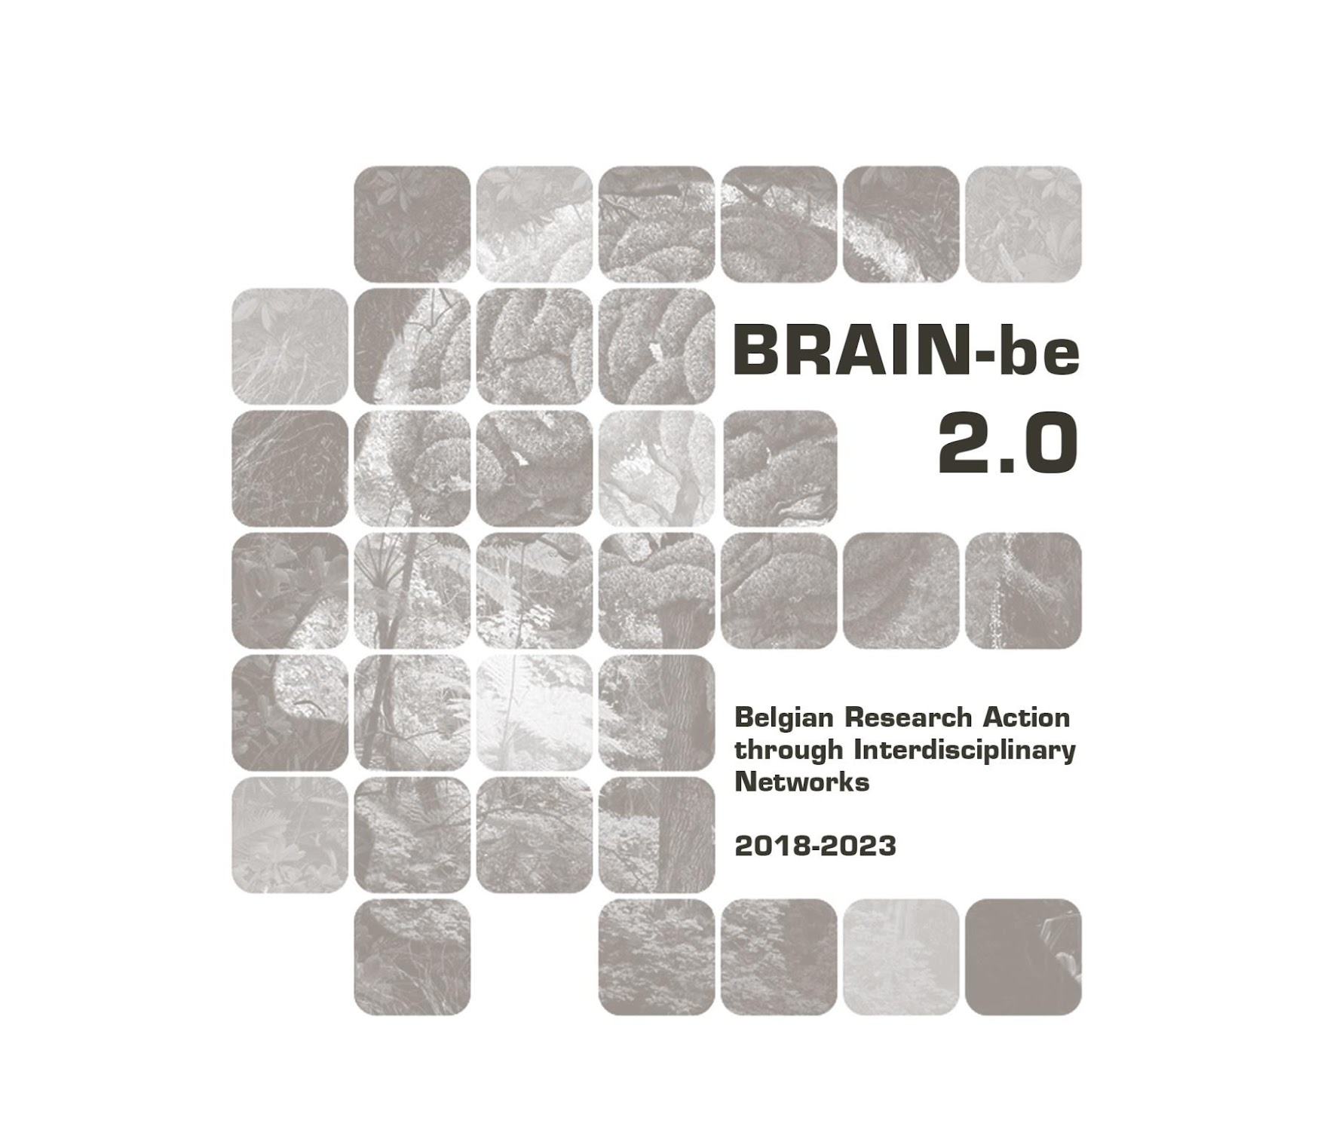
DiSSCo-Fed
Federal Support to the Distributed System of Scientific Collections
Patrick Semal (RBINS) - Aurore Mathys (RBINS & RMCA) - Arnaud Henrard (RMCA) - Cedric D’Udekem d’Acoz (RBINS) - Stijn Goolaerts (RBINS) - Jean-Marc Herpers (RBINS) - Franck Theten - Larissa Smirnova (RMCA) - Didier Van Den Spiegel (RMCA)

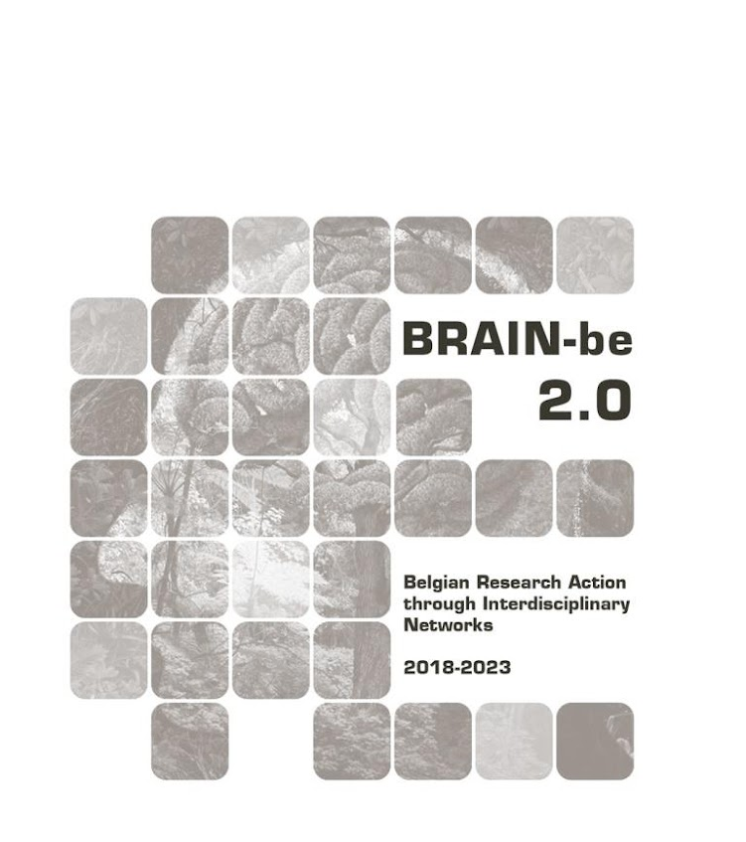
DiSSCo Fed
Federal Support to the Distributed System of Scientific Collections
Contract - FRSI/00/DI1
FINAL REPORT
PROMOTORS: Patrick Semal (RBINS)
Didier Van Den Spiegel (RMCA)
AUTHORS: Patrick Semal (RBINS)
Aurore Mathys (RBINS & RMCA)
Arnaud Henrard (RMCA)
Cedric D’Udekem d’Acoz (RBINS)
Stijn Goolaerts (RBINS)
Jean-Marc Herpers (RBINS)
Franck Theeten (RMCA)
Larissa Smirnova (RMCA)
Didier Van Den Spiegel (RMCA)

.
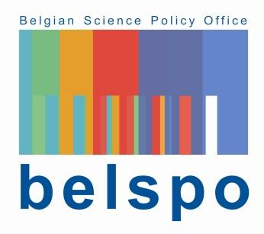

Published in 2023 by the Belgian Science Policy Office
WTCIII
Simon Bolivarlaan 30 bus 7
Boulevard Simon Bolivar 30 bte 7
B-1000 Brussels
Belgium
Tel: +32 (0)2 238 34 11
http://www.belspo.be
http://www.belspo.be/brain-be

Contact person: XXXXXXXX
Tel: +32 (0)2 238 3X XX

Neither the Belgian Science Policy Office nor any person acting on behalf of the Belgian Science Policy Office is responsible for the use which might be made of the following information. The authors are responsible for the content.
No part of this publication may be reproduced, stored in a retrieval system, or transmitted in any form or by any means, electronic, mechanical, photocopying, recording, or otherwise, without indicating the reference:
Semal P., Mathys A., Henrard A. d’Udekem d’Acoz C., Goolaerts S., Herpers J.-M, Theeten F., Smirnova L., Van Den Spiegel D. DiSSCo Fed Federal Support to the Distributed System of Scientific Collections, Contract - FRSI/00/DI1. Final Report. Brussels: Belgian Science Policy Office 2023 – 75 p. (BRAIN-be 2.0 - (Belgian Research Action through Interdisciplinary Networks))

table of contents

ABSTRACT 5
Context 5
Objectives 5
Conclusions 5
Keywords 5
1. INTRODUCTION 6
2. STATE OF THE ART AND OBJECTIVES 6
3. METHODOLOGY 8
4. SCIENTIFIC RESULTS AND RECOMMENDATIONS 8
Work Package 1: Project Management 8
Work Package 2 : Databasing the Types and illustrated specimens 9
Task 2.1 Data and Metadata databasing 9
Task 2.2 Digitization of associated documentation 15
Work Package 3 : Imaging the Types and illustrated specimens 17
Task 3.1 Digitization 2D by photography 19
Task 3.2 Digitization 2D+ by photostacking 21
Task 3.3 Digitization by photogrammetry 23
Task 3.4 High Resolution Digitization by Surface scanning 25
Task 3.5 Multispectral Digitization 31
Task 3.6 Microtomography 32
Work Package 4 : Valorisation & Preservation 61
Task 4.1 Valorisation 61
Task 4.2 Long term Preservation 67
Work Package 5 : Sustainability 70
Task 5.1 Alignment with DiSSCo and DiSSCo related projects 71
Task 5.2 Collaboration with other FSI and regional scientific institutions 72
Work Package 6: Routine activities in support to the digitization of the collections 73
Task 6.1 Preparation of the collection 73
Task 6.2 Preventive conservation 73
5. DISSEMINATION AND VALORISATION 73
6. PUBLICATIONS 73
7. ACKNOWLEDGEMENTS 75
ANNEXES 75

ABSTRACT

Context
DiSSCo, the Distributed System of Scientific Collections is a new world-class Research Infrastructure (RI) for Natural Science Collections. DiSSCo represents the largest ever formal agreement between natural history museums, botanic gardens and collection-holding universities in the world, grouping 1,5 billion specimens. 5,000 scientists. 170+ institutions from 23 countries.
The DiSSCo RI aims to create a new business model for one European collection that digitally unifies all European natural science assets under common access, curation, policies and practices that ensure that all the data is easily Findable, Accessible, Interoperable and Reusable (FAIR principles).

Objectives
The objectives of the DiSSCo Fed FRSI project was to help the digitisation efforts of the RBINS and RMAC which house the largest collection of natural history in Belgium and one of the biggest in Europe. The DiSSCo Fed is a major add-on of the DIGIT-4, the Digitization Programme of the Belgian Science Policy BELSPO which aims to support the Belgian federal museums, libraries and archives with the digitization of their cultural and scientific patrimony.
DISSCo Fed focussed on the digitisation of the Types and Illustrated specimens using several high resolution digitisation pipelines and establishing protocols in order to maximise the scientific value of the digital model.

Conclusions
The combined efforts of DIGIT and DiSSCo Fed initiatives allowed RBINS and RMCA to have about 280000 types and illustrated specimens at the end of the project. The initial estimation was about 300.000 type and illustrated specimens, but it seems today that it is an underestimation. It was indeed very difficult to really prioritise the digitisation of the type specimens as they are distributed in the general collection and they have to be discovered among the “regular” specimens. The total number of digitised specimens is at the end of 2022 about 5.7 million of specimens compared to the estimated size of 48 million of specimens.
The use of the high resolution digitisation pipelines allowed to digitise Type and illustrated specimens using appropriate workflows. Specific protocols were also developed for different case studies for the micro CT workflow.

Keywords
DiSSCo RI, Digitisation, Natural History collections, Type Specimens, Micro CT, Surface scanning, multispectral imaging

1. INTRODUCTION
Collections of natural history institutions worldwide reflect both the unique biodiversity of past and present life and the geological history of the Earth (Kemp, 2015). It is estimated that European natural history collections contain up to one billion specimens. They are now recognized as a distributed research infrastructure (DiSSCo, roadmap 2018). However, less than 20% of these collections has been digitised so far at the specimen level (One World Collection exercise and internal DiSSCo Survey, ICEDIG D2.1). This percentage is even lower if only specimens really imaged with a high resolution picture or a 3D scan are taken into count. The majority of natural history collections is therefore not accessible and cannot be used by the wider community to its fullest potential, to address critical challenges like the loss of biodiversity, the climate change, the invasive species or the vectors of diseases.
At the Belgian level, the biggest collections of natural history are hosted by two Belgian FSI (RBINS with 38.000.000 specimens and RMCA with 10.000.000 specimens). Together RBINS and RMCA are among the biggest international collections especially for some specific regions like sub-saharan Africa regions. The Belgian Herbarium, to a large extent federal (about 4.000.000 specimens) is hosted by Meise Botanic Garden (MBG) which is today a regional institution. The 3 institutions collaborate together in the framework of the NaturalHeritage BRAIN project aiming to establish a common search portal of the Belgian Natural History collections and preparing a common hub to the DiSSCo infrastructure (see Digitization landscape of the Belgian natural history collections).
The total number of “type” specimens (which allow to describe species) and other very rare specimens of important value is evaluated to 300.000 specimens for both federal institutions. Since several years RBINS and RMCA collaborate in the digitization of the biological collections sharing staff and digitization equipments in the framework of the digitization program of the collections hosted by FSI (DIGIT3, 2014-2018 and DIGIT-4, 2019-2025). In 2015, RBINS was granted a one-shot infrastructure funding and bought 2 micro-CT scanners (1 for small low dense specimens and 1 for bigger dense specimens). Those equipements produce very high resolution images of the internal structures and imaging applications create 3D digital specimens with external and internal structures.
The associated partner has so far digitised 3 million herbarium sheets which are available in high resolution images with associated metadata here : www.botanicalcollections.be. Additionally the data concerning the living collections with more than 22.500 records and 6700 mostly local african vernacular names of the flora of Central Africa have been published to GBIF and so made available to www.naturalheritage.be.
The DiSSCo ESFRI RI aims at offering a unique access point to collection specimens in their digital form (data and virtual specimen), enabling science, opening up the collection data to the public by overcoming the current isolated access model, and by prioritising specific groups of specimens in a new manner.

2. STATE OF THE ART AND OBJECTIVES
The duration of the present project (48 months) was almost the same than the Construction phase of DiSSCo (2019–2024): “Implementation of national/regional investment plans for infrastructure upgrades and large scale digitisation programmes; application of joint DiSSCo programmes and policies, quality control and risk management; establishment of regional/thematic hubs; active membership; construction of the DiSSCo Hub (including all services)”.
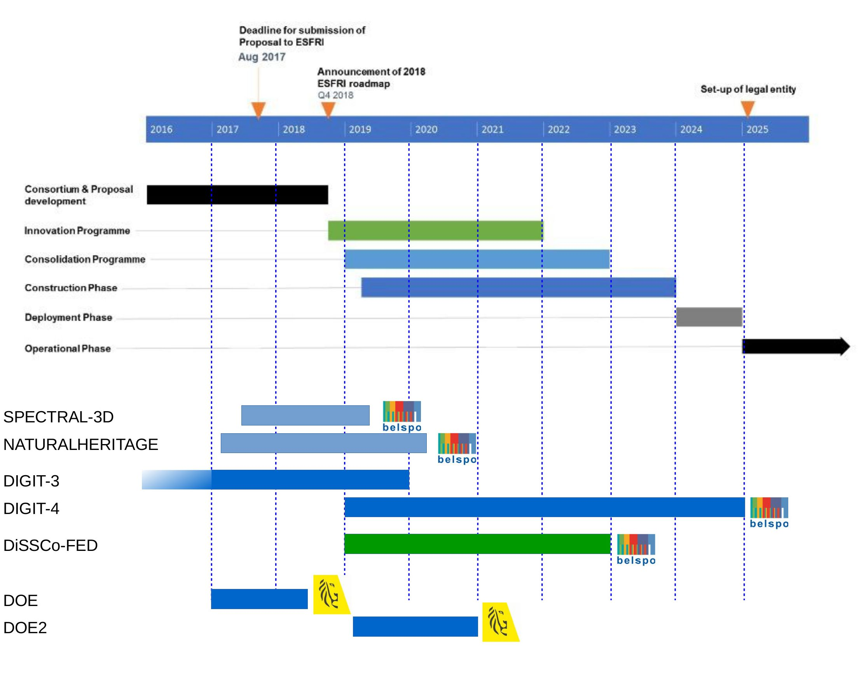
Figure 1: DiSSCo-Fed proposal in the time scale of Belgian and European projects and initiatives

The DiSSCO Fed proposal was a major component of our digitization strategy (RBINS & RMCA). In Europe some states have already made drastic steps forward. The Netherlands for example granted the complete digitization of the Dutch natural history collections as a one shot initiative (31 million €). In Belgium, the digitization of the federal collections is operated by the DIGIT programs (DIGIT, DIGIT-3/2013-2018 and DIGIT-4/2019-2025) and Flanders appointed several million € to digitise 3 million herbarium sheets (DOE ad DOE2). RBINS and RMCA prioritised their digitization efforts to the “types and illustrated specimens” which are the most important part of the collection and which are unique.
The digitization of this sub-collection requires the encoding of the data of the specimen and the imaging using the most appropriate technique. A simple picture is often not enough and a high resolution imaging is needed to allow the scientific valorisation of the digital specimen.
RBINS and RMCA developed digitization protocols adapted to the diversity of the specimens (size, morphology, region of interest) in the framework of the Agora 3D project and the preparatory phase of the DIGIT-3 program. In 2015-2016, RBINS acquired 2 microtomography scanners allowing them to digitise the internal structures of the specimens. Unfortunately no scientific staff was funded to operate the equipment at their maximal capacity and DIGIT fundings allows a maximum of 2 TFE Scientists which is insufficient for the high resolution digitization of the Types and Illustrated specimens.
Before DiSSCo Fed, 89.700 type specimens/part of specimens were already encoded at RBINS and 11.000 specimens were imaged. More than 110.000 additional type specimens needed to be digitised. At RMCA, 3.117 type specimens were already imported in the specimens database and about 100.000 type specimens need to be manually encoded or imported from old databases.
The digitization of the associated archives (about 300.000 pages) had also to be achieved.

3. METHODOLOGY
At RBINS, the DiSSCo FED project is working in synergy with the DIGIT-4 Belspo Program. The 2 FTE scientists and 5 FTE technicians of DIGIT work on the digitization of the collections and the associated documentation. The encoding in the DaRWIN CMS is also achieved by RBINS SSH staff (2.5 FTE). The 2.5 FTE of DiSSCo worked on the high resolution digitization of the collections using Micro CT and 3D digitization.
At the Africamuseum, none of the DIGIT-4 staff was dedicated to the natural sciences collections but some RMCA staff worked for the digitization of the natural history collections.
The objectives and priorities of DIGIT-4, FSI staff and DiSSCo Fed are the same for the period 2019-2022 and focus was given to the digitization of the type and illustrated specimens.

4. SCIENTIFIC RESULTS AND RECOMMENDATIONS

Work Package 1: Project Management
RBINS and RMCA have collaborated for several years in the digitization of their collections. They already share technical platforms, common database systems and staff. The collaboration of the 2 FSIs is structural. Both FSI collaborate also with Meise Botanic Garden (which holds the 3rd natural history collection sizewise in Belgium) in the framework of Belgian and international projects. People know each other facilitating the communication between partners and a common work.
The goal of this WP is to coordinate the implementation of the project as outlined in the work plan; ensure progress of the project, guarantee the timely delivery of the project’s outputs. As the 2 microtomography scanners are located at RBINS, the coordinator will ensure that the time sharing of the scanners will allow to reach the objectives for both institutions and the digitization on demand. The other digitization equipments are transportable and can be moved to the collection following the requirements. Common planning will be established in order to optimise the processes.
The period of the DiSSCo Fed project (2019-2022) is overlapping the COVID crisis. This meant that a large part of the project was concerned by forced telework periods and restricted access to the collections and offices.
Some of the tasks were reorganised and specific digitisation workflows were adapted in order to allow the digitisation of the specimens. Specific micro-scanning agendas were developed to provide safe working conditions to the operators (e.g. 2 days scanning and 3 days reconstruction in telework).
The CMS is a web application. It was therefore easy to adapt the work for the encoding. Specimens and labels were digitised at medium resolution allowing the encoding in the CMS as a remote activity. Priorities were also given to the preparation of XLS templates preparing mass import.
The figure 2 shows how the COVID crisis did not affect the digitisation activities. Results of digitisation are often better than the estimated KPI. The digitisation of slides and pictures was the only activity which was cancelled as it required the presence on site of the collaborator and volunteers.
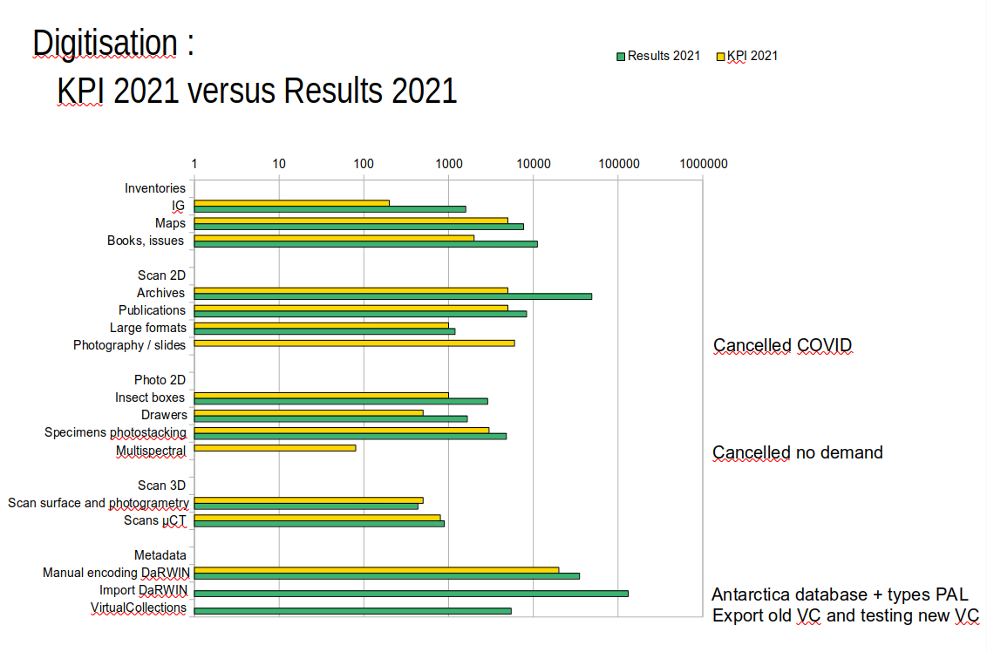
Figure 2: (no) Effect(s) of the COVID crisis on the DiSSCo-Fed project and the digitisation activities

Work Package 2 : Databasing the Types and illustrated specimens

Task 2.1 Data and Metadata databasing
This task database at the specimen level the collections not yet computerised. This will include all basic primary information regarding the object's (specimens) identity (i.e. the information as provided on the associated labels) and their conservation status (e.g. intact, damaged). All data were integrated in the database DaRWIN used in both institutions and available through the NaturalHeritage portal (BRAIN, 2017-2020). DaRWIN is an Open Source Collection Management System (CMS) developed by RBINS during DIGIT-1. The system was adopted and improved by RMCA a few years ago.
Staff Qualification: technician, scientists & IT, funding DIGIT-4, RBINS & RMCA

Task 2.1.1 RBINS (2019-2022)
The databasing of the specimens in DaRWIN CMS was done by 3 FTE encoders during the 2019-2022 period.
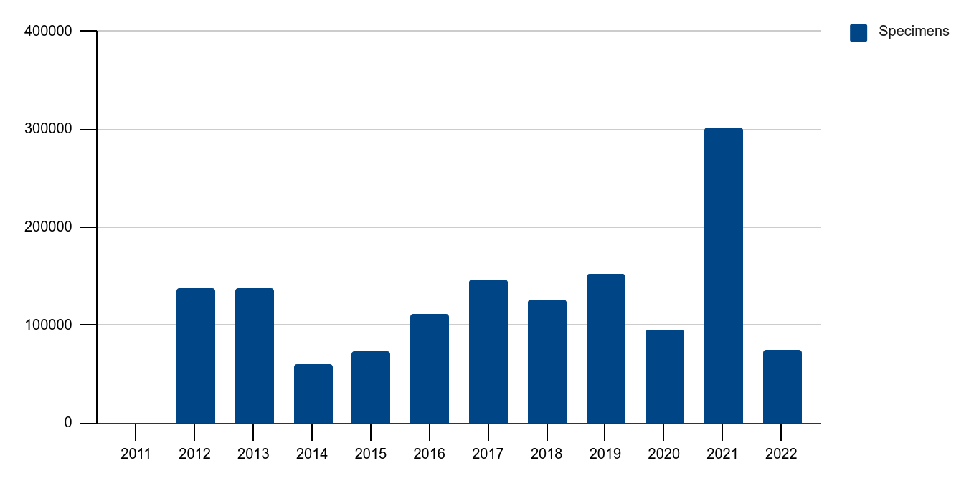
Figure 3: Encoded specimens in the DaRWIN Collection system
The encoding was done by direct manual encoding in the database or using XLS templates for importing of data in 3 steps (Taxonomy, Locations, Specimens). The encoding rate is stable with extra encoding when it was possible to include complete collections using XLS templates.
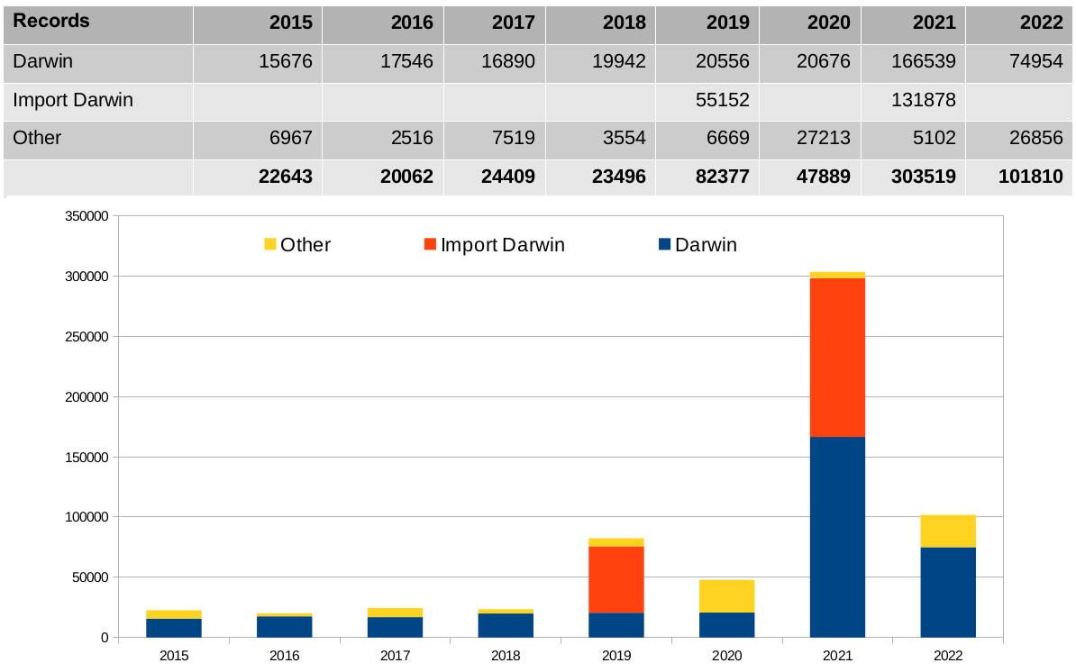
Table 1 & Figure 4: Databasing of data and metadata in the RBINS DaRWIN CMS
The cumulative number of encoded specimens grew regularly while the number of encoders decreased in the last years because priority was given to the imaging of the specimens using high resolution techniques.
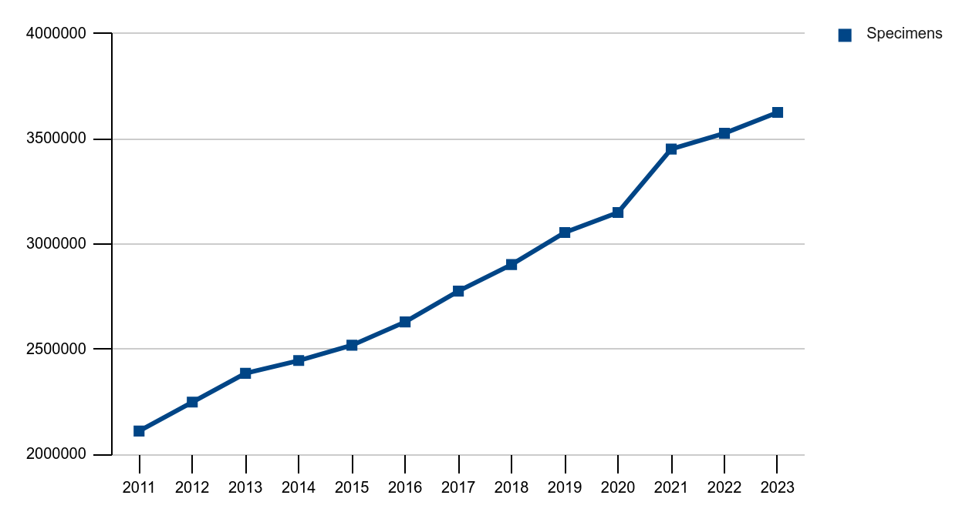
Figure 5: Cumulative databasing of the specimens in the RBINS DaRWIN CMS
The “types and illustrated specimens” are only a small proportion of the collections. During the 2019-2022 period, priority was given to the digitization of type specimens in DIGIT-4 and DiSSCo Fed. Nevertheless, this priority is not visible in the databasing efforts as the type specimens are not isolated from the specimens in the collections and that it was therefore not possible to encode only type specimens.
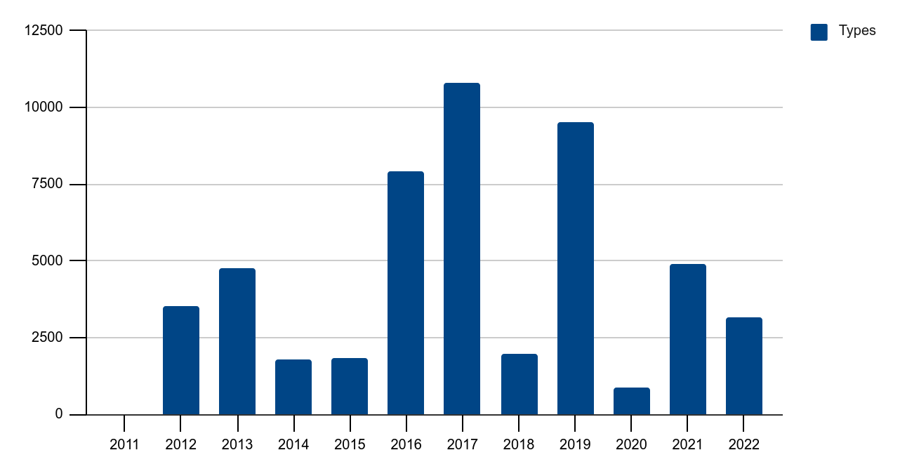
Figure 6: Databasing of data and metadata of types in the RBINS DaRWIN CMS
The cumulative number of encoded type specimens grew regularly while the number of encoders decreased in the last years because priority was given to the imaging of the specimens using high resolution techniques.
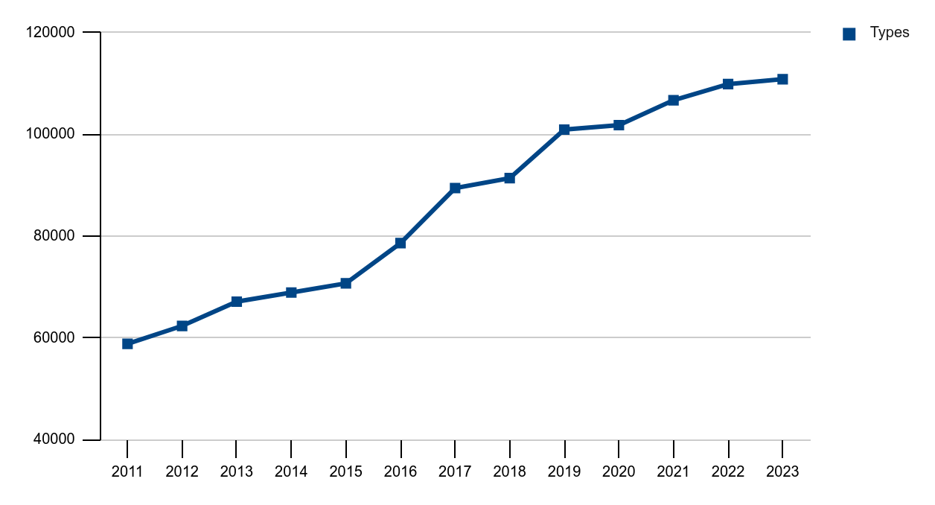
Figure 7: Cumulative databasing of the type specimens in the RBINS DaRWIN CMS

Task 2.1.2 RMCA (2019-2022)
The encoding of the specimens in the DaRWIN CMS was mainly achieved by the import of existing collections databases using the XLS templates. This allowed the import of about 1 million of specimens during the 2019-2022 period.
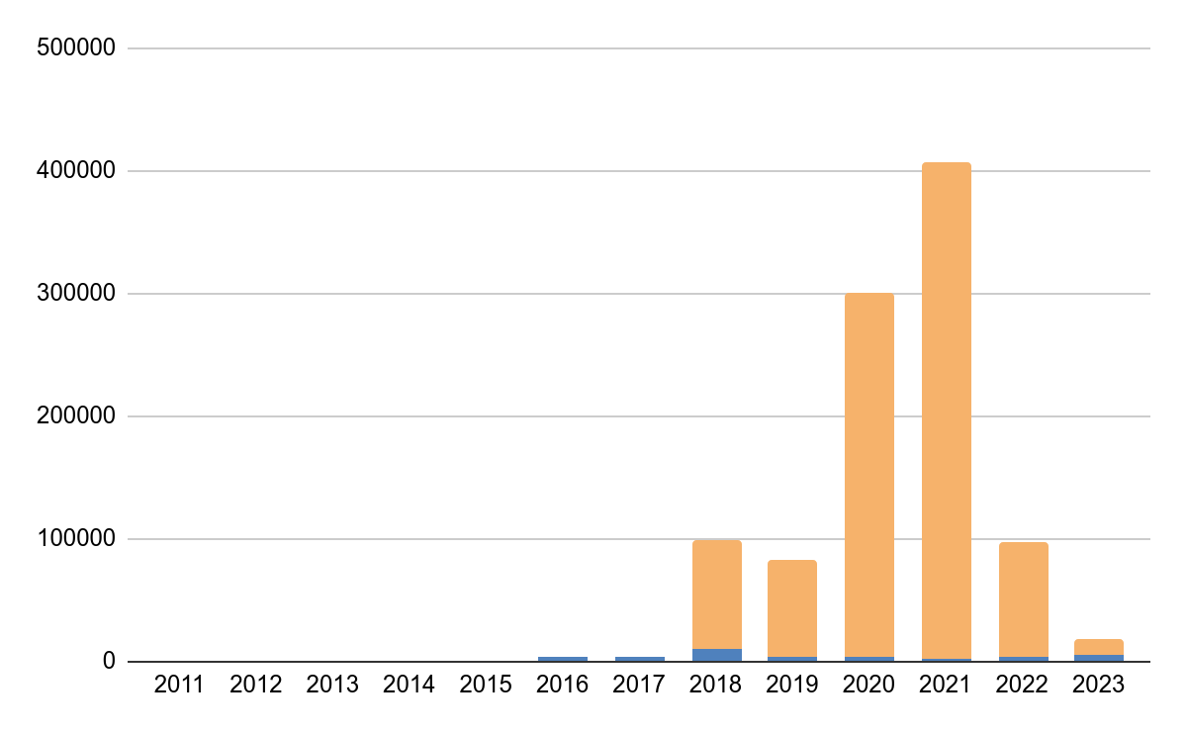Figure 8: Annual encoding of specimens in the DaRWIN CMS
(direct encoding in blue, and importing in orange)
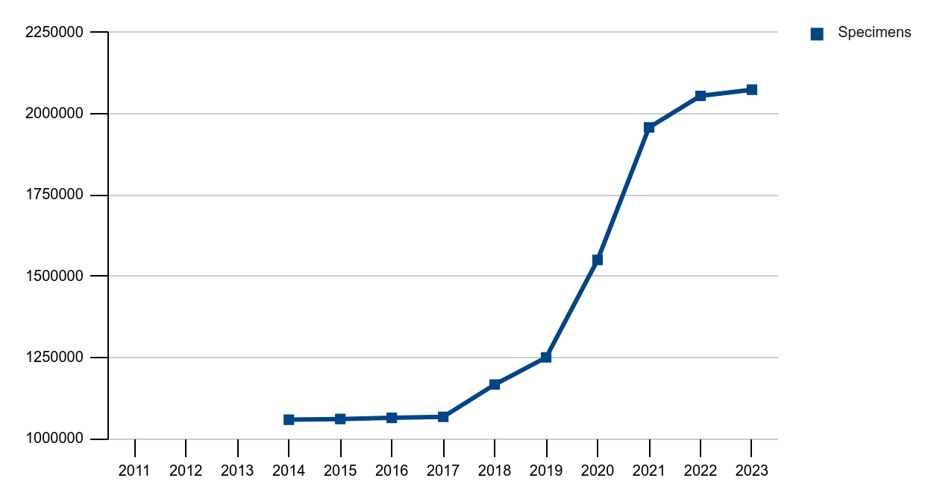
Figure 9: Cumulative databasing of the specimens in the RMCA DaRWIN CMS
The encoding of the type specimens in the DaRWIN CMS was achieved by the same import workflow of existing collections databases using the XLS templates. This allowed the import of about 65.000 of type specimens during the 2019-2022 period.
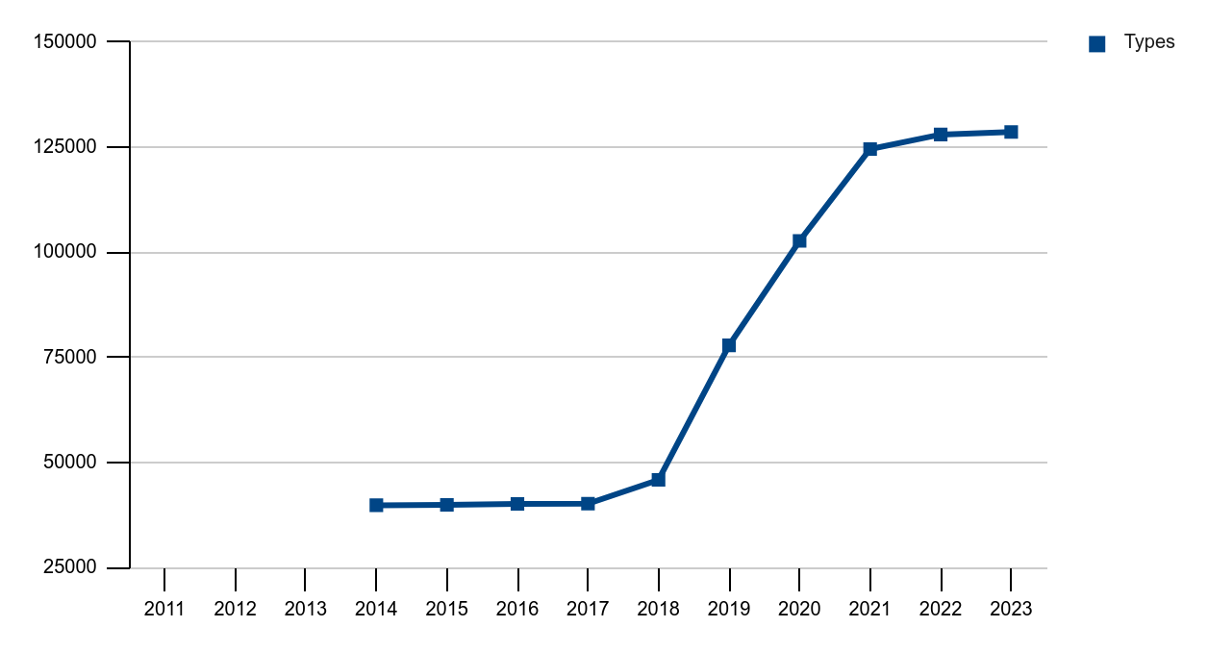
Figure 10: Cumulative databasing of the type specimens in the RMCA DaRWIN CMS
The “types and illustrated specimens” are only a small proportion of the collections. During the 2019-2022 period, priority was given to the digitization of type specimens in DIGIT-4 and DiSSCo Fed. Nevertheless, this priority is not visible in the databasing efforts as the type specimens are not isolated from the specimens in the collections and that it was therefore not possible to encode only type specimens.
Nevertheless, the total number of type specimens encoded in the DaRWIN CMS after the DiSSCo Fed project is 110857 type specimens at RBINS and 128647 type specimens at RMCA. At RBINS, we have to add 40000 type and illustrated specimens encoded in local Access databases in the Paleontology collection.

Task 2.1.3 The federal collection as research infrastructure
The size of the Belgian federal collection in natural sciences is evaluated to 52 million of specimens : 38 at RBINS, 10 at RMCA and 4 at MBG. The digitization of the 4 million Herbarium sheets was mainly achieved thanks to the DOE and DOE2 fundings of the Flemish Government (75%). The digitization of the 48 million specimens housed by RBINS and RMCA are partially digitised (about 5.7 million specimens are already digitised, 11% ).
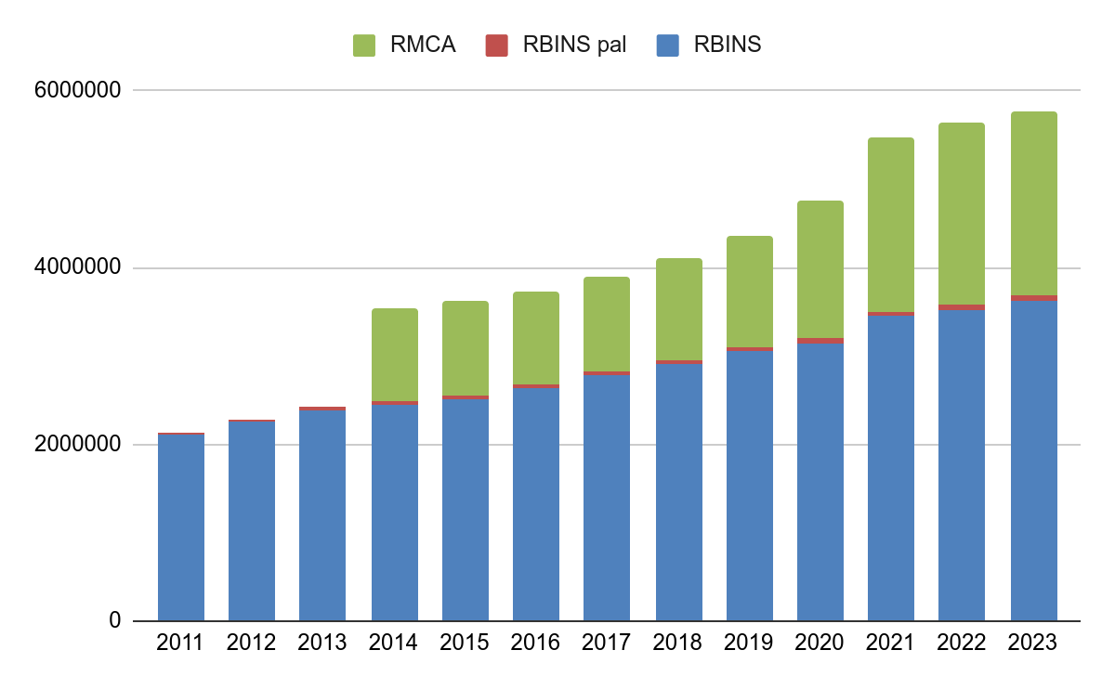
Figure 11: Cumulative databasing of the specimens in the RBINS and RMCA CMS
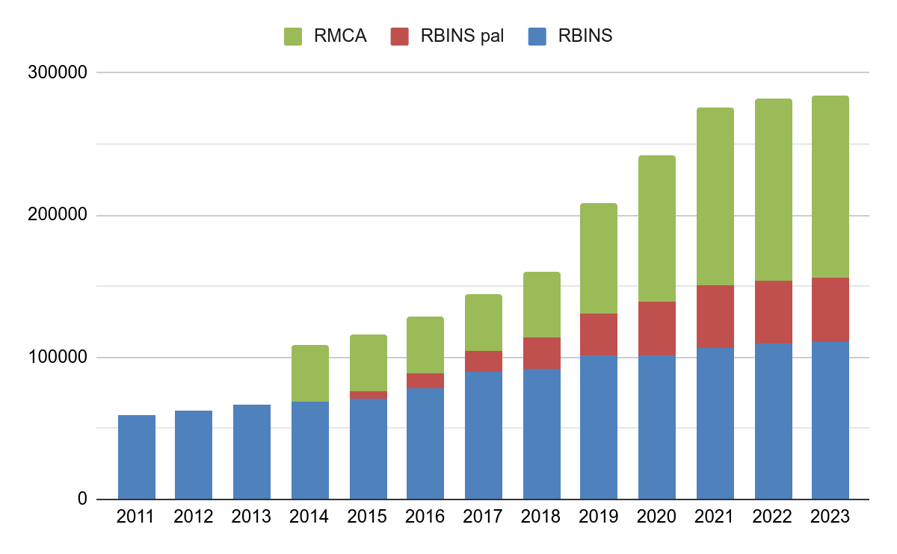
Figure 12: Cumulative databasing of the type specimens in the RBINS and RMCA CMS
Palaeontology is well represented in the Types (and illustrated specimens) category as the type and illustrated specimens are isolated from the general collection and the priority of the digitization effort can be focused only in this category.
The distribution of the specimens and type specimens in the RBINS collections shows that the digitization level is not the same in the different collections and is mainly related to the size of the collection.
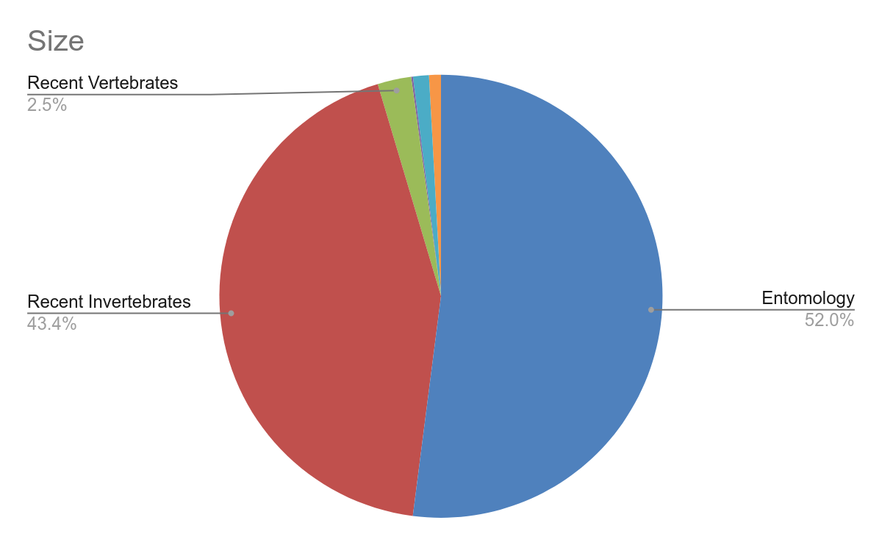
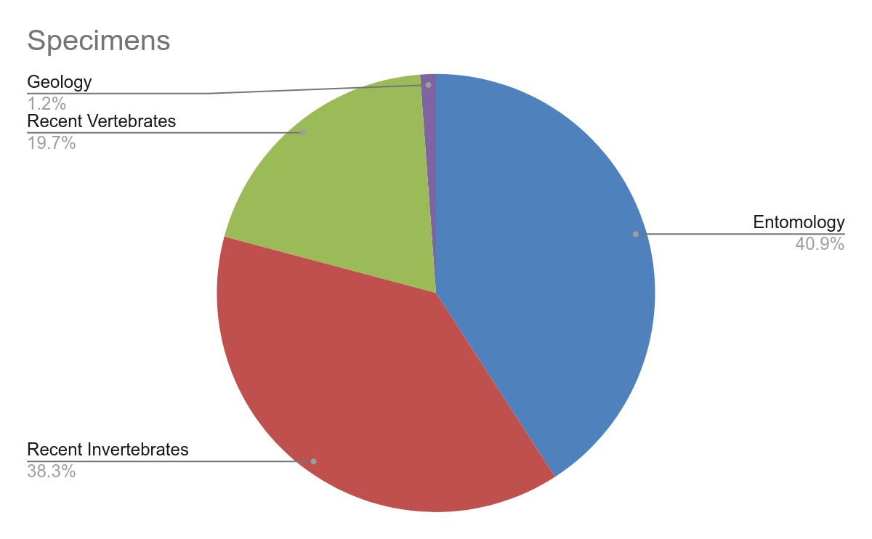 | 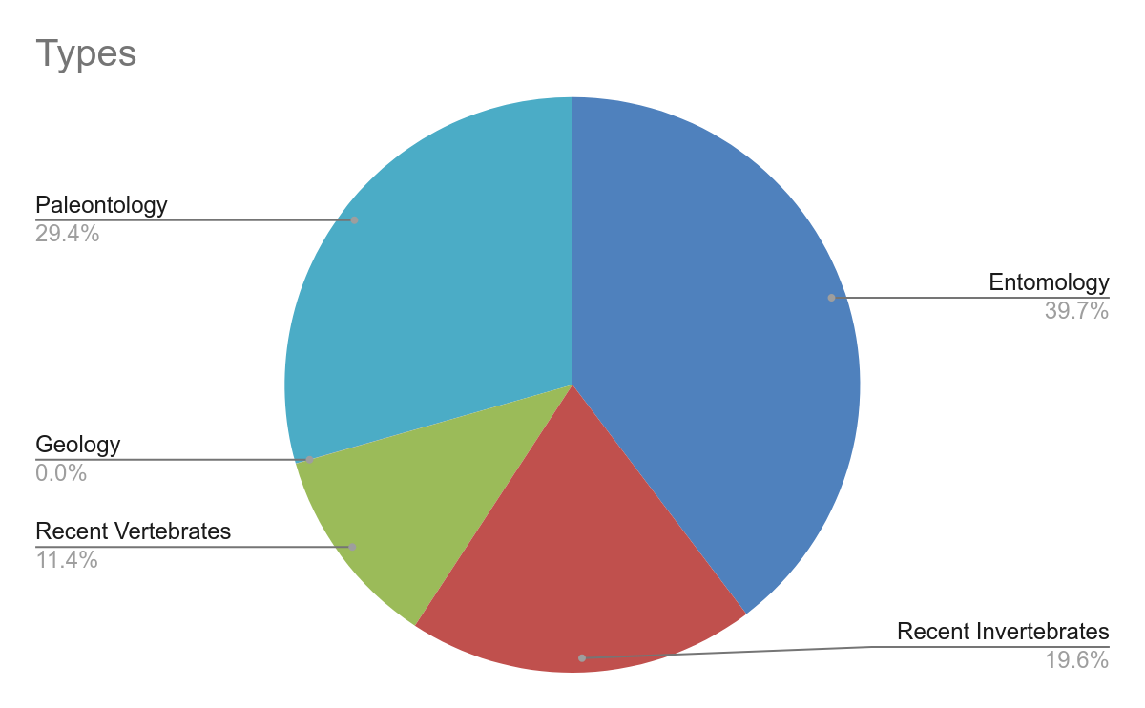
Figure 13: proportions of specimens and types specimens encoded by collection at RBINS
The digitization of the recent vertebrates collections is more advanced with a 80 % digitization rate compared to the 8-9% rate obtained for the largest collections as Entomology and Recent invertebrates collections.

Task 2.2 Digitization of associated documentation
Documentation associated with natural history specimens is an important part of the value of the specimens and should be fully inventoried, digitised and combined with the primary data (Task 2.1); these include for example original drawings, annotated original manuscripts (papers, species lists, notebooks, etc.) with information on sampling localities, collector identity, sampling methods, species’ distributions, etc., and potential other associated literature data. If possible the associated documentation should be accessible through Open Access Repositories.
Staff Qualification: technician, funding DIGIT-4, RBINS & RMCA
The digitization of the associated documentation was achieved by the DIGIT-4 program at RBINS. This digitization is divided into different projects following the pipelines used for the digitization.
The different categories are : A4 Archives, A0 maps, A4 publications and pictures. The table 2 summarises the digitization statistics for the 2019-2022 period.

Year | Archives | Maps | Publications | Pictures
2019 | 47859 | 5859
2020 | 10000 | 1121 | 70927 | 20000
2021 | 48961 | 1190 | 8325
2022 | 36603 | 2336 | 2321 | 1514
Total | 143423 | 10506 | 81573 | 21514

Table 2: Digitisation of the associated documentation in the RBINS during the period (2019-2022)
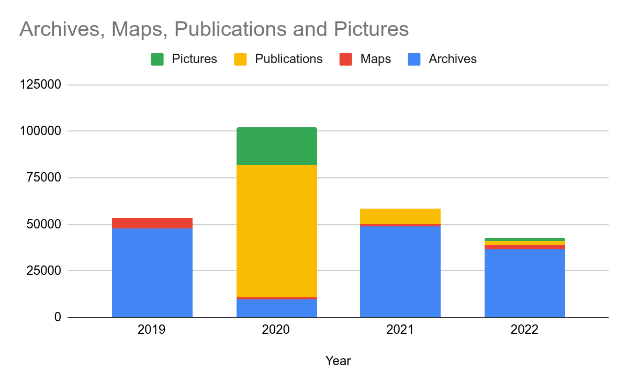
Figure 14: Digitisation of the associated documentation in the RBINS
Most of this associated documentation was uploaded on the Plone Platforms used by RBINS for the sharing of unstructured information requiring a full indexation and allowing a google like search functionality.
At RMCA, a total of 9463 index cards, 13125 pages of registers and 175 original drawings were digitised during the 2019-2022 period.
During the DiSSCo Fed project, the total number of scans related to the associated documentation is therefore equal to 279.779 for both FSIs.

Work Package 3 : Imaging the Types and illustrated specimens
The imaging of the specimens in the digitization process really started with the DIGIT-3 program. Before digitization was more considered as a digital cataloguing of the basic primary information. Several projects at the Belgian level (Agora-3D, Spectral 3D) or at the European level (COSCH, Synthesys-3) evaluated and defined best practices in the digitization of Natural History Collections. The last version of the “Handbook for 3D digitization of the Natural History collections” was coordinated by J. Brecko is and A. Mathys working in digitization at RBINS and RMCA. The handbook is published by the European Journal of Taxonomy and supported by CETAF.
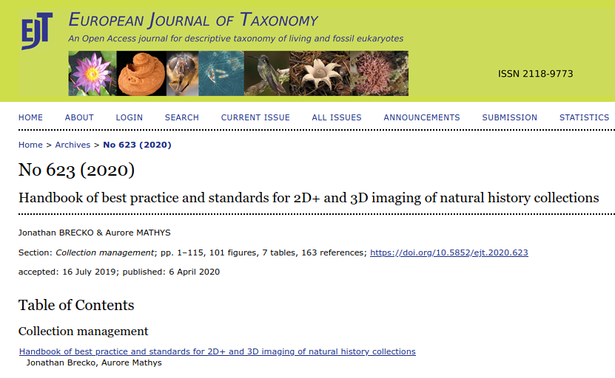
Figure 15: Brecko, J., & Mathys, A. (2020). Handbook of best practice and standards for 2D+ and 3D imaging of natural history collections. European Journal of Taxonomy, (623). https://doi.org/10.5852/ejt.2020.623
More recently, RBINS coordinates, in the framework of the Synthesys + project, the setup of a decision key allowing to choose the best digitisation technique for each type of collection following the size and the complexity of the specimens, and the final use of the virtual specimens. The DIGIT-KEY tool provides a key to define the best digitisation techniques following the collection and the aims of the digitisation. It also lists the different setups of digitisation available in one institution. RBINS and RMAc have together the largest variety of digitising setup covering most of the digitisation needs in DIGIT and DiSSCo Fed.
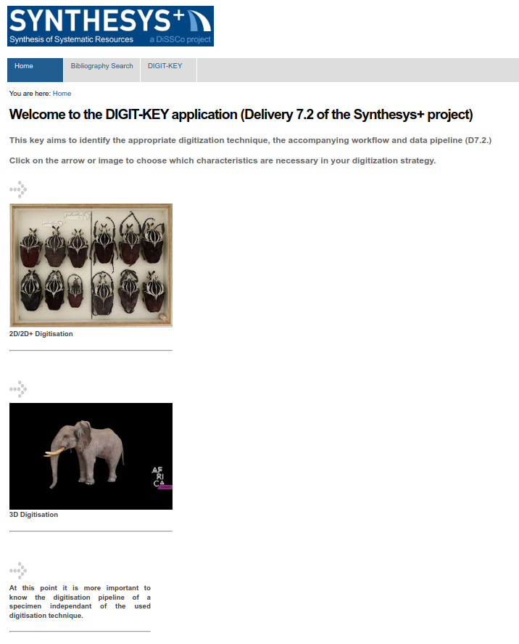
Figure 16: DIGIT KEY https://digit.naturalheritage.be/
During the 2019-2022 period, the digitization of the (type) specimens uses different pipelines as described in DIGIT-KEY. RBINS and AfricaMuseum collaborate in the digitisation of the collections not only using the same CMS but also sharing equipment, staff and projects.

The table 3 provides the digitisation indicators for the different pipelines at RBINS
Year | Drawers / Boxes | 2D | Multi- spectral | Focus stacking | 3D | µ CT
2019-2022 | 13172 | 7146 | 30 | 11915 | 1646 | 5735
Table 3: Digitisation of the containers and specimens in the RBINS during the period (2019-2022)
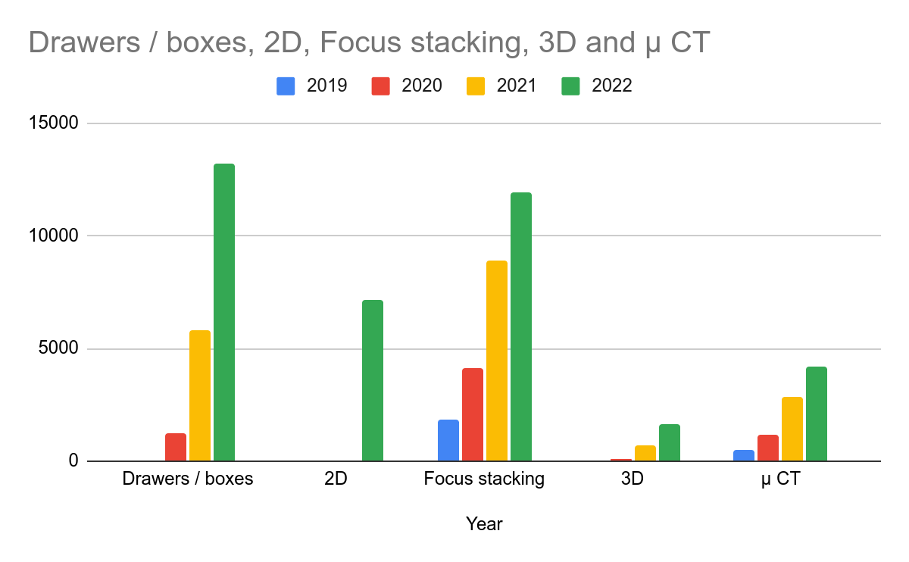
Figure 17: Cumulative digitisation at RBINS using the different pipelines during the 2019-2022 period
The table 4 provides the digitisation indicators for the different pipelines at RMCA.
Years | Drawers / Boxes | Focus stacking | Multispectral | 3D | µ CT
2019-2022 | 25954 | 2000 | 30 | 250 | 716
Table 4: Digitisation of the containers and specimens in the RMCA during the period (2019-2022)

Task 3.1 Digitization 2D by photography
The 2D digitization of specimens is used for basic imaging. The imaging of each specimen is not possible with the available human resources. The priority of digitization at the specimen level was given to the type and illustrated specimens and for the digitization on demand with a direct scientific valorisation. Depending on the type of collection, 1 to 6 pictures are produced by specimen. It is mainly operated by technicians or by jobstudents.
For many collections the imaging of the drawers or the boxes is a solution for a first digitisation level. This can be helpful to stakeholders to identify easily the specimens of interest in the collection. This is not precise enough for a scientific study but it gives a good overview of the collection.
The imaging is achieved with a full frame DSLR Canon 5DSR (50 Mpx) with a wide lens. The box is illuminated using 2 flat led panels and the camera is tethered with the EOS utility software using a Windows 10 computer. The RAW image is saved as image source. The geometry of the image and the images settings are corrected using DXO suite and the final image is saved in jpg format to export to the valorisation platform.
Staff Qualification: technician
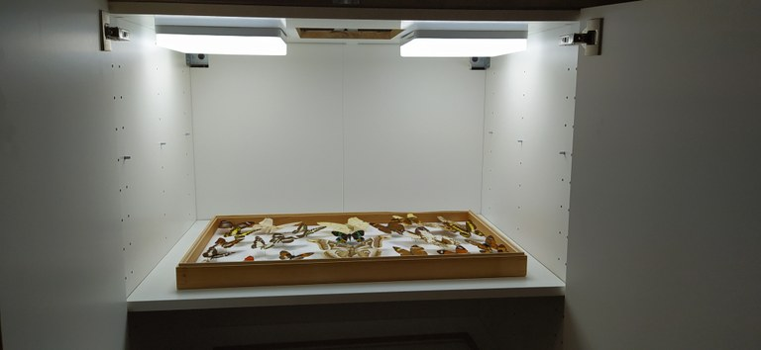
Figure 18: Setup for the digitization of the complete insects boxes using two top led panels
At RBINS, the images are uploaded on the collections/entomology Plone site while they are saved in virtualcollections at RMCA.

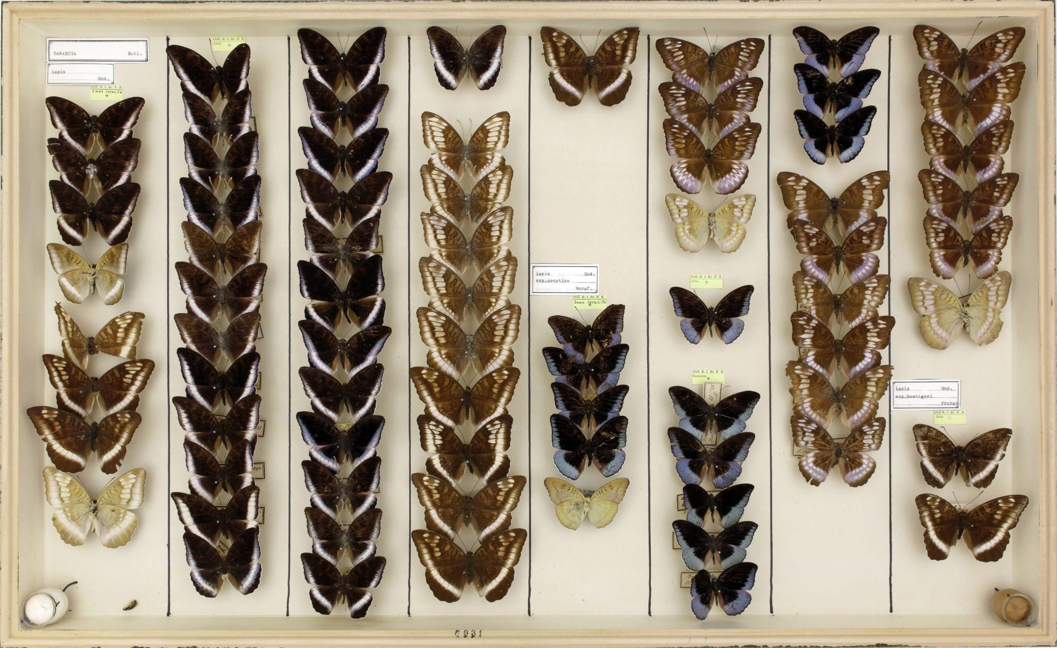
Figure 19: Full view of an insect box using a Canon EOS 5DSR (50 Mpx) ZOOM 10%
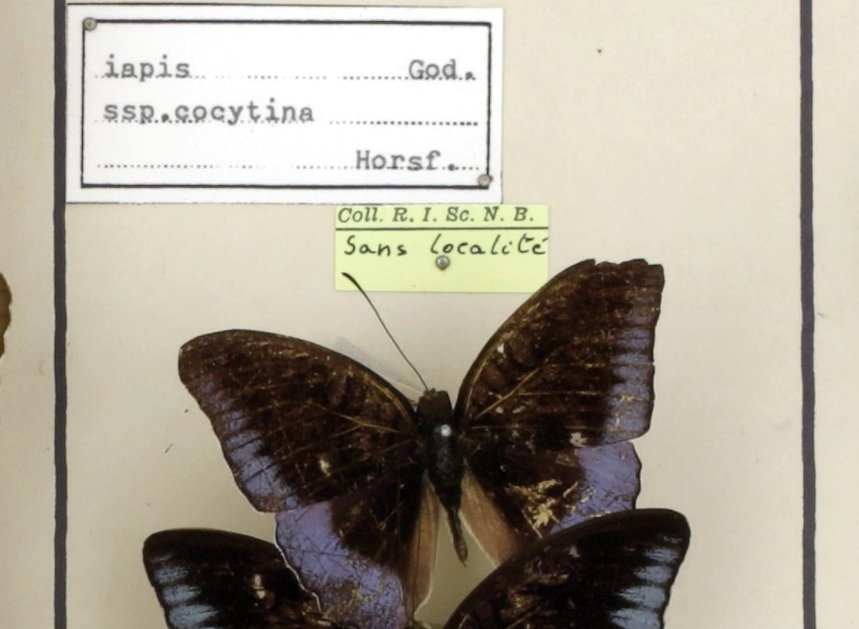
Figure 20: Detailed view of the previous insect box using a Canon EOS 5DSR (50 Mpx) ZOOM 100%
The digitisation at the container level (box or drawer) allows to evaluate the collection but also to count specimens and retrieve Type specimens which are often labelled with a different colour label.
During the 2019-2022 period, RMCA digitised 25.954 boxes corresponding to 998.386 spécimens (counted manually by the operator). RBINS digitised 13.172 boxes or drawers and the counting was not achieved. RBINS tried the Inselect software developed by the NHM London for automatic counting but the overlapping of the specimens in the boxes did not allow us to count the specimens with a good accuracy. Technologies evolve rapidly and a counting approach using AI could be available in the short to medium term reducing drastically the time required for the digitisation of a box as the manual counting could represent 50% of the digitisation time.

Task 3.2 Digitization 2D+ by photostacking
Photo Stacking is an upgraded version of macrophotography. It produces extended focus pictures of small specimens. Both institutions use this technique to digitise type specimens of Entomology and Invertebrate collections. The photo stacking can be achieved on dry specimens or on wet specimens in alcohol.
Staff Qualification: technician and scientist
At RBINS, about 100 type specimens of crustaceans were photographed in stacking during the period 2018-2023. The technique gives outstanding results for crabs and crab-like crustaceans but less interesting results for shrimps. In groups were the inter-species differences are very subtle, like freshwater crabs, photostacking yields objective views of a great precision, often quite superior to classical photography (among others for the frontal views, where the depth field is important, and gonopods) and more reliable than line drawings, which may present inaccuracies due to the lack of care of the illustrator.+
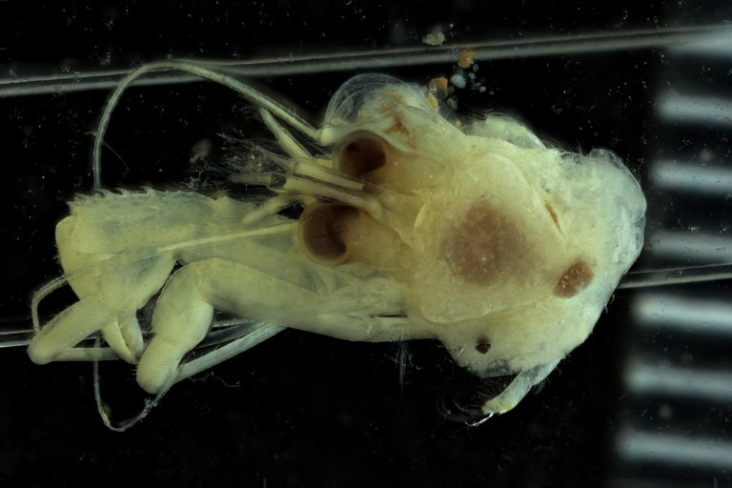
Figure 21: Digitisation of a specimen in alcohol using the photostacking setup
BE-RBINS-INV HOLOTYPE MALE INV.13459 Anapagurus congolensis dorsal

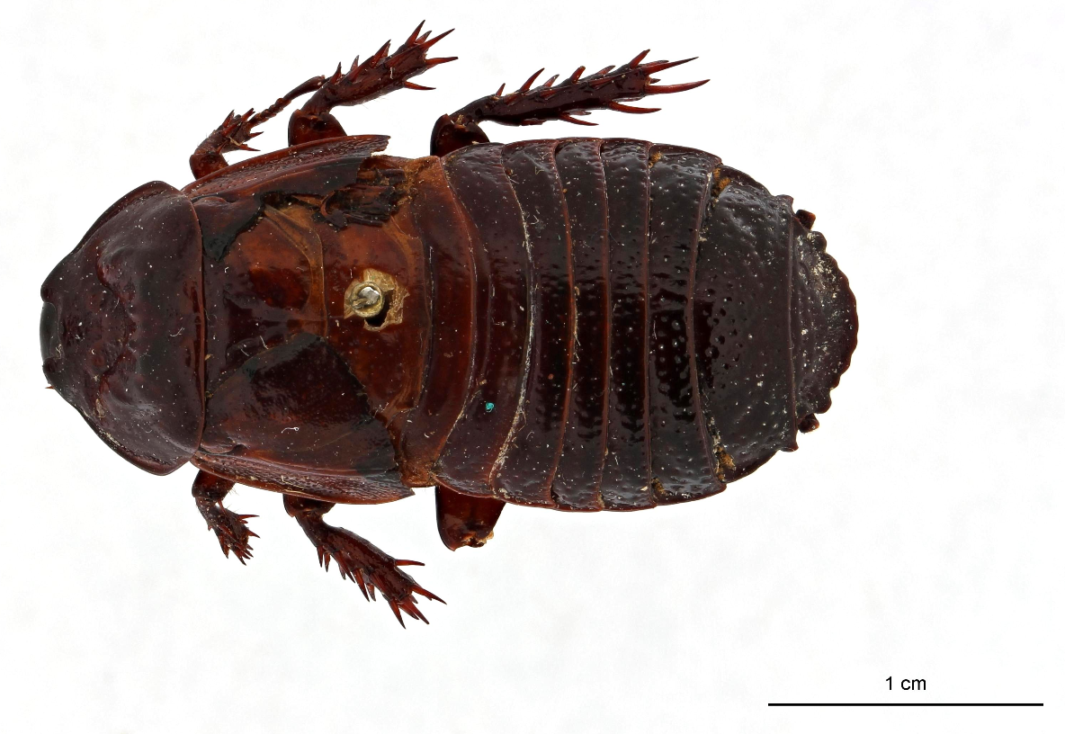 | 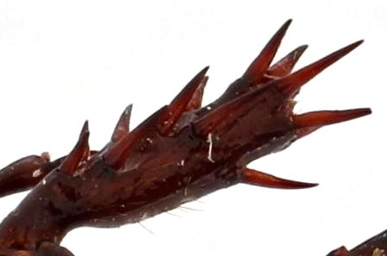  Detailed view at 100%
Figure 22: Digitisation of a dry specimen using the photostacking setup
Holotype, Panesthia hamifera Hanitsch, 1930, dorsal view

3D digitisation of the specimens

Task 3.3 Digitization by photogrammetry
Photogrammetry digitization is used today in the routine activities of collection management. It is used when 50 µm of resolution is enough for the digital model or when the texture is important for the scientific value of the specimen. We used this 3D digitization to create digital collections of human fossils or of Mollusc type specimens where the orientation of the view is crucial for the identification. Photogrammetry can be combined with photo stacking to produce textured 3D models of small specimens.
Staff Qualification: technician, funding DIGIT-4, DiSSCO-fed, RBINS & RMCA
At RBINS, photogrammetry was used to digitise the human remains collected during the Belgian colonial period in the DRC and Rwanda. This digitisation was achieved in the framework of the BRAIN HOME project. The virtual models are not uploaded to Sketchfab as the other 3D models for ethical reasons because these bones are the remains of persons who required respect. The 3D models can be shared with the RDC and Rwandese authorities to make provenance studies and prepare requests for repatriation.
Photogrammetry produces the best quality of the colour texture but requires hundreds of images to produce a good quality shape with a high level of detail. see DIGIT-KEY. Semi automated setups using motorised turntables and tethered DSLR cameras were developed in the framework of the different digitisation programs.
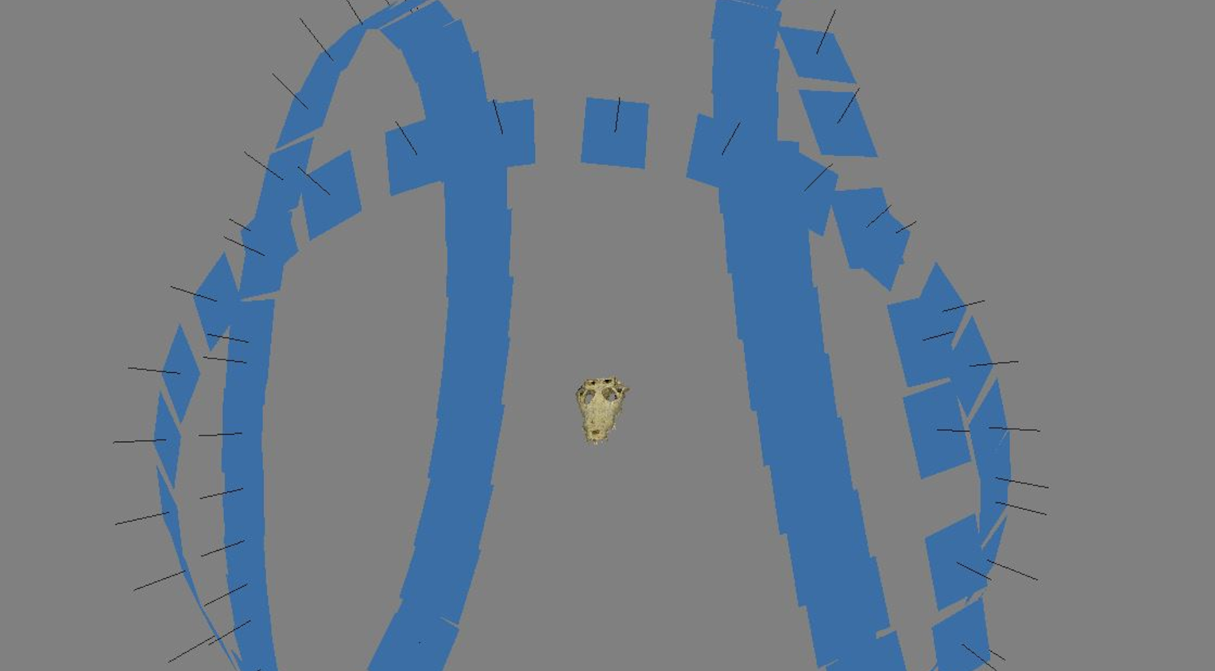
Figure 23: Aligned 108 pictures (3 rotations) used to create the 3D model with the SfM Agisoft Photoscan
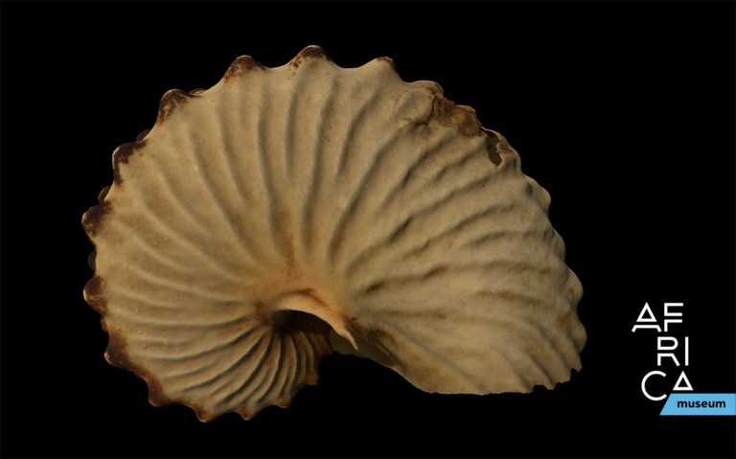
Figure 24: 3D model of a Argonauta tuberculata, produced by SfM photogrammetry at the AfricaMuseum

Task 3.4 High Resolution Digitization by Surface scanning
This technique is used to digitise specimens for which the texture is not a priority.
Two structured light scanners covered already different needs:
- the LMI HDI has a resolution around 50-60 µm for medium specimens (15 - 100 cm)
- the Mechscan digitizes smaller specimens with a 10 µm resolution.
Two new additional scanners and professional 3D software were ordered in the framework of the Dissco-Fed project:
- The Keyence VR5000 microscope opens new possibilities to digitize small specimens like pinned insects with a resolution up to 2 µm at an incredible speed (about 10 sec for a high resolution 3D model of one view). The microscope/scanner also captures the texture which can be displayed on the 3d model. The associated software developed for metrology in industry provides amazing tools for measures and reporting. This new equipment can speed up drastically (> 5X) the digitization of the “dry” insects and mollusks type specimens. The microscope/scanner is transportable, it can easily moved to the institution hosting the collections.
- The Artec Spider portable scanner allows to digitize large samples (e.g. large mammals, dinosaurs) with a resolution of 50 µm. This range is missing in our current imaging infrastructure. The Artech spider scanner can produce also a good quality texture.
The Artec EVA and the Artec Micro were also acquired during the 2019-2022 period to completely cover the needs for the different categories of specimens/collections.
The creation and the optimization of accurate 3D models is important to allow the final user to manipulate and study the digital object(s). We already tested and used several free or Open Source softwares (Meshmixer, GOM Inspect, Meshlab, Blender) but Geomagic wrap which is very expensive (about 12000 € / licence) is really faster and more precise than alternative options. The acquisition of this software really speeds up the preparation of the 3D models with a better quality.
Staff Qualification: scientist

Task 3.4.1 Keyence VR5000
The Keyence VR5000 has no competitor when it comes to high resolution 3D scanning. This equipment allows the recording of very fine detail not recorded by other SL scanners over a surface up to 200 by 100 mm. Unfortunately, it only allows recording one view at a time and not the complete 3D. Additionally, while it records colour texture it can’t export it. Thus we research solutions to overcome both shortcomings of the equipment. To do so we focused on two types of collections: the fossils collections and a vertebrate collection of scrimshaws.
The Keyence VR5000 enables the recording of fine details of the fossils. The collection of fossils chosen are relatively flat and can successfully be recorded with a single view. To be able to have 3D textured models that can be shared in virtual collections we had to combine different tools together:
- The 3D model is exported from the Keyence software as well as the 2D coloured image of the fossils (which has no texture).
- The 3D model is opened in Geomagic Wrap and the 2D image is projected as a texture on the model by identifying a few key features at the extremity of the fossil plate.
- The model can then be exported with texture and be shared online.
During the DiSSCo Fed project, the Keyence was used to obtain high-resolution digitization of flat specimens like paleobotany type specimens. In this case a single view allows to digitise multilevel flat specimens and access to details which are not available through classical photography.
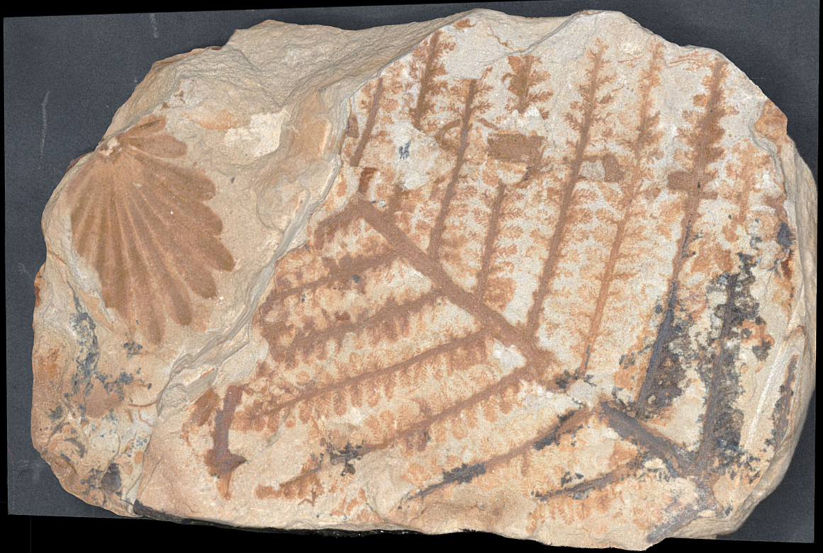 | 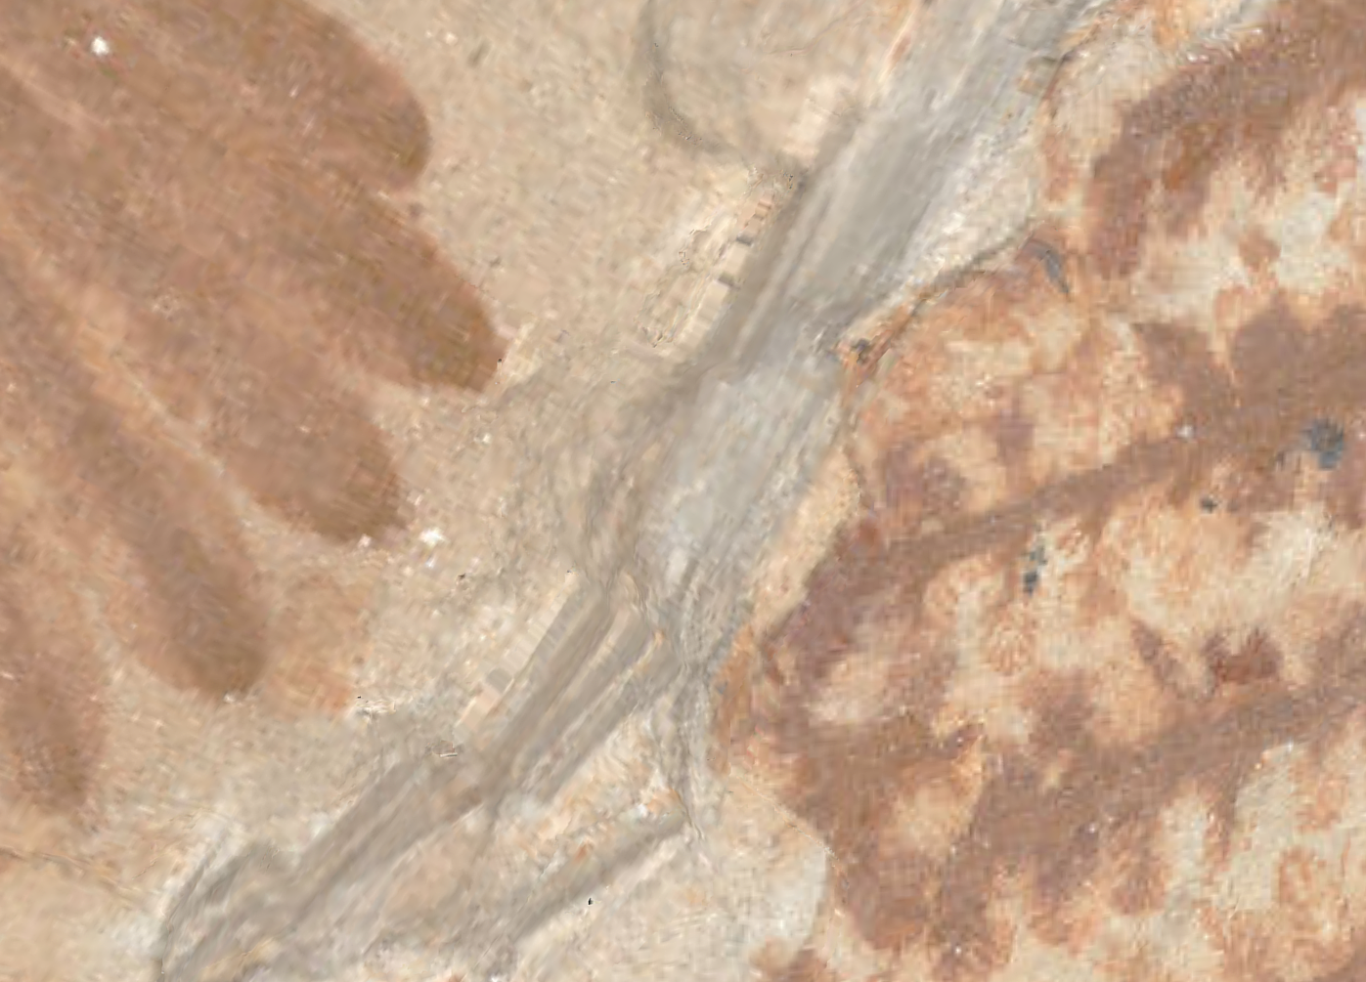
General view of the textured model | Detailed view of the textured model
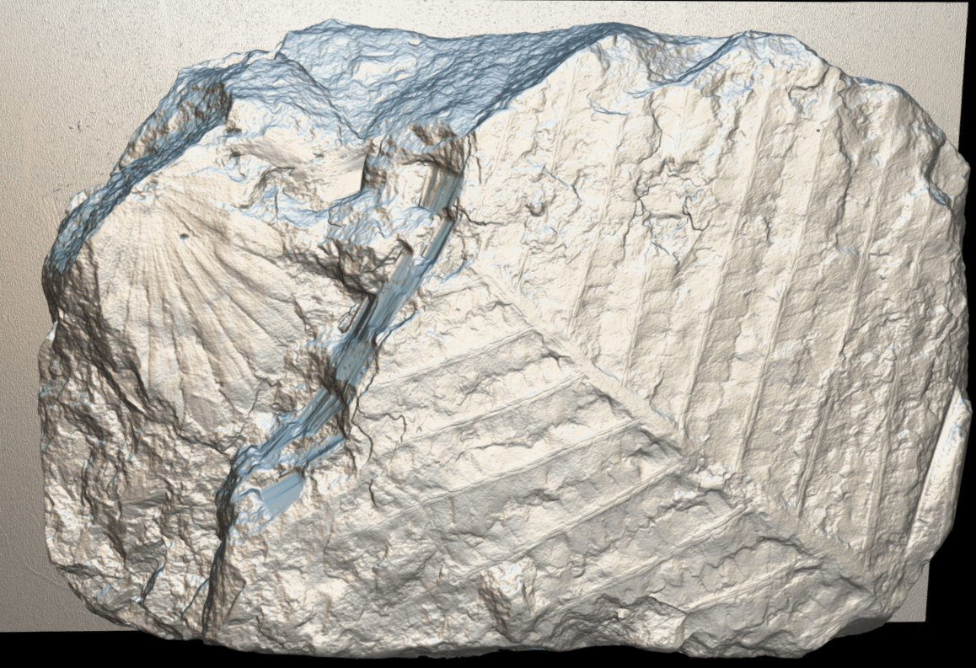 | 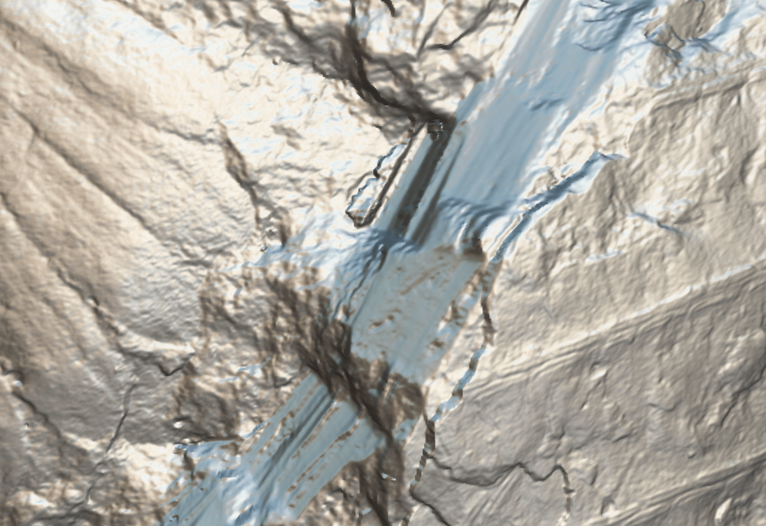
General view of the shape model | Detailed view of the shape model
Figure 24: Example of paleobotany fossils digitised with the Keyence VR5000 and textured using Geomagic
The Keyence VR5000 can also be used to digitise complete volume but this requires many acquisitions and a huge time of post treatment to realign all the views together and merge them in a unique 3D model. This option was chosen for a unique collection of scrimshaws housed by the Recent vertebrates collection. Scrimshaws are tridimensional objects that need to be viewed from all sides as most of them are decorated on both sides. Having only one side is not representative. The artwork is composed by very thin scratches highlighted with black pigment.
Unfortunately, not even the Mechscan, which is the 3D structured light scanner with the best resolution(10 µm) could record the fine engravings fully, the Keyence was the only tool able to do that (Fig. X). Thus, we decided to scan all sides of the object with the Keyence and recombine the different sides in a third-party software (GOM Inspect or Artec Studio are both fine options for that). Next, we needed the texture. Projecting the texture in Geomagic like for the fossils was more challenging and often imprecise, thus we opted to digitise the scrimshaw as well with SfM at a low resolution and project the SfM texture onto the Keyence re-assemble model for best results.
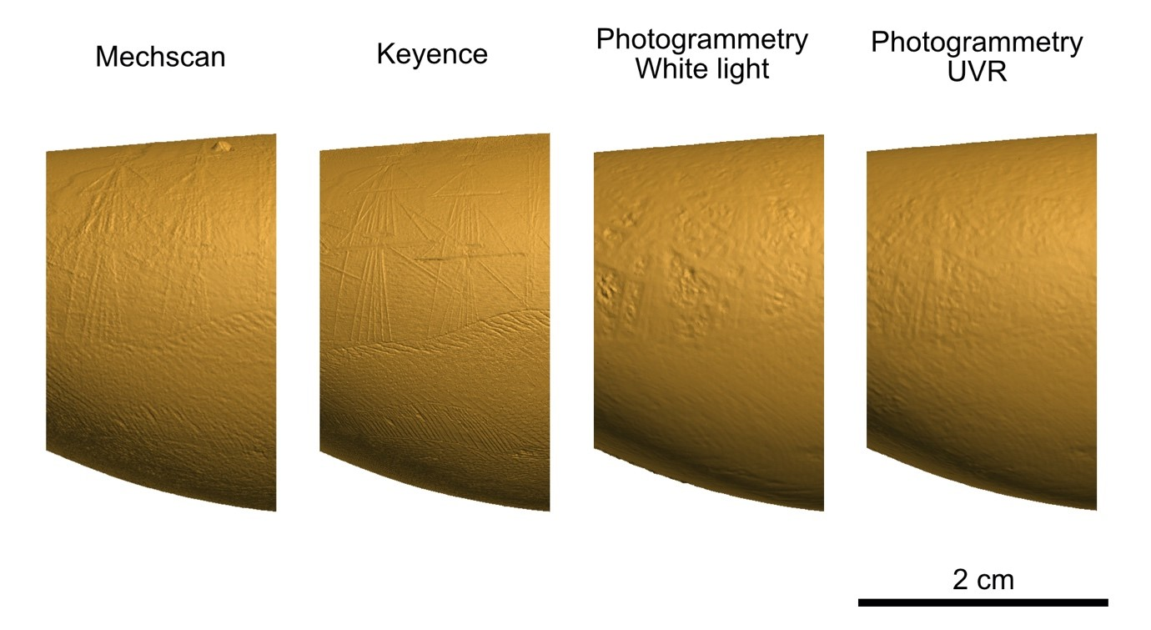
Figure 25: Difference of detail between Mechscan SL scanner, Keyence and photogrammetry (classic and spectral). The Keyence clearly offers a higher resolution over the other techniques of 3D digitization.
During the project, 145 scrimshaws and associated items were scanned with the Keyence VR-5000. The ones that were too large were scanned with other SL scanners such as Mechscan and HDI. In order to have a good texture, 172 were also digitised with SfM.
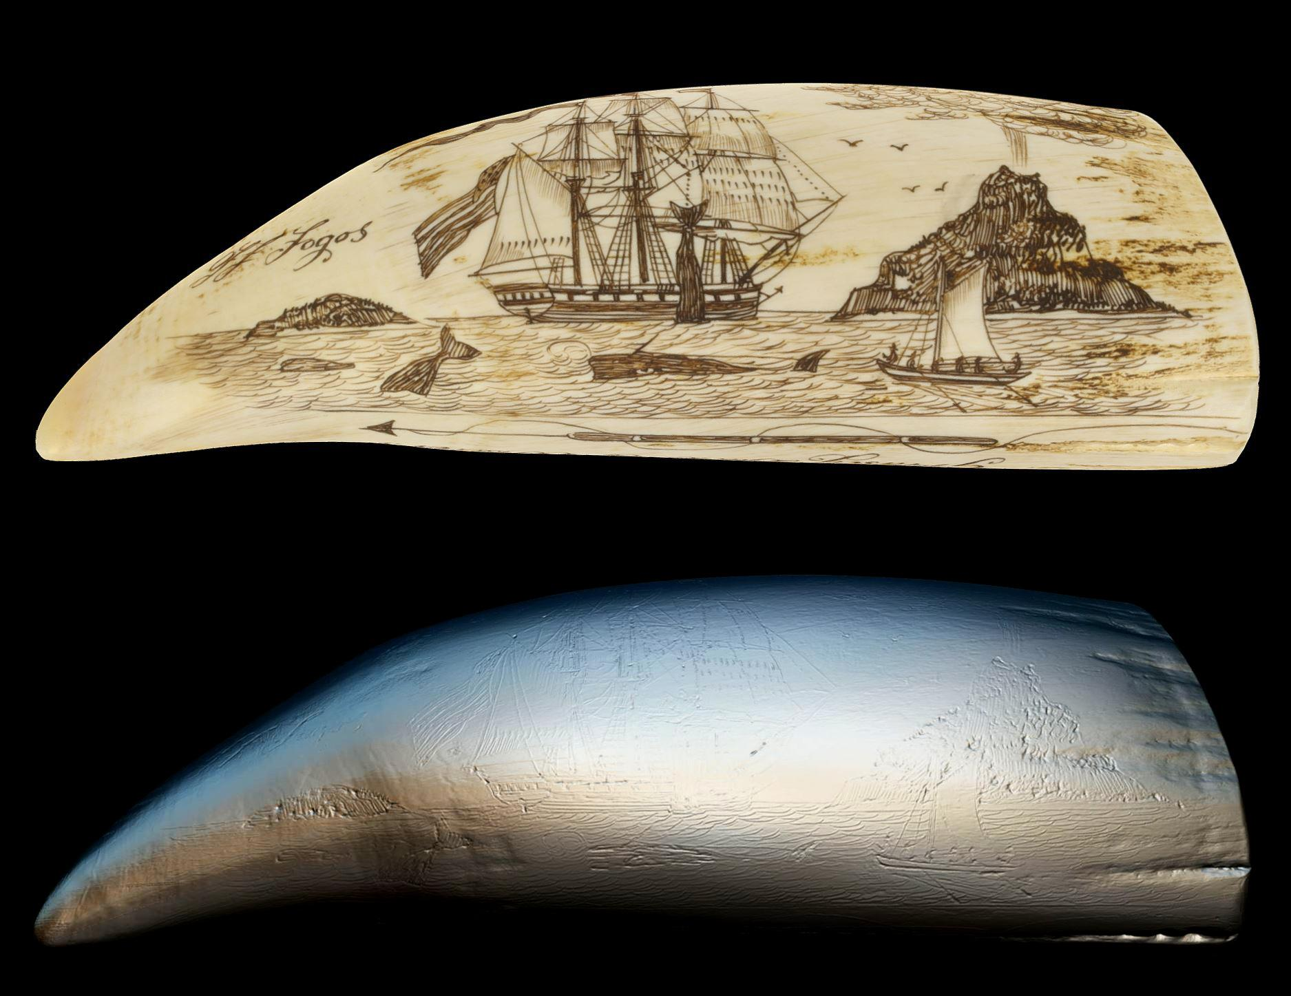
Figure 26: Up: scrimshaw with the SfM texture.
Down: reassemble mesh from the Keyence at x12 magnification.

Task 3.4.2 Artec Space Spider
Both RMCA and RBINS have recently purchased a handled structured light: Artec Space Spider. It is ideal for medium size objects requiring a good resolution.
At RBINS the Artec Space Spider together with the HDI advance were used to capture the holotype of the Iguanodon and paratype in partnership with the Brain project Iguanodon 2.0. It was desired to have high resolution models of the bones of the main type specimens, while the rest were digitized at lower resolution within the Iguanodon 2.0 project. The challenge when digitizing a skeleton of such size with a high resolution scanner is that large data is generated and models must be optimized to reassemble the full skeleton.
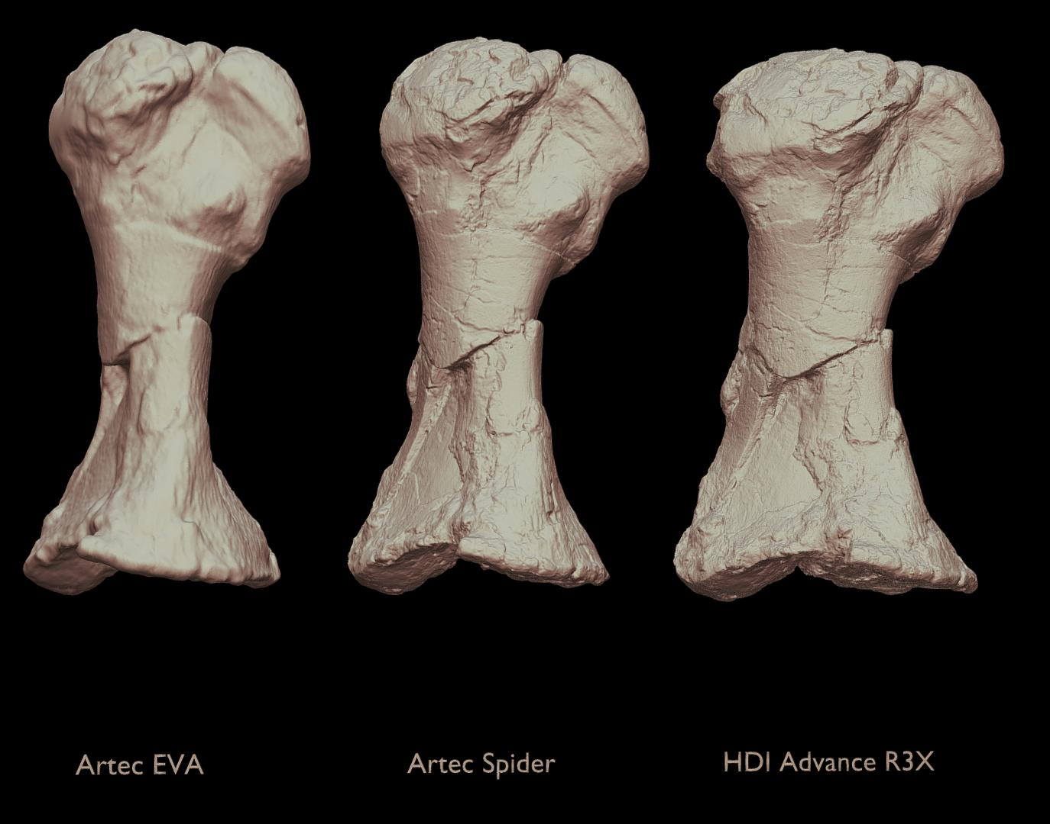
Figure 27: Resolution comparison of an iguanodon bone with 3D different SL scanner
The ARTEC Spider scanner was also used to fully digitise a skeleton of a Cave lion from the Goyet site allowing the 3D printing of a complete replica for tour exhibition.

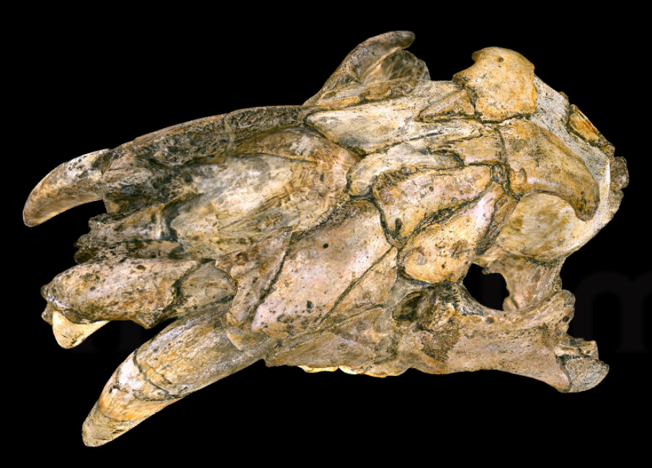 | 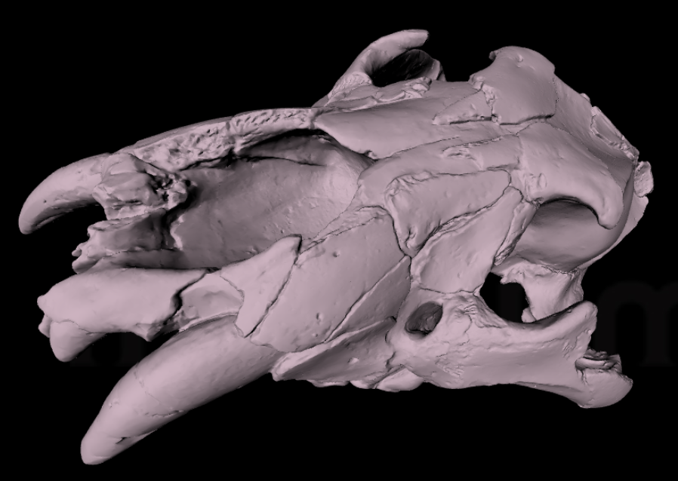
Textured view | Meshed view
Figure 28: Digitisation with ARTEC Spider: Cave Lion skull from Goyet Cave
At RMCA, the Artec Space Spider was mostly used to scan elephant long bones of mostly juvenile elephants, but also the complete skeleton of a young elephant. Long bones of large african mammals are among the most demanded collections by external researchers to perform studies on large series. Additionally, scanning an entire skeleton is useful to propose a reference skeleton for educational purposes. Finally, some birds were scanned with SL to test the feasibility and the usability of the models. While the results were decent, researchers estimate it has no added value to the study of the collections thus 3D digitization of birds with SL was not pursued further.
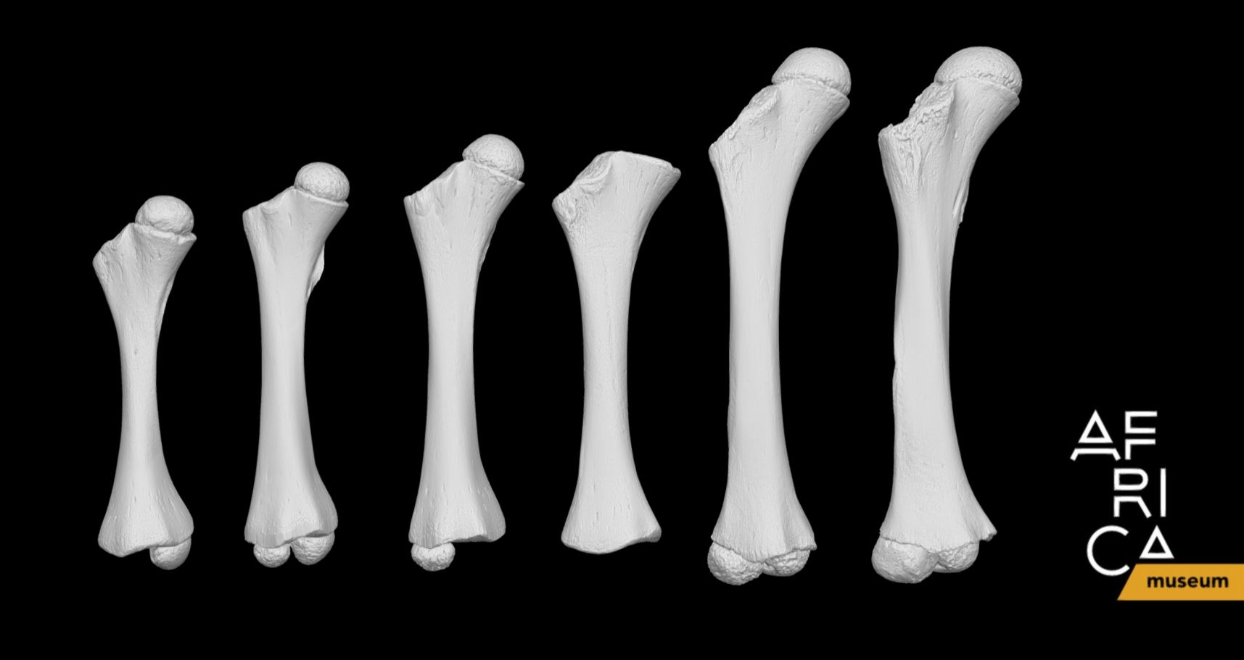
Figure 29: Rigth femur from juvenile elephants scanned with Artec Space Spider

Collection | Artec Spider | Artec Micro
Mammals | 202
Birds | 7
Arthropods |  | 4
Entomology |  | 26
Human Sciences | 11
Total | 220 | 30
Table 5: Statistics of surface scanning with Structure Light at RMCA (Artec Spider and Micro)

Task 3.5 Multispectral Digitization
Human vision spectrum is limited compared to the other animals. We thus describe nature with incomplete data. Many animals, plants or minerals produce specific signals outside of the human visible spectrum. The multispectral digitization allows to capture this signal and produce information about the nature of the specimen but also about its conservation. Combined with photogrammetry this approach delivers multispectral models (UV, IR or multibands) which are very informative in some taxonomic groups (e.g. Arthropods).
Staff Qualification: scientist
Multispectral imaging is traditionally used in 2D, but we worked in developing a 3D method. During DiSSCo-fed, we continued the development of the method and setup according to the challenges encountered during 3Dspectral.
Within the project we tested a new set of custom made LED multispectral panels allowing us to use 12 wavelengths. Additionally, the setup was modified so the panels and the camera are supported by a single stand, which takes less space and is easier to use on the field.
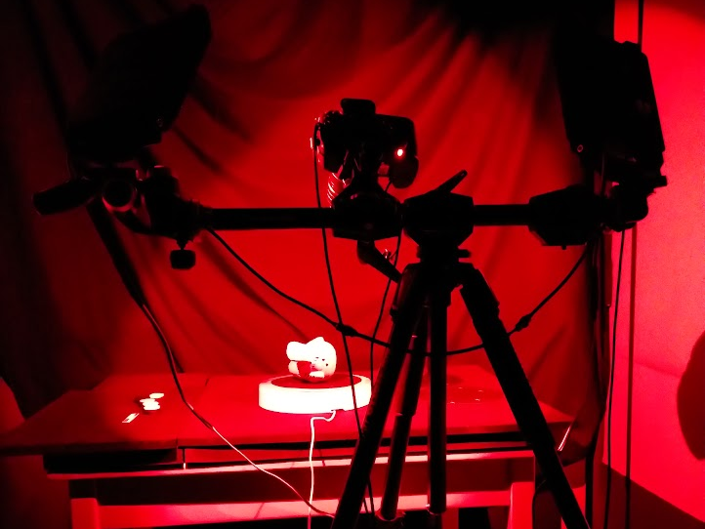 | 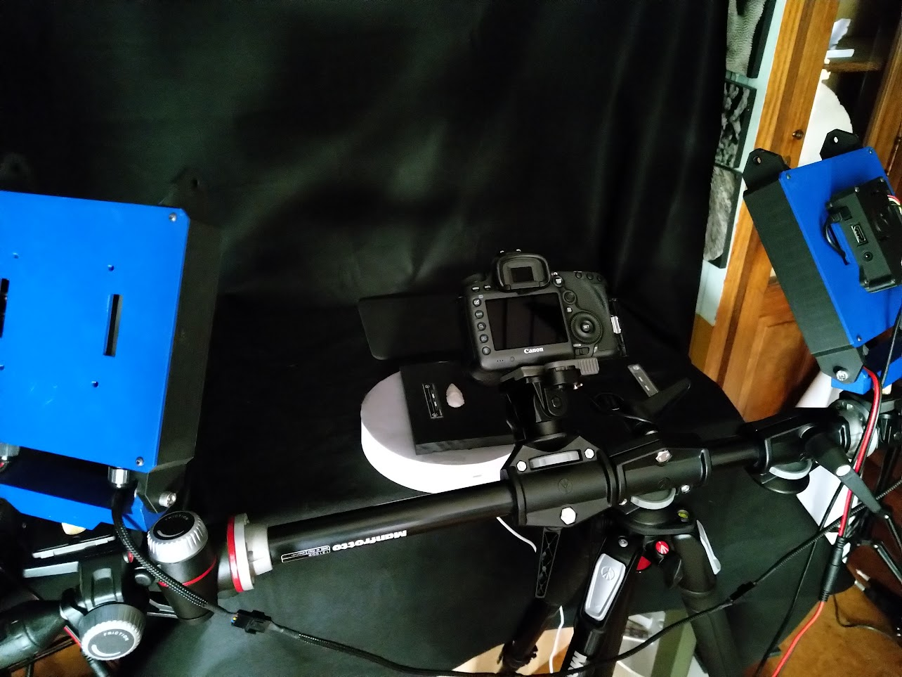
Figure 30: Picture of the 3D mutltispectral setup with the new version of the LEDs pannels
We investigated in 2D some of the reptile and amphibians collection of RBINS, to see wether it could add an additional layer of information, like learning which species fluoresce. One of the challenges with wet collection is that fluorescence decreases over time (Kohler et al. 2019) therefore only recent specimens could be investigated. We choose to start with amphibians and reptiles as these are two groups that have already shown potential, and several scientists at RBINS are actively involved in research and taxonomy of reptiles and amphibians. Additionally to fluorescence, it was decided to investigate the specimens for ultraviolet reflected and infrared reflected in case these invisible wavelengths reveal something invisible to the naked eye. About 30 specimens were tested, with ventral and dorsal views (Figure 31).
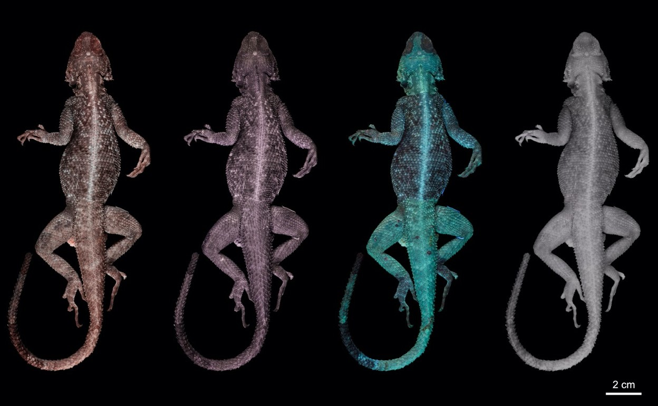

Figure 31: Multiband imaging of natural sciences collections. Example of multiband image of Agama agama, dorsal view. From left to right: visible light, ultraviolet reflected, ultraviolet fluorescence, infrared reflected.

Regarding 3D multispectral, we evaluated the potential of multispectral SfM to improve the photogrammetric model of the scrimshaws. While using UV illumination did improve the quality of the 3D produced in SfM, it wasn’t sufficient to record the fine engravings, thus the choice of using the Keyence SL scanner instead (cf. 3.4.1).
At RMCA, we opted to digitise in 3D multispectral a sample of 30 ethnographic masks and to see wether it could be a tool to help differentiate pigments used.

Task 3.6 Microtomography
RBINS acquired 2 microtomography scanners in 2016 (One shot call of the State Secretary Elke Sleurs, 2015). RBINS choose 2 different equipment in order to maximise the digitization process. The 2 scanners can work in parallel while a bigger scanner with 2 sources and 2 detectors is limited to 1 sample at once.
- the EasyTom 150 – RX Solution
The EasyTom 150 – RX Solution was used for scanning large or medium-sized samples, most of the time down to a voxel resolution of 10 µm (sometimes down to a voxel resolution of 6 µm, then with inferior quality). The source is a 150 Kv, which is dedicated to dense specimens like cores, minerals, fossils and dense vertebrate tissues.
- the TESCAN XRE
This scanner was used for scanning small (< 10cm) and low-dense specimens like the invertebrate specimens. In our case we scan with a voxel resolution from 30 to 1 µm.

Collection | RBINS | RMCA
Mammals | 99 | 143
Fishes | 71 | 73
Amphibians | 81 | 41
Reptiles | 170 | 80
Arthropods | 6 | 342
Insects | 10 | 0
Crustacea | 316 | 0
Diplopoda | 0 | 26
Molluscs | 1616 | 0
Echinodermata | 143 | 0
Vermes | 0 | 8
Paleontology | 2811 | 0
Human Sciences | 312 | 0
Geology | 0 | 3
Total | 5735 | 716

Table 6: Statistics of micro CT scans using RX Solutions and XRE Tescan setups
Combined results of DIGIT and DiSSCo Fed.

The following sections describe the results of the DiSSCo Fed tasks related to the micro CT digitisation. This includes the digitisation of type specimens but also methodological developments allowing to produce the best quality of images for the different categories of specimens and constraints.

Task 3.6.1 Microtomography of mammals types at RMCA (RX Solution EasyTom)
RMCA collections hold rare types of mammals including primates, rodents, Chiroptera and Bovidae. During this project, skulls have been scanned with µCT to record all inside structures, while the During the DiSSCo Fed project, the priority was given to the digitization of types and Illustrated specimens allowing a scientific valorisation or to develop new protocols for the digitisation of Type Specimens as they can not be treated with contrast agents.
bodies stored in alcohol were scanned to extract the skeleton. This allowed them to virtually reassemble the skull with the rest of the skeleton, but it also allowed them to share the type collection with the research and public community. During the project, the 122 specimens were scanned for a total of 196 scans as some elements of the specimens were scanned separately. All scans were performed using the RX Solution scanner.
The meshes were extracted using Dragonfly and cleaned with GOM Inspect. Only the bones were segmented. The segmentation is semi-automatic: indeed parts of the specimens require manual segmentation. Manual segmentation is a challenge as it is extremely time-consuming and sometimes requires anatomical knowledge to understand what needs to be segmented. This is one of the biggest limitations encountered in microcomputed tomography as segmentation of a specimen can take up to a few days, depending on the complexity of the manual segmentation. This means that for one day of scan, we may need several days of segmentation. Additionally, segmentation requires powerful workstations.
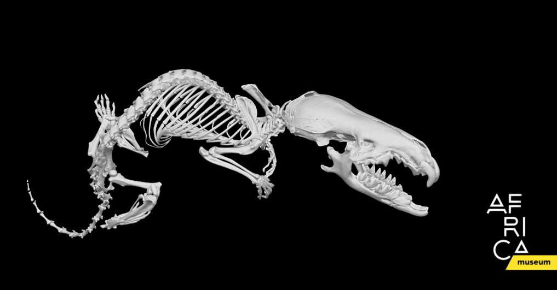
Figure 32: Paracrocidura schoutedeni. Body: 37µm, skull: 12µm
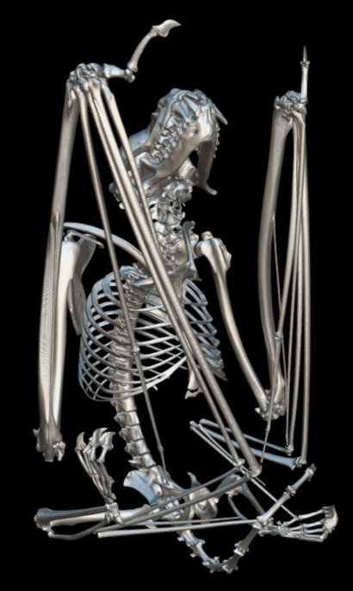 | 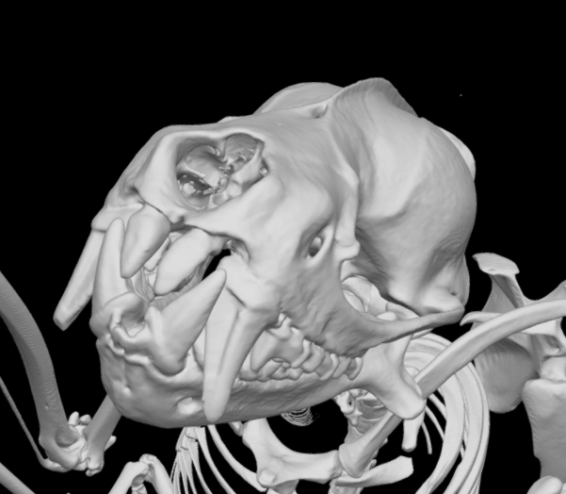
Figure 33: 15309 Mops osborni occidentalis. Body: 36.4µm

Task 3.6.2 Microtomography of ichthyology types at RMCA (RX Solution EasyTom)
RMCA ichthyology collections are the most important for central Africa and it continues to grow. They contain many type specimens. Within the project 53 type specimens of fish were scanned, some were even being described during the project.The scans are part of both the collection management process and use on current research on the collections.

Task 3.6.3 Microtomography of spiders and some other invertebrates at RMCA (XRE)
One of the highlights of the research in the RMCA, are its studies in arachnology. These were carried out without interruption for more than half a century now (from 1964 onwards). The RMCA arachnologists and collaborators described a significant number of species, so much so that a large number of spider types (more than 4,460 records, including nearly 1,300 holotypes) present in the RMCA collections result from these studies. With its focus on Afrotropical spiders, the RMCA spider collection, therefore, represents a very unique reference collection and undoubtedly the most important in the world. Nearly 96,800 arachnid data (comprising 87,600 spider records, and not including Acari) are encoded and represent more than 321,000 specimens. The quality of the collection and its ease of use (all samples are sorted at the morphospecific level, identified at least to the family and encoded in the section's database) has therefore already attracted hundreds of specialist visitors from all over the world.
The use of 3D technology is a great opportunity and has not yet been exploited in the field of spider taxonomy. The XRE microscanner was used for this task as it is dedicated to low contrast specimens and can produce higher resolution images than the RX solution Easytom.
The importance of digital conservation data of collection material is obvious. Physical spider specimens are mainly preserved in an alcohol solution and slowly deteriorate through time (especially coloration), with information being lost for future studies. Digital conservation is especially crucial for type specimens as they often represent unique reference specimens and, therefore an inestimable value for the institutions harbouring them, and for science as well. A virtual access enables any scientist (but also non-scientists) to get a first and quick access to information about the specimens as it can be seen in the collection, without the need for borrowing the physical samples. Thus, it avoids the risk of damage by excessive (or bad) manipulations, or getting lost by sending with postal services. Furthermore, digitization serves as a sort of “back up”, if destroyed by fire as it happened to two Brazilian museums that have faced a series of fires in the recent past, resulting in irreparable losses. Therefore, digitization programs also contribute to a very important role in the preservation of our collections.
In spiders, the copulatory organs were included since the first publication with valid taxonomic names by Carl Alexander Clerck in 1757. They are now included in every description, as they are proved to be essential for distinguishing between different species, even closely related taxa. Line drawings were for a long time the only information source, allowing essential structures to be highlighted and much easier to recognize, especially during the process of identification. Then, methods of image stacking in combination with motorised microscopes and digital photography have facilitated sharp photographs of even tiny details. The use of scanning electron microscopes pushes the observation to even extremely smaller scales but often requires irreversible preparations, such as drying and gold sputter-coating. Photographic illustrations offer a helpful additional source of information as they show real structures and colours (even if it can be altered by preservation conditions and time). However, all these 2D techniques are subject to interpretation. Finding the exact same plan when observing a specimen under stereomicroscope is often challenging and may lead to misidentification, especially if the sample was not correctly placed or has been modified or deteriorated (e.g. due to collection methods, preservation conditions, etc.). The association of 2D and 3D techniques offers much more possibilities and clearly facilitates the comparison process, especially with 3D models showing all complex structures, in any possible orientation (see Figure 34-C). It also helps to get a better comprehension and interpretation of these structures, sometimes provided with hardly distinguishing translucent parts, and facilitates their highlighting when creating drawings.
Such a combination of 2D and 3D images could be formidable tools for interactive identification keys.

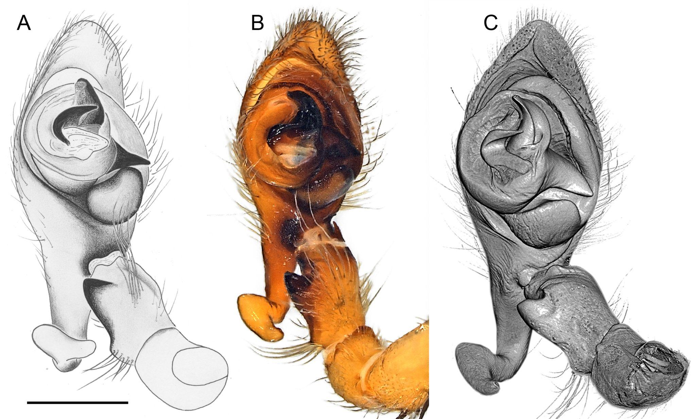
Figure 34. Different imaging methods used to illustrate the male palp of a new spider species in the Udubidae family from Madagascar (Holotype, BE_RMCA_ARA.Ara.247343). A. Drawing. B. 2D microphotography. C. 3D µCT scan.
Designing a protocol to prepare spider samples for reconstructing 3D models using Micro-CT scans
Spiders are challenging to µCT scan because of the low density of the body or tissues. Indeed, when immersed in aqueous solution (such as in alcohol, the typical preservation solution for spiders), the density between the sample and the solution is very similar and the sample is often barely distinguishable from its environment when the acquisition of µCT scans is performed (see Figure 35-A). Different tests were made (essentially male pedipalps) to find the best way of digitising spider samples using µCT in order to propose an as non-destructive as possible method to prepare such samples. Besides the low contrasting density when immersed in alcohol, one of the major constraints when digitising genitals is the relatively small size of the male pedipal, ranging from 0.5 mm to a few mm. To achieve a high resolution, such as 1µm (or lower) of voxel size for the smallest pieces of spider palp, the sample needs to be placed as close as possible to the X Rays source. When immersed in alcohol, the sample is enclosed inside a container (Figure 36-A) and, due to steric constraints, it is not possible to reach the optimal smallest distance to achieve the highest resolution.
To improve the density contrast, a contrasting or staining agent (such as iodine solutions) can be used. Staining is a reversible process so that the sample can be gently washed and relocated in its original tube. The palp is first temporarily (overnight) immersed in an iodine solution (LUGOL), following the recommendations of Metscher (2009). The palp can be scanned in water solution (or 30-50% alcohol) or out of alcohol, being placed in a small container where the atmosphere is saturated with vapor (using a piece of cotton imbibed of 95% alcohol or acetone) (Figure. 35-A). It is important that the surface of the palp is not covered with a coat of drops of alcohol.
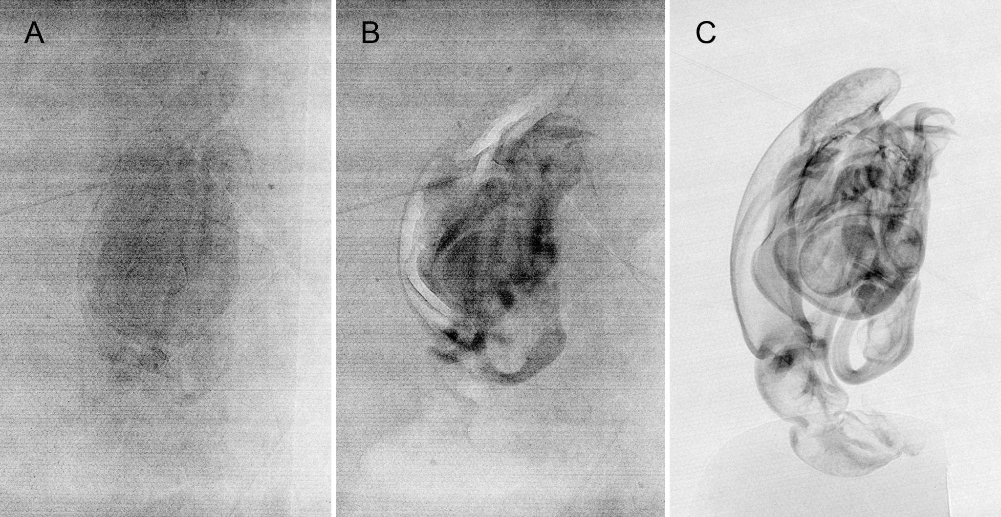Figure 34-A. Acquisition images (Xray scans) of the right palp of Mallinella submonticola, paratype specimen (BE_RMCA_ARA.Ara.161528) under different treatments. A. µCT scan of palp in aqueous solution. B. µCT scan of palp in aqueous solution, previously treated with a contrasting agent (LUGOL). C. µCT scan of the same palp (previously treated with LUGOL), then dried.
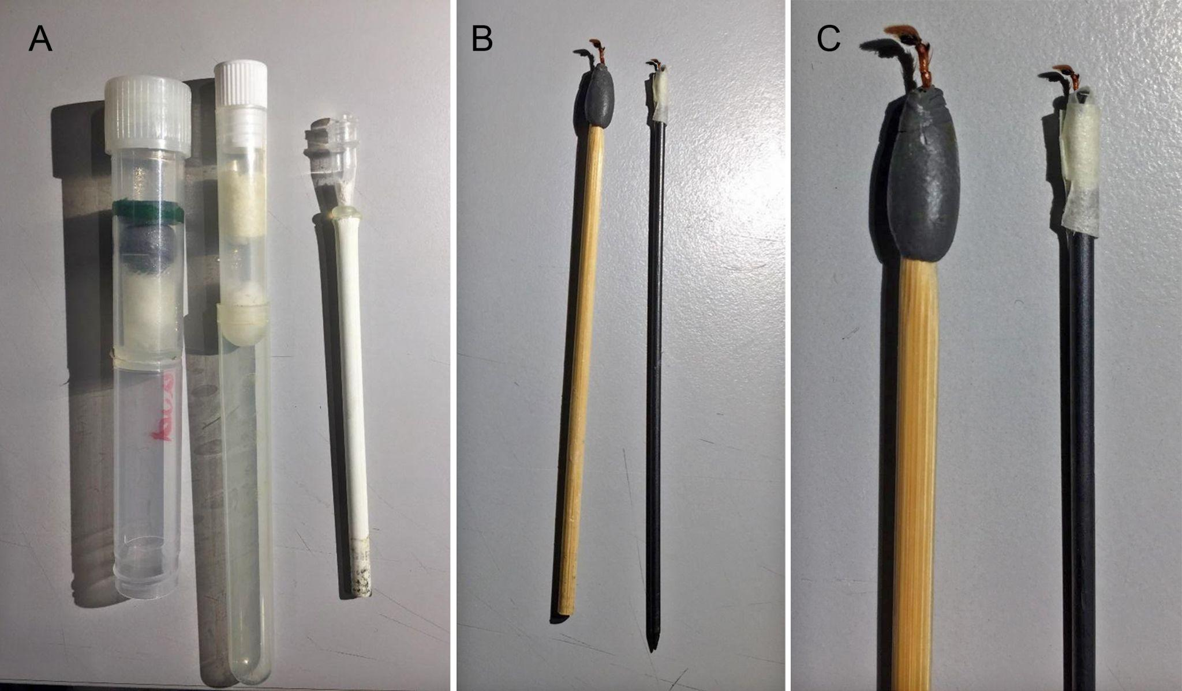Figure 35. The results are however much better when the palp is air-dried (still after staining) and scanned freely. Dried palp is easier to prepare, gently fixed on top of a wood or carbon stick, using plasticine or low tack tape (see Figure 35-C). The sample can be rehydrated using a wetting agent as described in Jocqué (2008) and Baccaloni 2012). For example, a comparison of results without and with LUGOL treatments and scanned in aqueous solution or in the air can be seen in Figure 34.

The method was used to produce 3D models of palps (see an example) but also female genitalia (see an example) or even spider bodies (see an exemple).
Finally, this protocol coil could also be applied to other invertebrate organisms, and was even tested for stomach Flukes (see Task 4.1 Valorisation).
References
- Metscher, BD. 2009. MicroCT for comparative morphology: simple staining methods allow high-contrast 3D imaging of diverse non-mineralized animal tissues. BMC Physiology 9:11. pmid:19545439
- Baccaloni, J. (2012). A Preliminary Comparison of Trisodium Phosphate with Agepon and Decon90 as Wetting Agents to Hydrate Dried Arachnida and Myriapoda Specimens. NatSCA News, Issue 22, 71 ‐ 79.
- Jocque, R.(2008). How to hydrate dried spiders. Newsletter of the British Arachnological Society,112: 5.

Task 3.6.4 Microtomography Diplopoda at RMCA
Copulation, genital morphology, and sperm storage are not very well understood in millipedes. The use of Microtomography provides new morphological data regarding millipede reproductive systems in both the female and male, including chitinous sclerites and membranes, muscles, glands, oviducts, and sperm conduits. During the project we illustrated the morphology of the gonopods of a new species of Harpagophora. The new observation will allow us to understand how these structures move during copulation and similar observation on female genitalia will allow us to tentatively identify a lock-and-key-like mechanism.
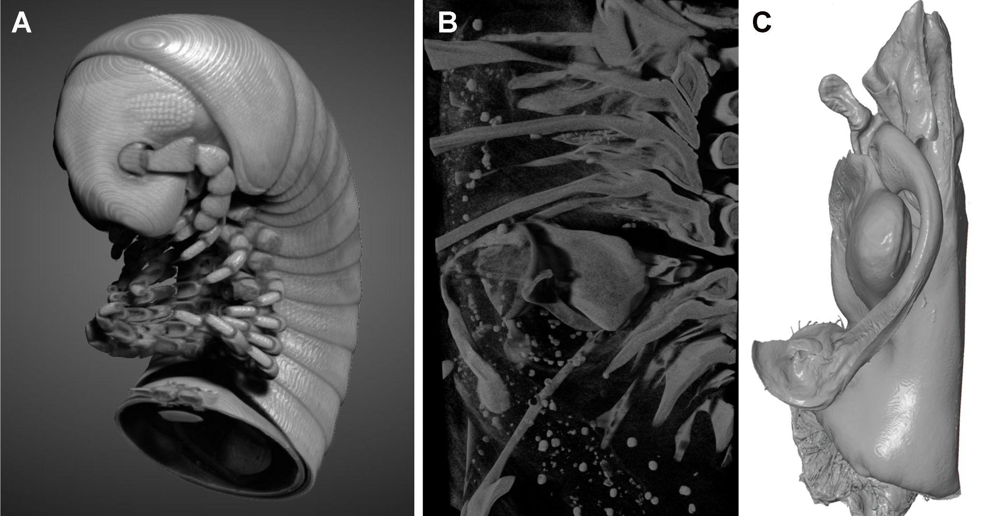
Figure 36. A: Anterior part of Harpagophora sp.; B: Sagittal section through rings 4-9; C: Left gonopod, mesal view

In total, 75 Holotype, 63 Paratype and 41 non-type specimens were digitised.
- Arachnida: Araneae (13 families) and Opiliones (one family)
- Araneae. Barychelidae: 3 samples (10 scans); Ctenidae: 58 samples (93 scans); Entypesidae: 1 sample (3 scans); Lycosidae: 4 samples (4 scans); Migidae: 2 samples (7 scans); Pholcidae: two samples (10 scans); Salticidae: 3 samples (7 scans); Sparassidae: 1 sample (2 scans); Theraphosidae: 1 sample (4 scans); Udubidae: 3 samples (8 scans); Viridasiidae: 5 samples (7 scans); Zodariidae: 113 samples (180 scans); Opiliones. Biantidae: 2 sample (7 scans).
- Diplopoda. Harpagophoridae: 4 samples (26 scans).
- Vermes. Gastrothylacidae: 2 samples (4 scans); Paramphistomidae 1 sample (4 scans).
All data are stored on the NAS of RMCA, which will be saved to the LTP.

Task 3.6.5 Microtomography of recent invertebrates at RBINS
1995 scans, mostly from type specimens from RBINS collections, were acquired in the framework of DiSSCo fed, as an effort to digitise type collections:
- 1616 were mollusks (usually shells),
- 143 Echinodermata,
- 218 crustaceans
- a few other invertebrates.
We usually did one scan per specimen, but about 5% of specimens had to be scanned twice in order to improve the parameters.
Different output 2D and 3D items were produced in processing the scans:
- 1103 tridimensional models
- 695 specimens snapshots of the rendering images with about 10 snapshots per specimen, in different orientation for a total of about 7000 snapshots
A. 3D-models
In theory, 3D-models should be the ideal output files obtained from µCT scans. They can be obtained by segmentation of the slices of both machines (in our case using the programme Dragonfly ORS). However, the EasyTom150-RX software is able to create 3D models directly from the projections, during the reconstruction process, which is a huge gain of time. The quality of these "direct models" is very variable depending on the nature of specimens: worthless for soft specimens but usually excellent for dense homogeneous specimens like shells. In the case of molluscan shells, the "direct models" are usually much more precise than those obtained by the segmentation of the reconstructed slices.
In practice, 3D-models are not always the best kind of output files. Certainly, they are items easy to manipulate in all directions and useful for some kinds of morphometric analyses. However, the surface texture and details are often blurred. Therefore, depending on the taxonomical group, the usefulness of the models varies considerably:
- Useful and often spectacular results are often obtained for skeletons of vertebrates.
- Satisfying results are also obtained for mollusc shells, especially for "direct models".
- For echinoderms, the models were of variable quality but usually disappointing.
- For decapod crustaceans, 3D models were of very limited utility, because the limits between contiguous structures often become blurred.
B. Short movies
It is possible to easily create short movies from slices using Dragonfly ORS. The results can be spectacular. However, movies are more useful as didactic outputs than as scientific tools. So, only a few were created.
C. Snapshots of renderings and segmented structures (2D images).
The rendering images obtained directly from the slices are often very detailed and the program Dragonfly ORS includes various tools to select the range of density to visualise, to play with transparency or on the contrary to obtain images of specimens with an opaque surface, to use a wide array of density-related false colours. It is possible to obtain snapshots (2D images) of these views, which are usually more detailed than models. Similarly, it is also possible to take snapshots of "segmented structures", i.e. of structures, which have been digitally dissected, prior to the creation of 3D-models. Such 2D images can be very useful for scientific publications. In the case of decapod crustaceans, snapshots were often excellent, while 3D-models were very disappointing.
In some cases, different snapshots of the same view, but with different histograms of density were taken and later on manually combined with a classical image software like Adobe Photoshop or Affinity Photo, in keeping the best parts of these snapshots. This is an approach that was very useful for specimens both with dense and less dense structures and where noise artefacts appeared on some of the snapshots involved.
Compared to photographs, microCT snapshots have advantages and disadvantages :
- First of all, photographs (classical photography, stacking photography, Scanning Electron Photography) are much less expensive than the use of µCT and do not require an operator as skilled as for µCT. However, when 3D models are created anyway, it does not cost much time to make some snapshots, especially when they include details not visible on the models.
- Photographs are a direct figuration of the item studied, which will include no artefacts (except inadequate exposure, lack of focussing or for SEM charging problems). µCT snapshots are no photographs of the specimen itself but images reconstructed by an algorithm processing slides, which were themselves reconstructed from projections. Furthermore, the functions for editing the renderings (especially the histograms of density) are delicate to use. As a consequence, in some cases, the images may include very problematic artefacts. This is especially the case in opaque views. The less dense parts of a continuous structure can become invisible, resulting in a misleading image. Inversely, noise resulting from the refraction of X rays may look like an element of the structure of interest. Normally, the operator will try to minimise these problems or, as said earlier, will merge different views with different histogram values. However, when looking at microCT 2D images, one should always bear in mind that it may present significant artefact and that they do not have the reliability of photographs.
- µCT snapshots often have a resolution inferior to photographs (especially when it concerns larger items), resulting in smoothing of the surfaces on the picture. In many cases, this is a disadvantage, but not always, as sometimes it results in a cleaner image.
- Structures with a very low density to RX are often indistinct on µCT snapshots. In some cases (when these low density structures are important for scientific study), this is a disadvantage. However, in other cases, their elimination allows for the sharper views of the surface. This can be illustrated by the following example of images of a spider crab of the genus Pisa, where short hairs and dirts are hiding the fine relief of the carapace on photographs and are eliminated on the µCT snapshots, the X rays acting literally like a kärcher: photograph on left side, microCT snapshot or right side:
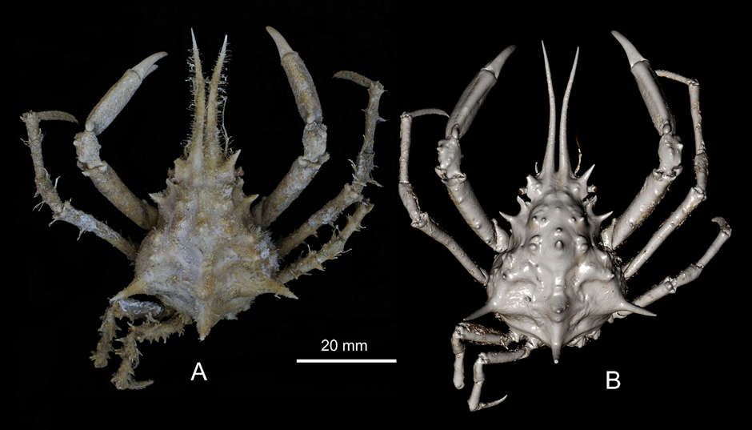
Figure 37. Pisa sp. nov., adult male. Atlantique Sud, stn 110, Angola, 16°36ʹ S, 11°27ʹ E, 110 m, 27 Jan. 1949 (RBINS, INV. 116851). A, photography in stacking; B, microCT snapshot.
Even more spectacular differences can be seen in the case of Pilumnus stebbingi Capart, 1951, which is a little crab covered by a dense fur of short setae. In this case, false colours have been used in addition.
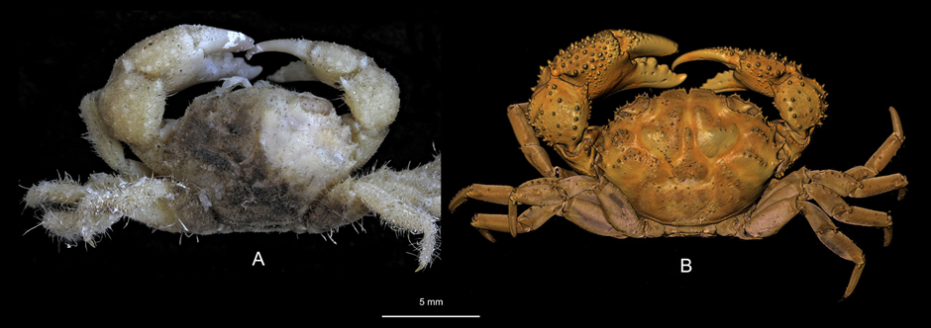
Figure 38. Pilumnus stebbingi Capart, 1951, male syntype. Atlantique Sud, stn 32, Angola, 7°17ʹ S, 12°42ʹ E, 29–30 Sep. 1948 (RBINS, INV. 113818). A, photography in stacking; B, microCT snapshot.
- A great advantage of microCT snapshots over photographs is that once the renderings are optimally tuned, it is possible to quickly and easily get views (snapshots) in any orientation possible, while it is often difficult and time consuming to position the specimen when taking photographs.
- (f) This usually requires segmentation of the structure, but it is often possible to visualise separately internal structures, without dissecting the specimen.
As an example, here is the calcareous ring of a sea cucumber, i.e. an internal calcified structure situated near the mouth of the organism:
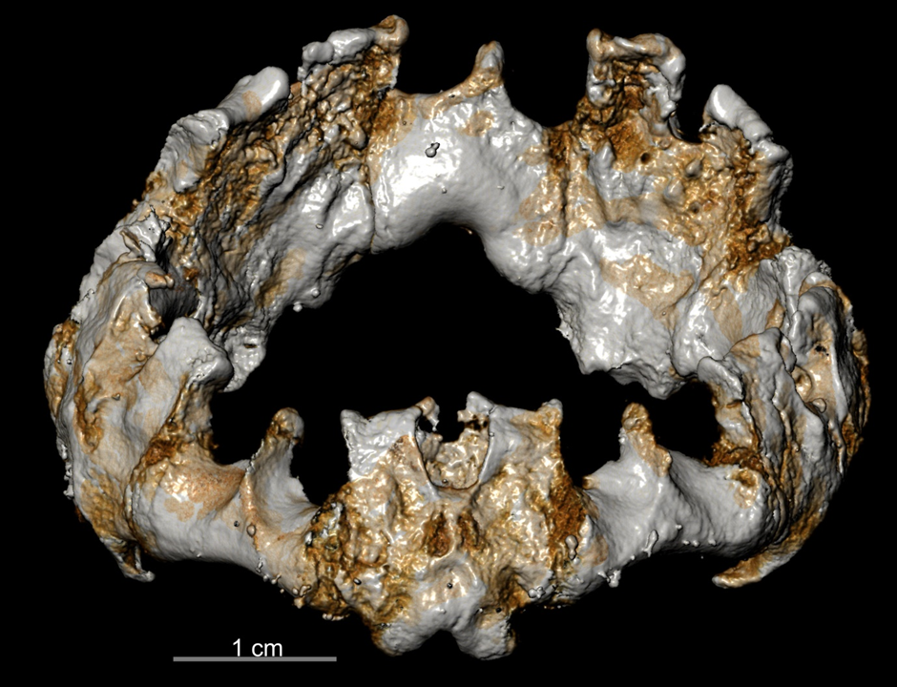
Figure 39. Holothuria (Cystipus) yann Samyn in Samyn & Vandenspiegel, 2016, type,
calcareus ring, digitally dissected in processing microCT files.
Another example is provided by the Neopentadactyla mixta (Östergren, 1898), France, Chausey Islands, RBINS, HOL.1736/2. The calcified structures can be segmented and 3d model of it can be displayed virtually in situ.
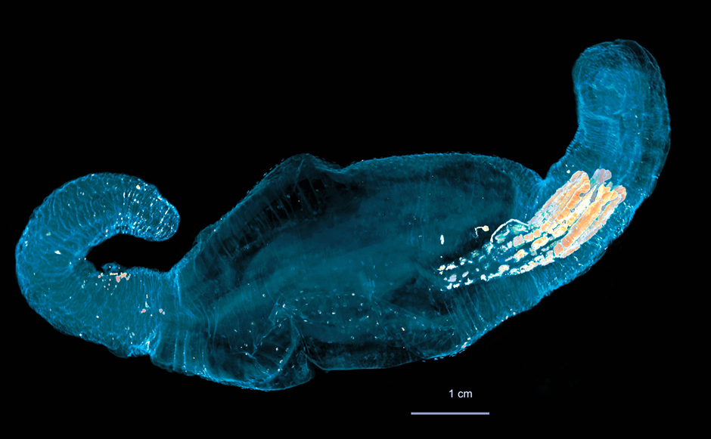
Figure 40. Neopentadactyla mixta (Östergren, 1898), France, Chausey Islands,
RBINS, HOL.1736/2; calcareous ring in situ.
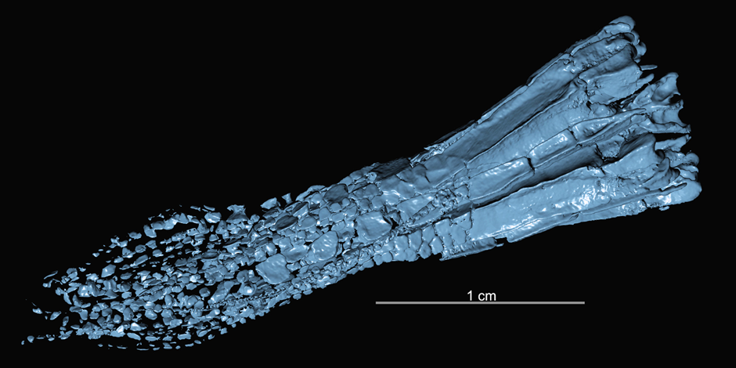
Figure 41. Neopentadactyla mixta (Östergren, 1898), France, Chausey Islands,
Neopentadactyla mixta (Östergren, 1898), RBINS, HOL.1736/2
In the same vein, section views of calcified specimens like shells can be obtained very easily, in order to reveal internal structures, as illustrated here. Such views are almost impossible to achieve with other techniques.
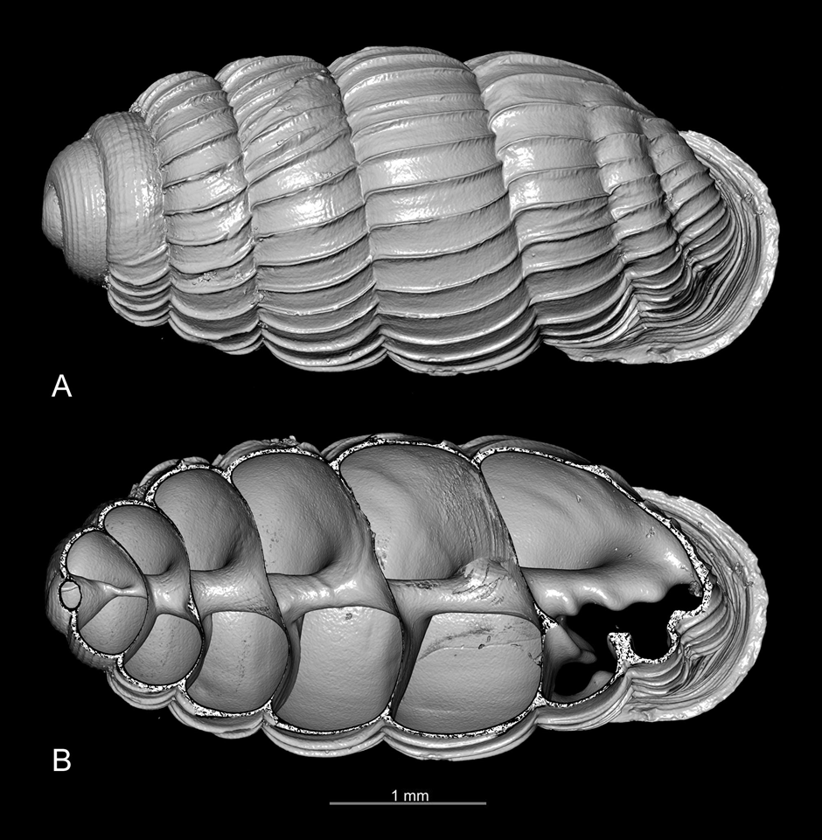
Figure 42. Ptychotrema (Ennea) pseudosilvaticum Adam, Van Bruggen & Van Goethem, 1994, syntype (RBINS, BE-RBINS-INV-TYPES-MT-2817), dorsal view.
A, complete shell. B, shell longitudinally cut with the program Dragonfly ORS.
- Another option impossible to obtain with photography, except X-ray photography are transparency views. The colours and the levels of transparency, etc... can be fine-tuned.
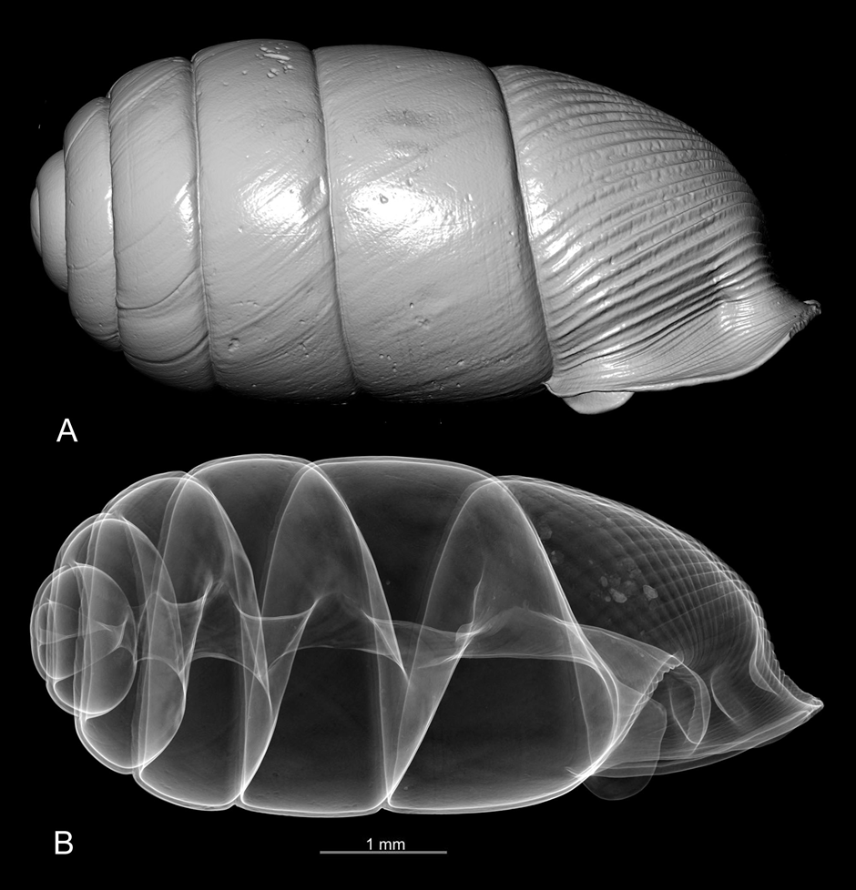
Figure 43. Gulella rumrutiensis (Preston, 1911), BE-RBINS-INV-TYPES-MT-2826, syntype.
A, opaque view. B, transparency view.

D. Fields of application and limitations of microCT in the study of recent organisms.
As seen in the previous section, microCT scanning is an efficient tool for studying the morphology of recent organisms. However, only hard structures are easy to scan. Soft and poorly calcified organisms usually require staining (for example with lugol), in order to obtain scans of good quality. However, as the present project is essentially focused on the scanning of type specimens, staining was not used. The scan of shells, corals and vertebrates (skeletons) usually yielded outstanding results, both for snapshots and 3D models.For echinoderms, the quality of the results is rather variable, but usually good in snapshots, mediocre in 3D models. . The most tricky are usually holothurians, although the scans of some species were excellent. One of the most interesting applications was the possibility to visualise the jaw system of sea urchins (the so-called Aristotle lantern) without breaking their test.
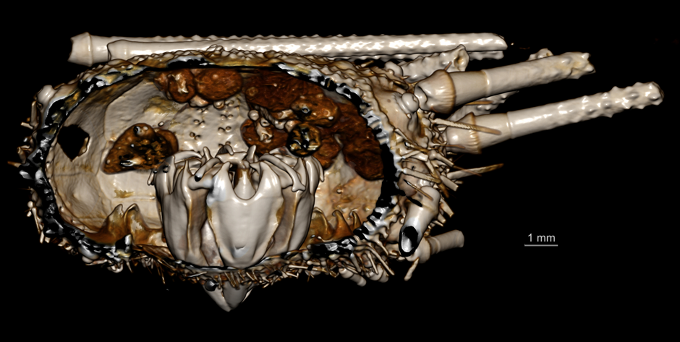
Figure 44. Aporocidaris incerta (Koehler, 1902), BE-RBINS-INV-ECH-744,
test digitally cut open, so that the Aristotle lantern can be seen in its natural position.
The scan of crustaceans required low voltage and a non metallic filter should be put on the source. Very variable results depending on groups. The scan of highly calcified crustaceans like crabs often results in outstanding snapshot pictures, but usually not in good 3D models, as the limits between structures are often fusing.
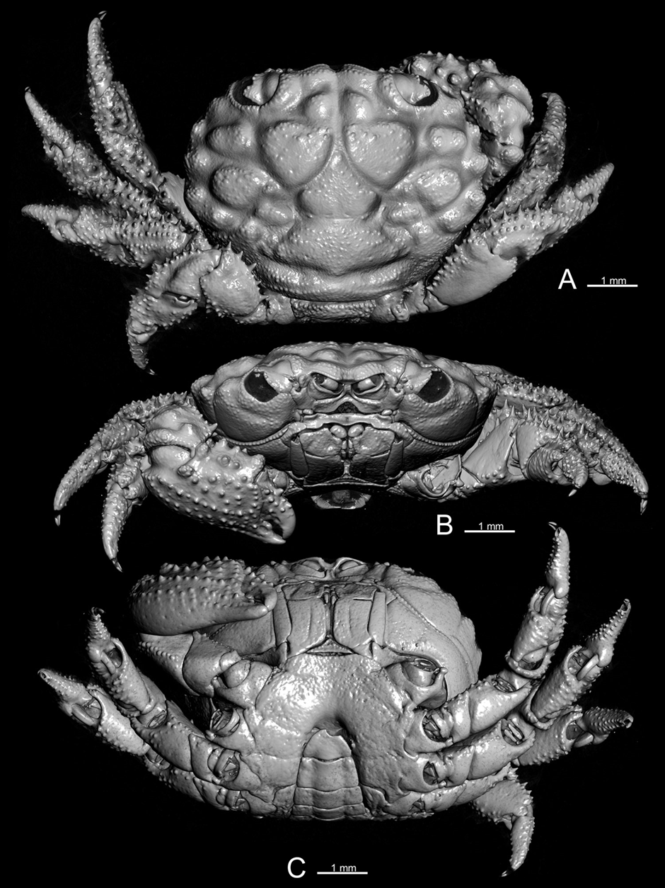
Figure 45. Example of taxonomic plate of crab obtained with microCT snapshots. Tweedieia odhneri (Gordon, 1934). ♀ paratype, Macclesfield Bank (RBINS, INV. 113725).
On the other hand, the scan of softer crustaceans usually results in poor scans, not suitable for taxonomic studies.
Here is an example of poor scan of an isopod:
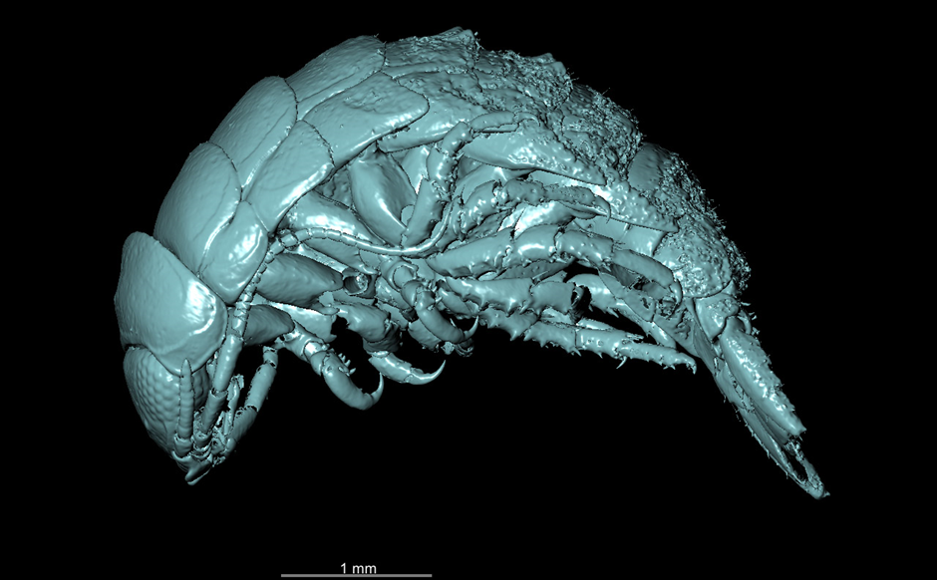
Figure 46. Example of a poor scan of isopod, Tachaea leopoldi Nierstrasz, 1930, syntype, BE-RBINS-INV-TYPES-112283-Tachaea-leopoldi.
In the case of amphipod crustaceans, some groups like Eusiridae and Epimeriidae, surprisingly, had rather good results. However, with such organisms, big difficulties have been met for immobilising the specimens during the scan. One option was to pin the specimen ventrally with fine non-metallic points (as illustrated here below) or in putting them full of agar gelose. The later method was very efficient, but very time consuming (requiring a lot of "cooking" procedures) and this was not good for the specimens, as pieces of agar often remained stuck on the specimens.
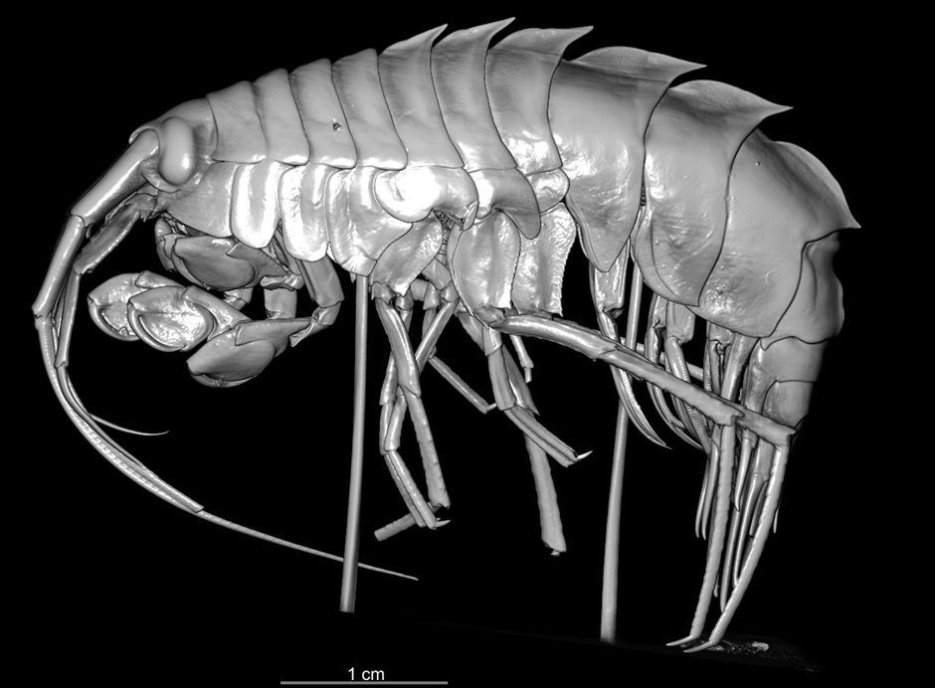
Figure 47. Eusirus pontomedon Verheye & d'Udekem d'Acoz, 2020, paratype, BE-RBINS-INV-TYPES-122797A.
Finally, it is important to insist that without staining, no good scans of soft-bodied organisms can be achieved. Here is an example of scan of an earthworm, without staining :
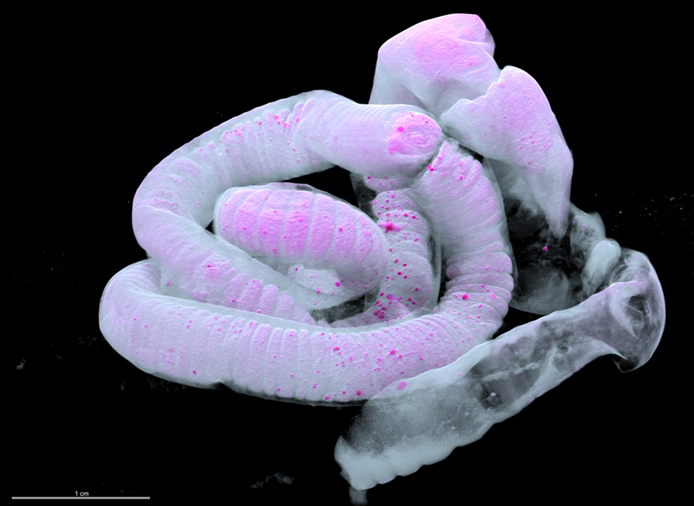
Figure 48. Example of a poor scan of an earthworm obtained without staining (rendering with false colours). Pheretima (Pheretima) leopoldi Michaelsen, 1930. Holotype.
Central Sumatra: Tandjoeng Keling (RBINS collections).

Task 3.6.3 Microtomography of recent vertebrates at RBINS
116 scans, mostly from type specimens from RBINS collections, were acquired, as an effort to digitise type collections. In the case of vertebrates, it was actually possible to digitally extract bony structures for easy examination (e.g. pharyngal teeth of cyprinid fishes, bony spikes of hemipenises in male snakes), or to watch the stomach content and even eggs in ovaries, without dissecting the specimen.

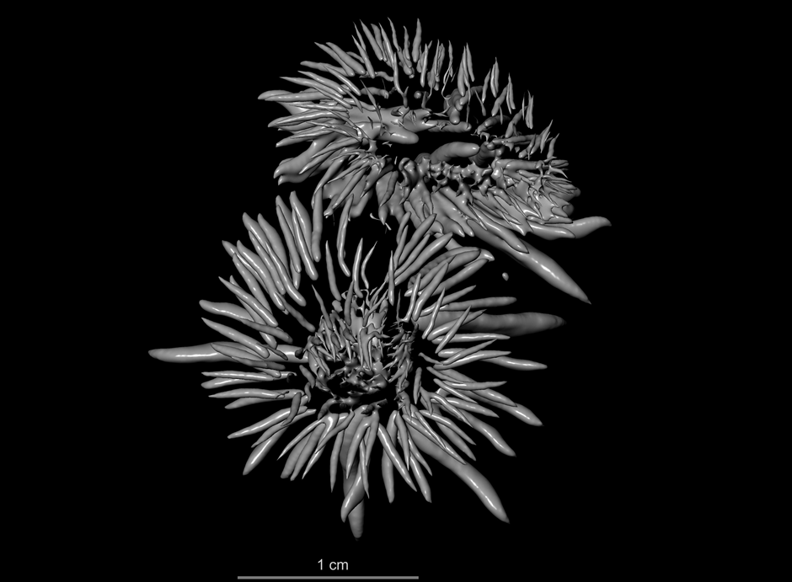
Figure 49. Bony spikes of hemipenises of the snake Philothamnus carinatus (Andersson, 1901)
in their natural disposition, BE-RBINS-VER-Rep-19284.
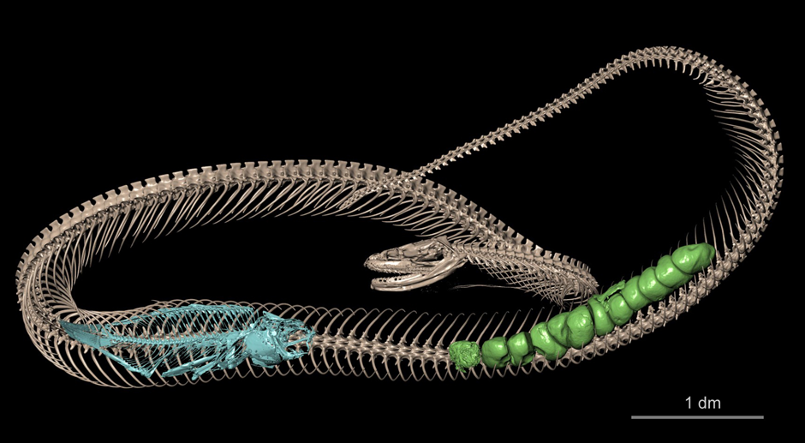
Figure 50. Hydraethiops melanogaster Günther, 1872, BE-RBINS-VER-REP-16258. The stomach content (fish, in blue) and the eggs within the ovaries (in green) can be seen within the snake.

Task 3.6.4 Micro-CT imaging of type specimens from the RBINS palaeontology collections
- Number of digitised specimens: 1224 fossils
A. A very diverse array of specimens, matrixes and results
The achieved work includes CT-imaging of specimens exhibiting a very diverse array of size, geologic age, mineralogy, and biological affinity. The scanned objects include both fossil invertebrates, vertebrates, and plants. For the invertebrates, specimens from both the Paleozoic (IP) and Mesozoic and Cenozoic (IST) subcollections were digitised, including e.g., brachiopod, gastropod, bivalve, trilobite, cephalopod, coral, and crinoid fossils. For the vertebrates, specimens from the Reptilia (including mosasaurs, turtles, crocodiles, and dinosaurs like Iguanodon), Amfibia, Pisces (including both bony and cartilaginous fishes), Mammalia (both terrestrial and marine) and Birds were digitised.
B. High density challenges
In general, fossils are much denser than biological specimens; shells and bones are mineralized, specimens are embedded in sediment (carbonite or silicate, fine- or coarse grained, cemented or uncemented), and cavities filled with minerals like calcite and pyrite. This translates to a much higher percentage of atoms with high atomic numbers, thus a much higher level of attenuation, thus necessitating a much higher intensity of the X-ray bundle emitted by the source to obtain useful CT-scanning data. The RX EasyTom has a more powerful source than the XRE UniTom, maximally 150 kV versus maximally 120 kV respectively, thus, almost all the fossils were scanned with the RX machine.
The large diversity in the shape, size, and biologic, geologic, and geographic origin of the material meant that each fossil posed its own set of challenges. For each fossil, a somewhat different approach in the scanning methodology was necessary to avoid as much as possible artefacts and to ensure that the results were of optimal quality and useability, both for the research, conservation, and outreach domains.
Specific points of concern consisted of the relative position of the specimen to the beam and detector as well as within the X-ray bundle, and the mineralogy of the specimen, in particular when high attenuation materials were present like pyrite. Some historical specimens were also glued onto cardboard or glass, providing their own set of challenges, as in general these specimens could only be sub optimally mounted in the RX chamber.
From our hands-on expertise, we can conclude that the RX machine is perfect for CT-scanning of fossils varying from 5 mm up to 10 cm diameter. For smaller specimens, higher spatial resolution (lower voxel sizes) can be more easily attained with the XRE (lower voxel size limit of 500 nm for XRE versus 4 µm for RX), also regarding the scanning time, which increased considerable, up to a factor 10, when spatial resolutions below 20 µm were wanted (in small spot size mode). For larger specimens, high quality output can still be obtained, but one becomes very dependent on the nature of the specimen. Several specimens turned out to be too large or too dense for the RX, resulting in CT-images lacking contrast and being full of noise. In these cases, the specimens were set aside to be digitized by other techniques. Examples of specimens of moderate size that resulted in low contract and lots of artefacts were Jurassic ammonites. Much better surface models from these specimens were obtained by surface scanning (see Figure 51-D)
Two functions were also of interest, the shift mode, allowing to stitch horizontally two images together, and the stack function, allowing to stitch several scans vertically together. Problems only occurred when a shift and a stack was combined for very elongated specimens. For example, for a shift 2 + stack 7, it proved difficult to extract in 16-bitt tiffs, but in general extracting in jpg was still possible. The extracting time however was in these cases long, and could take several hours, with very large outputs (size of output image stack >100Gb), while extracting a single scan was mostly a matter of 15 minutes and only up to 10Gb in output image-stack size.
For several type specimens of Jurassic ammonites, the outputs of the CT-imaging combined a lack of contrast with ample noise, preventing observing internal characters and segment qualitative surface models. For these specimens, much better results were obtained from surface scanning, in particular for their suture, a very important taxonomic feature in ammonites, with white light (A-B; Artec Space Spider) or structured light (C-D; Meshscan).
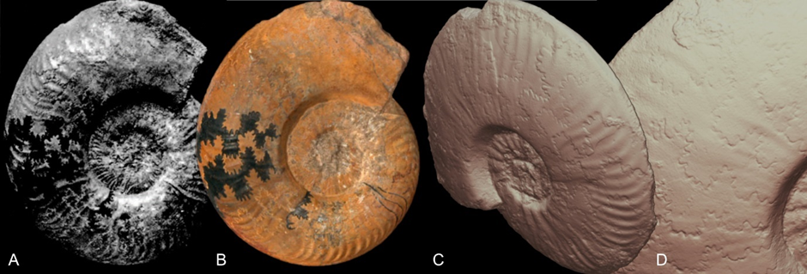
Figure 51. Examples of workarounds when CT-scanning did not deliver excellent results. A-B. Jurassic ammonite Phlyseogrammoceras bichelonnei Maubeuge, 1949, specimen as figured in original description (A) and screenshot from 3D model made with Artec Spider onto which the surface texture including the coloured sutures are well-digitized (B). C-D. Jurassic ammonite Phlyseogrammoceras braconnieri (IRSNB 9437), screenshots of 3D model with excellent results for the suture

C. Meshes for Sketchfab
Going from exported image-stack to 3D meshes ready for Sketchfab included two main steps,
- segmentation in Dragonfly with export of reconstructed model in STL format
- mesh optimization in GOM Inspect
Segmentation in Dragonfly ORS necessitated a sturdy pc with large amounts of RAM and heavy graphic card to accommodate the image stacks that sometimes were generally 10Gb (and up to >100Gb) in size. Still, a full segmentation process, from loading your data into Dragonfly, to segmenting, exporting the mesh and saving the .ors file, generally took from 10 minutes to several hours.
Segmentation of CT-imaging data into 3D meshes was done in Dragonfly ORS, exporting into .stl or .ply files. In general, a fast (histogram-based) segmentation was tried for. Over time, this process was further optimised, in such a way that it became possible to segment several specimens in less than one hour, at least for scans with low amounts of artefacts. In general, the more artefacts, the higher the segmenting time (Fig SG2A-B).
Segmenting also proved very time consuming for specimens with lots of internal voids. Examples were the open structure of turtle and mosasaur bones, or invertebrate fossils encased in partly weathered carbonates, where the weathering caused secondary porosity. A quick segmentation of these specimens resulted in meshes that were far too large to be handled in any software (>10Gb or more).
Ongoing, it was found that the smoothing function in Dragonfly ORS worked easier and better and was less time consuming than exporting without smoothing in Dragonfly ORS and doing this step in GOM Inspect.
In general, all our obtained meshes were too large to immediately upload onto Sketchfab. The ‘thinning’ of these meshes was executed in GOM Inspect, however, in many cases resulting in the loss of some detail of the mesh. However, special attention was paid to still retain the important taxonomic information, e.g., by thinning the attached sediment matrix much more than the actual specimen itself.
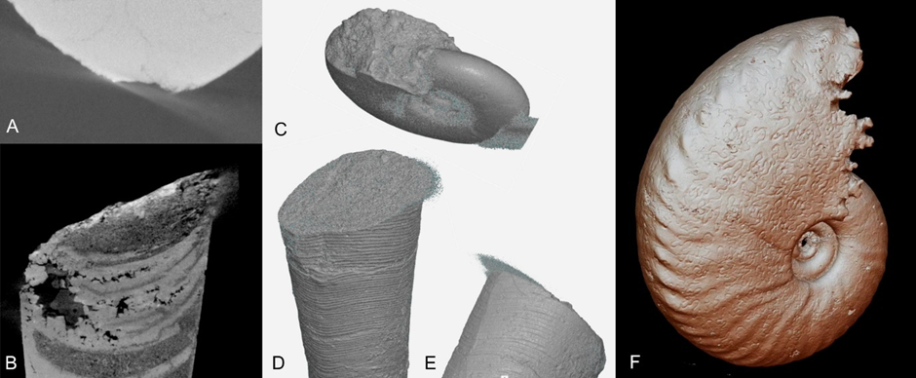
Figure 52. Examples of frequently encountered artefacts in CT-scanning of fossils and crisp direct models. A. 2D rendering of a CT-scanning image stack revealing a moderate level streak artefact at its outer extremity. Such artefact can almost unnoticeably be segmented out in Dragonfly ORS but necessitates manual segmentation. B. An example of an artefact that is almost impossible to segment out, due to the lack of contrast between the artefact and the actual specimen. C. A direct model of a scan with moderate level of artefacts, obscuring taxonomic important details. D-E. A direct model with moderate level of artefacts not obscuring taxonomic important characteristics. In addition, the ornament with delicate ribs is very crisp. F. A crisp ‘direct model’ without artefacts beautifully displaying the small details of the ornament plus the sutures of the ammonite.

D. Crisp direct models
An update of the RX X-Act software in 2022 made it possible to directly export a mesh (with .stl extension) from X-Act software at the very end of the image stack extracting process. These ‘direct models’ meant a major gain in time, eliminating the Dragonfly ORS segmentation step. However, no parameters could be changed, so that these direct models were only good from scans with no or very limited artefacts. In all other cases, segmentation in Dragonfly ORS remained necessary.
One other major benefit of these ‘direct models’ is that these displayed the outer surface of the specimens in a much crisper way than those obtained from segmenting the specimen in Dragonfly ORS. This was very beneficial when small outer surface ornament details were concerned (see FigSG2D-E), and, very interestingly for Ammonoid sutures (see Figure 52-F).
Nonetheless, like the models exported from Dragonfly, their file size was generally too large for Sketchfab (>2Gb), and a ‘thinning’ step in GOM Inspect still needed to be performed.

E. A powerful and versatile imaging tool!
CT-scanning is also a very powerful and versatile imaging tool. Stunning images can be created both from rendering the original image stack, or by segmenting specific volumes of interest into meshes.
For 2D and 3D rendering, we used Dragonfly ORS. This powerful 3D software allows you to adjust many parameters. For fossils, the hard gradient function was found to be of large significance for 3D renderings (e.g., Figures 53D,I, 54A-D, 56 A-B, E, 59C). Renderings were exported as screenshots, after adjusting the histogram, contrast, shading, light source position, hard gradient and removing all annotations except the scale bar. For scientific publications, one additional step involved using an image processing software to scale the obtained image to 600 dpi tiffs (Figure 53A-L). In addition, also 2D (e.g., flyovers) and 3D animations could be exported as movies or gifs.
For meshes, from complete specimens to specific volumes of interest, screenshots could be made from any possible direction, both when manipulating the mesh in GOM Inspect (e.g., Figure 55), or, when loaded onto Sketchfab (e.g., Figure 52F).
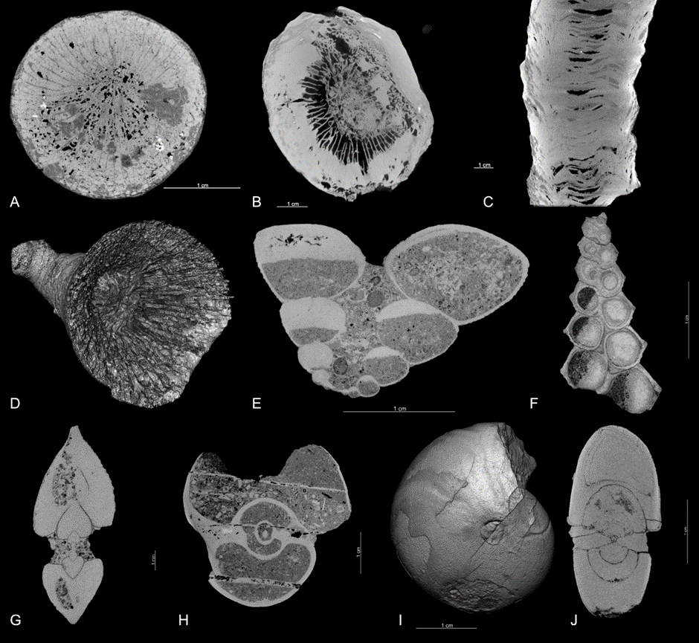
Figure 53. Examples of highly qualitative virtual cuts that reveal hidden information resulting from CT-scanning of historical type specimens. All from 19th century publications by de Koninck describing fossils from the Belgian Carboniferous. A-D. Virtual sections (A-C) revealing internal structures and a 3D render (D) of solitary corals of the genus Zaphrentis. E-H. Virtual cuts of different genera of Gastropoda, allowing to observe changes in growth and shell thickness as well as geopetal infill. I-J. 3D render (I) and 2-cut of ammonoid Goniatites inconstans (IRSNB a03599) allowing to produce growth curves without destroying this unique specimen.
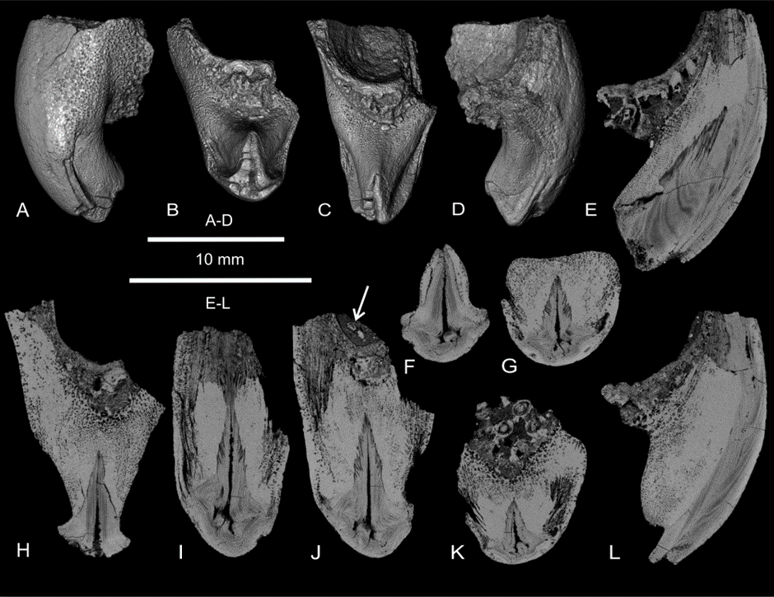
Figure 54. Examples of stunning images that can be obtained from rendering a single CT-imaging stack. Screenshots of a 3D render (A-D) and 2D virtual cuts through the same specimen (E-L), a calcareous skeleton of a 52-million-year-old cuttlefish fossil from Belgium (after Goolaerts et al., 2020, fig. 6).
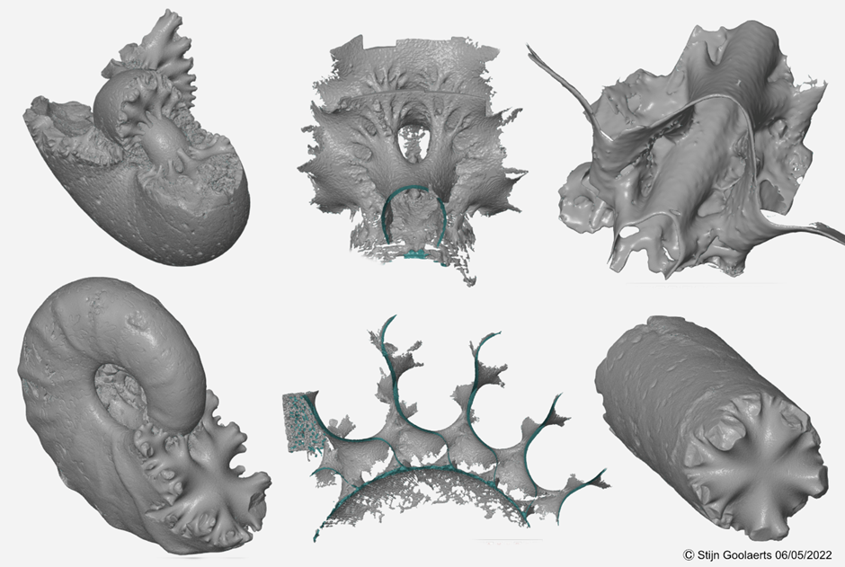
Figure 55. Examples of stunning images that can be obtained from segmenting CT-scanning data. Screenshots of 3D meshes loaded into GOM Inspect of entire specimens or segmented volumes of interest.
All from 66-million-year-old pyritic-limonitic ammonoid fossils.

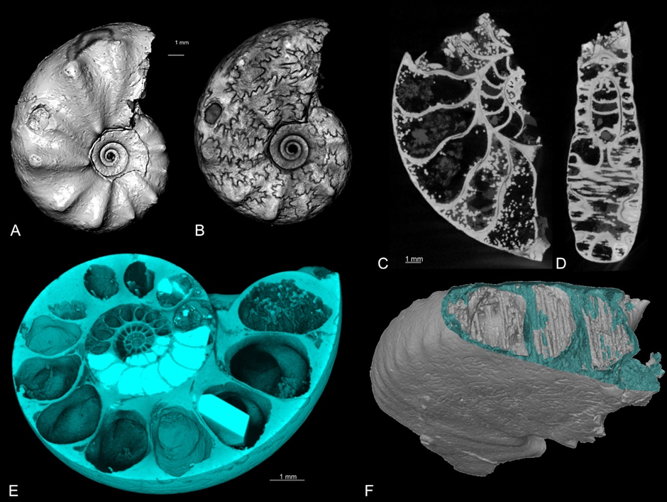
Figure 56.Examples of stunning images that can be obtained from rendering and segmenting CT-scanning data. All of pyritic-limonitic ammonite fossils. A-B. Examples of the effects of different settings on the 3D render of the same ammonite specimen in Dragonfly ORS, in which the ribbing stands out better in (A) and the sutures in (B). C-D, F. Example of bonus information that can be obtained on the taphonomy of the ammonite fossil, with Fe-oxide-hydroxide stalactites being formed inside some of the ammonite chambers, seen in 2D slices (C-D) and in the (cut open) 3D direct model (F). E. Another example of bonus information received on the taphonomy of the ammonite specimen, visualised by a screenshot of 3D rendering virtually cutting the specimen in half through the embryonic conch, revealing secondary mineral infillings in some chambers and a crystal growing in another chamber.

F. Discovering fossils inside fossils
Most Paleozoic and Mesozoic invertebrate fossils are embedded in a host rock, thus as a rule, there are other fossils hiding inside the type specimens. While most of them are of moderate scientific interest, some are important biostratigraphic marker fossils, and their discovery within specimens may be of prime scientific importance. This is especially the case for old (19th – mid 20th century) specimens, for which stratigraphic documentation was not at the same detail it is today. An example is given in FigSG7, where the presence of Nummulites planulatus was discovered in the sediment attached to a cuttlefish fossil described by Vincent in 1901, allowing it to firmly position to the original level of provenance within the stratigraphic record.
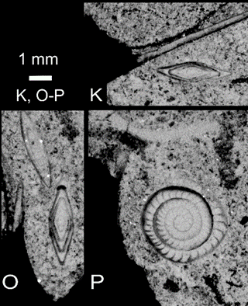
Figure 57. Example of fossils hiding inside type specimens. K,O-P: Biostratigraphic marker fossil Nummulites planulatus discovered in the sediment of one of Vincent (1901)’s specimens of Belosaepia, a 52 million-year-old cuttlefish fossil, allowing to confirm and further refine the original stratigraphic data supplied in Vincent (1901)’s paper. (Cut-out from Goolaerts et al., 2022, fig. 6).
G. Preventing the need for destructive cutting
Cutting specimens to reveal internal hidden features is standard practice in taxonomic description in several invertebrate fossil groups: cephalopods are cut in half to allow for measurements to construct growth curves and to investigate details of the siphuncle, corals are cut into several thin-sections, and brachiopods are fully destroyed by acetate peeling.
In the last couple of years, new conservation rules banned destructive cutting of historical type specimens, thus hampering research, and preventing a thorough restudy of these important specimens. This can now be fully overcome (see e.g., Figs SG3,4,7), at least for those specimens from which good CT-imaging results were obtained.
H. Challenging pyrite, taphonomy, metal bars, and metal bearing paint
Pyrite is a frequent part of fossils and is generally unstable over time. Its ‘decay’ makes specimen crack, crumble and turn into acid and dust over time. The production of acid may also destroy the labels. Special conservation techniques are in place to safeguard as many possible these pyritic type specimens. However, while these techniques and actions can slow the deterioration process, it cannot be fully eradicated. For these specimens, CT-imaging would thus not only be useful for the research and outreach domain, but also for conservation; in case the specimen would not survive on the long term, there is a digital cast. And probably, the CT-imaging would provide data on how much, in which form and where the pyrite would be present, and that in 3D, allowing to further finetune the efforts of the conservation team.
However, pyrite (FeS₂), like other metals, is known for its high attenuation, generally causing many problems in CT-scanning, with results full of streak artefacts (e.g., Fig. SG8A). Still, it was decided to invest considerable time to investigate to which extent we could CT-scan specimens containing pyrite or said to be made entirely out of pyrite and/or limonite (FeOOH). Our efforts paid off, and let to amazing results: for most of the scanned specimens, we were able to obtain high quality output, both for 2D virtual cuts as for 3D meshes.
Two groups of specimens were of special interest to us:
- Pyritic - limonitic ammonites: highly qualitative CT-imaging results were obtained from most of them, leading to high quality surface meshes (both from segmenting in Dragonfly and direct models, with the latter ones generally being a little crisper), aiding in their long-term preservation. Interestingly, these results also supplied details on their taphonomy and state of preservation (see e.g., Figs SG2F, 5, 6A-F for some of the results), also aiding in future conservation efforts.
- Bones of Iguanodon from Bernissart: while these fossils are reputed for the presence of unstable pyrite internally, we obtained stunningly detailed images from several specimens. While the obtained images are useful in the research domain, the CT-imaging also allowed to inspect the preservation state of these specimens, also supplying details on where and in which form the pyrite is present, and that in 3D, aiding future conservation efforts. Even more, it also let us discover details of the conservation techniques used by Louis De Pauw, like inserting metal bars (see Fig.SG9A-B, E), and that the specimen numbers were painted with metal-bearing paint (see Fig.SG9C).
Pyrite was also discovered to be present in some specimens for which prior to the CT-imaging such presence was never suspected (see e.g., FigSG8A-B). This means that preventive measures can now be taken, yet another benefit of CT-scanning the RBINS paleontology type collection.
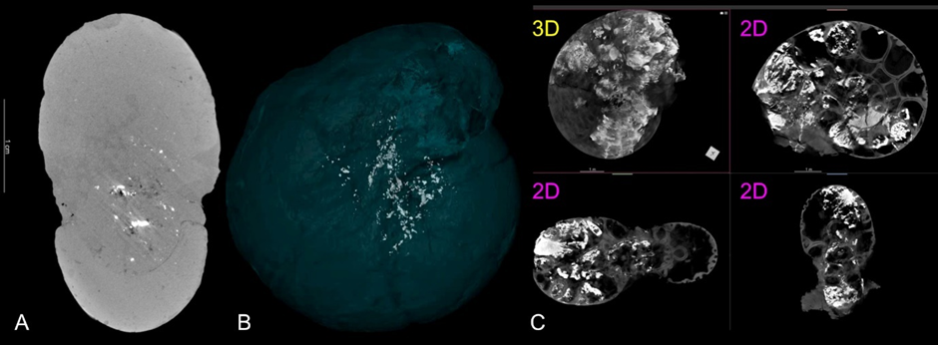
Figure 58. Examples of CT-imaging results that are also useful for conservation. A-B. Example of a specimen with pyrite (white spots) being present on the inside, made visible in a 2D and 3D rendering. Streak artefacts of the pyrite are also visible in the 2D rendering. For this specimen, the presence of pyrite on its inside was unknown prior to the CT-scanning. C. Example of 3D and 2D renders of a partially pyritic ammonite specimen, revealing details on the pyrite being present internally, allowing for a better conservation treatment.

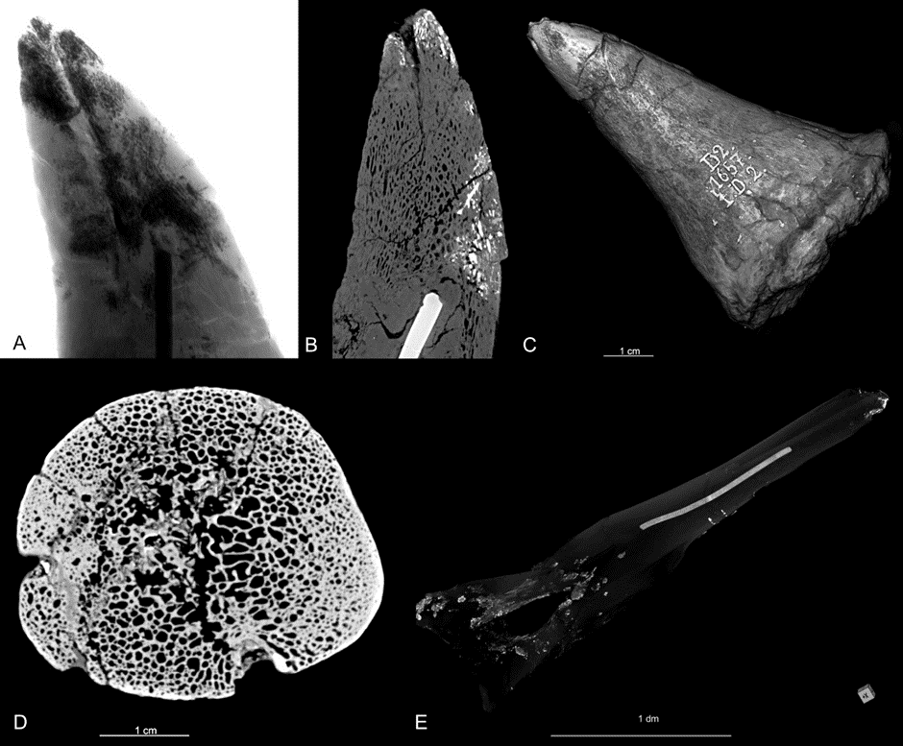
Figure 59. Some results of CT-imaging of Iguanodon bones. A. Radiography of the tip of an Iguanodon thumb, revealing that pyrite (dark areas) and a metal bar are present. B. A 2D render of the same specimen, revealing more details on the location and habitus of the pyrite (white): pyrite fills bone cavities but only in parts of the specimen. C. A 3D render of a digitally cut Iguanodon thumb. Note that the specimen number, painted with lead-bearing paint, stands out very well as well. D. A high quality virtual 2D cut through another thumb of Iguanodon. One can observe its internal bone structure in all detail! E. A 3D render of an Iguanodon bone with the specimen made transparent to reveal the 3D location of pyrite and a metal bar.

Work Package 4 : Valorisation & Preservation
The reporting of some of the tasks related to the valorisation are presented in the valorisation & dissemination section.

4.1.1 Sharing 3D Models
The 3D digitisation of the specimen is time consuming but it provides high quality models which can be used for a remote scientific study and/or to access complex 3D structures and 3D measuring tools.
The microtomography and surface scanning/photogrammetry digitisation pipelines produce very large datasets (up to 200 Gb/specimen). The task will evaluate how to provide access to the data by the scientific community using the naturalheritage.be portal and establish protocol(s) to share on demand the High Resolution data (raw microCT datasets) with the stakeholders.
RBINS and RMCA use the sketchfab platform (Premium licence) to share surface models and 3D reconstruction models of internal structures with an integration of the 3D models in the FSI CMS (Table 7).

Institution | Collections | Models on Sketchfab
IRSNB | 86 | 6345
Africamuseum | 63 | 1304
Table 7: 3D Models available on the Sketchfab platform
This is not the ideal solution for the long term but it is certainly the easiest and cheapest solution for the short term. Most of the RBINS 3D models are not published in the sketchfab platform as the search module of sketchfab is not good for scientific purposes.
All 3D views are therefore available using Iframes in the CMS or virtualcollections pages and with the search interfaces of the CMS.
RBINS & RMCA are also using the Morphosource platform for some models (Table 8).

Institution | Models on Morphosource
IRSNB | 233
Africamuseum | 674
Table 8: 3D Models available on the Morphosource platform
RBINS and RMCA collaborate also in the evaluation of alternative and open source solutions which require a storage infrastructure but can have advantages compared to the Sketchfab platform:
- 3DHOP developed by the INIST, CNR (Italy) and
- 3D Voyager developed for the Smithsonian (USA)
These solutions are in evaluation by RBINS and RMCA. The integration of such 3D web viewer technologies and a unified multimedia server is also under development. One of the advantages is that it is possible to use multiresolution models for a better experience on mobile devices and low bandwidth computers.
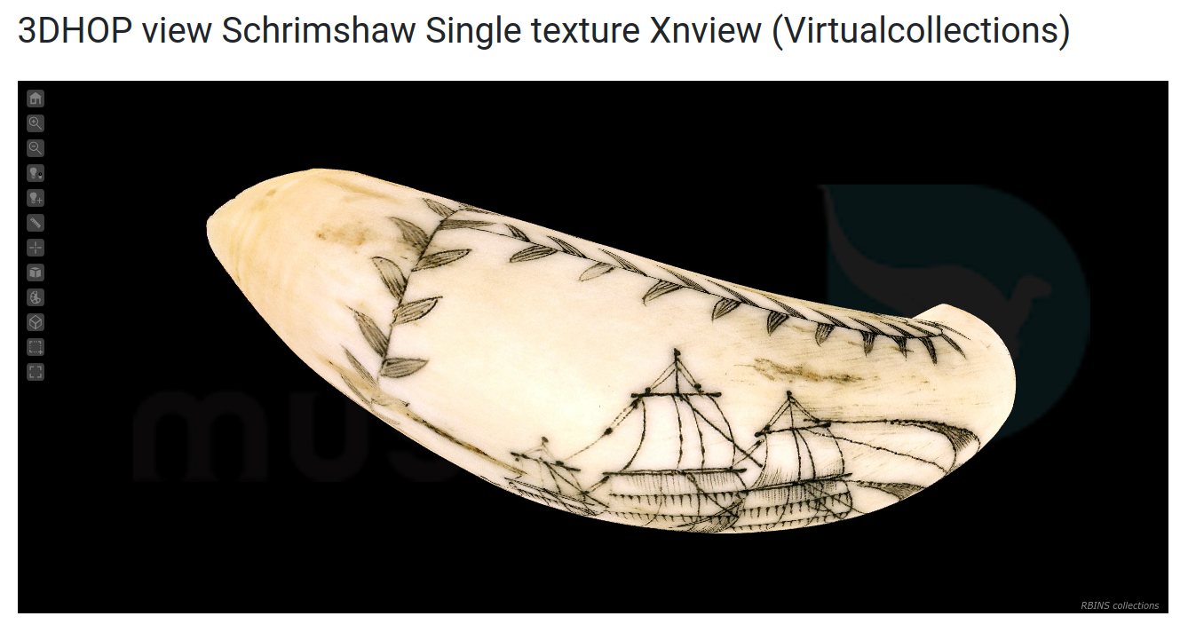
Figure 60. Evaluation of the 3DHOP viewer with a scrimshaw 3D model acquired
with the Keyence VR-5000 and reconstructed with Geomagic

Task 4.2 Long term Preservation
All the resulting data (including raw data) are preserved on the long term preservation platform created by BELSPO in the framework of the DIGIT program. As the preparation phase of DiSSCo will also establish common rules and propose technical solutions for the preservation of the digital specimens at an international level, the ultimate decision for the digital specimens will be at the level of the global infrastructure. Nevertheless, it is important to evaluate the environmental cost of permanent access to high resolution data (e.g. cloud storage). The digitisation of a single 3mm ant can produce more than 100 GB of data while the demand for accessing these 3D HR data can be very limited and distant in time. The thousands of specimens digitised by µCT during this project will produce more than 1000 TB of data. It is a societal responsibility to evaluate whether these data should be available instantaneously (at a high environmental cost) or through infrastructures and processes requiring less energy resources. The LTP of BELSPO provides access on demand (few hours).
We evaluated how we can give access to the data to the stakeholders in a satisfactory way while minimising the environmental impact of the service. The BELSPO option could be a more sustainable solution than the “100% on the cloud” option but this requires creating a specific workflow with an exchange platform.

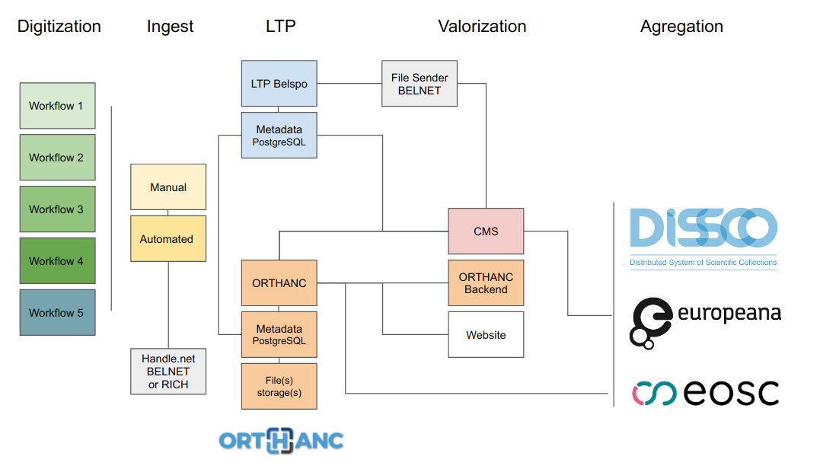
Figure 61. Proposed workflow for the digitization pipelines and
integration of the Long Term Preservation of Belspo storage in the workflow.
RBINS is saving the data related to the digitisation of the collections on the BELSPO LTP platform which is composed by 2 redundant tape systems in 2 separated data centers. This task was achieved manually before COVID and was totally blocked during 2020 because it required the presence of the staff on site as the connection to the LTP is based on a private network only accessible on site.
We decided to adapt a workflow from the Royal Belgian Institute for Space Aeronomy. This is based on a folder hierarchy on a network server. The hierarchy provides some of the required metadata like the digitisation technique and the equipment. A script is looking in the hierarchy if new data are uploaded in the folders structure. If a new dataset is detected, a second script prepares the data to upload on the LTP and submits the dataset with the metadata to the BELSPO LTP platform.
The following section describes the workflow developed at the RBINS

Task 4.2.1 Hardware and data type to be sent
2 types of machines are used: a PC running Ubuntu with a size limited to 4TB and a server. These 2 systems are connected by a dedicated network card to the LTP servers. The PC is used in case of external hard drives needed to be connected, while the server is used by the majority of users to deposit their files ready to be sent.
The type of data sent is a simple zip file (or TAR file for uncompressed data like bats recording with ultrasounds), it is accompanied by an xml file containing the folder title and the MD5 of the zip file. The zip contains also a text file describing the contents of the zip file.

Task 4.2.2 Data
The files placed on the server (or external disk) are placed in a directory structure based on the technique used to generate these files. Directory name is based on the specimen code as defined in the DaRWIN Collection Management System. This code consists of the following sequence:
BE-RBINS-coll-subcoll-DaRWIN code-Taxon or sample name-other metadata where :
- BE-RBINS-: is constant and designates the institution
- coll-subcoll: collection and (if necessary) subcollection, in the form of a 3-4 letter code
- DaRWIN code: DaRWIN code, if the sample is in this database
- Taxon or sample name: Specific name of the sample
- other metadata: gender, type, data type,...
During the sending process, the folder name will be used to create the name of the zip file, to which these information will be added:
Folder name-date-time-technical code where:
- date-time: generated when the archive is created
- technical code: code made up of 3-4 letters and a number, allowing to know how the files in the directory were generated: microCT, photography, surface scanner, etc.
The full name of the zip file sent will therefore look like this:
BE-RBINS-PAL-IST-02732-Pleurotoma-undata-RAW-DATA-30-11-2022-14h19-CT03.zip

Task 4.2.3 Method to create the package and to send data to LTP.
The program used to create the zip file and send to LTP is a reuse and adaptation of the program used by the aeronomy institute. It consists of a series of shell scripts under Linux.
The process is divided into 3 steps managed by 3 files:
- find_candidates.sh: to read directories and find folders to send.
- create_packets.sh: to generate the zip file (with a python subroutine, ltp_preingest.py) and an XML file
- upload_packets.sh: to send files to LTP (sftp, with private key)
Other files are also used for parameters and common functions : digit03ltp.sh, dataset_prezip.param, dataset.param.
Files are sent on the LTP server in a directory which is checked regularly for new incomes. They are treated by lots : they must be placed in a directory with a unique name. In that directory, the XML must be placed, as well as the zip file, in a subdirectory called data.
If ingestion is good, files can be checked on another website. If not, they are placed in a directory “rejected” where they can be checked for problems.

Task 4.2.4 Files and Metadata Inventory and files retrieved from the LTP.
A list of all the files sent is maintained in an excel file, to allow users to check whether their data have been sent to LTP.
Retrieving the zip files occurs by placing an XML in a special directory on the retrieve server, XML containing the ID of the zip.
An offline copy of each zip and XML sent to LTP is maintained in RBINS, on local hard disks, to be able to retrieve data quickly if necessary.

Task 4.2.5 Impact of COVID and effect of the automatic transfer to LTP
Before COVID, the transfer of data to LTP was achieved by manual encoding. The required Human resource for this task was 0.5 FTE (about 1 Zip file / working day) because it required several copy actions through the internal network of RBINS as only one computer is effectively connected to the private network dedicated to the LTP. During the COVID, the task was very limited due to the Telework incompatible with this LTP task.
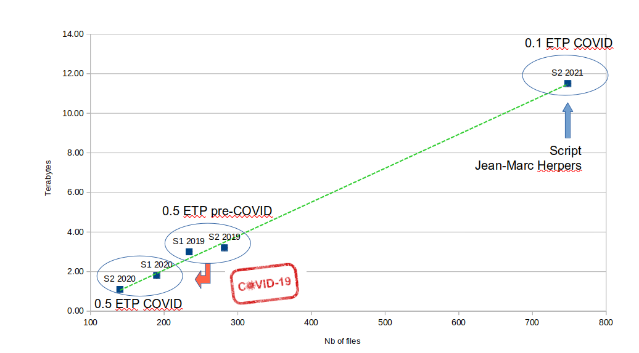
Figure 62. Evolution of the number of files and the size of data transferred to the LTP Platform
With the new workflow using automated scripts, the number of ZIP files uploaded on the LTP platform increased dramatically (+ 250 %) for a human time divided by 5.

Work Package 5 : Sustainability
Establishing a long term sustainability plan for the maintenance of the infrastructure after the end of this funding is a permanent challenge. RBINS and RMCA structurally collaborate using the same CMS, the same setups and a part of the digitisation staff.
All developments are made using Opensource technologies especially the Collection Management System DaRWIN and the NaturalHeritage portal.
Belgium is committed to play an important part in the DiSSCo infrastructure preparing, constructing and consolidation phase. Sustainability is guaranteed by the mobilisation of additional collections, competences and funding in the larger framework of DiSSCo both at Belgian and international level.

Task 5.1 Alignment with DiSSCo and DiSSCo related projects
- Digitization: prepare the alignment of the digitization priorities and the digital specimen(s) output(s) to those of the global DiSSCo infrastructure. Use the Synthesys+ project to evaluate the common prioritisation procedure which has to be established for the digitization on demand. The digitization of the Type Specimens is established as a priority until the end of 2022. Afterwards, we will follow the priorities established by DiSSCo in order to align our efforts with the decisions of the ESFRI.
During the DiSSCo Fed project RBINS and RMCA implemented the recommendations of CETAF related to the use of Unique identifiers. We followed the DiSSCo to provide different UUID to Specimens and to the respective parts of the specimen (Skin, Skeleton, DNA). These are related using the UUID. The UUID is also used to relate the specimen to the multimedia files (e.g. images, 3D files, bibliography). The compatibility of the images with the IIIF standard was implemented at RMCA and is ongoing at RBINS.
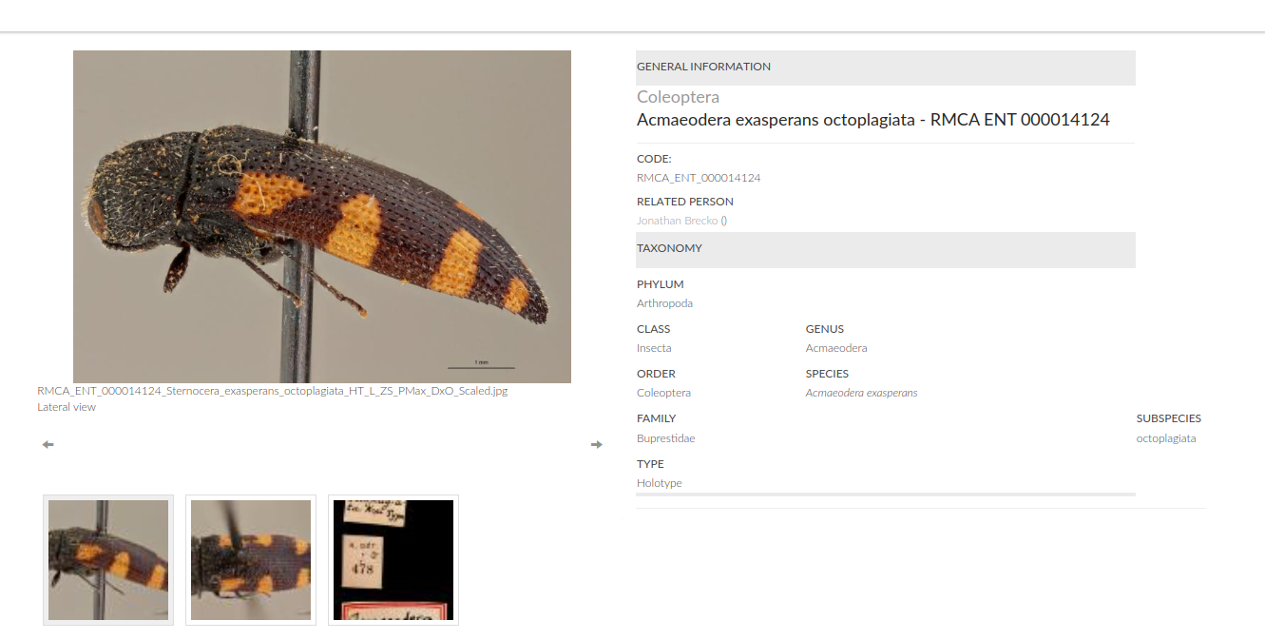
Figure 63. Virtual Coll view of Acmaeodera exasperans octoplagiata - RMCA ENT 000014124
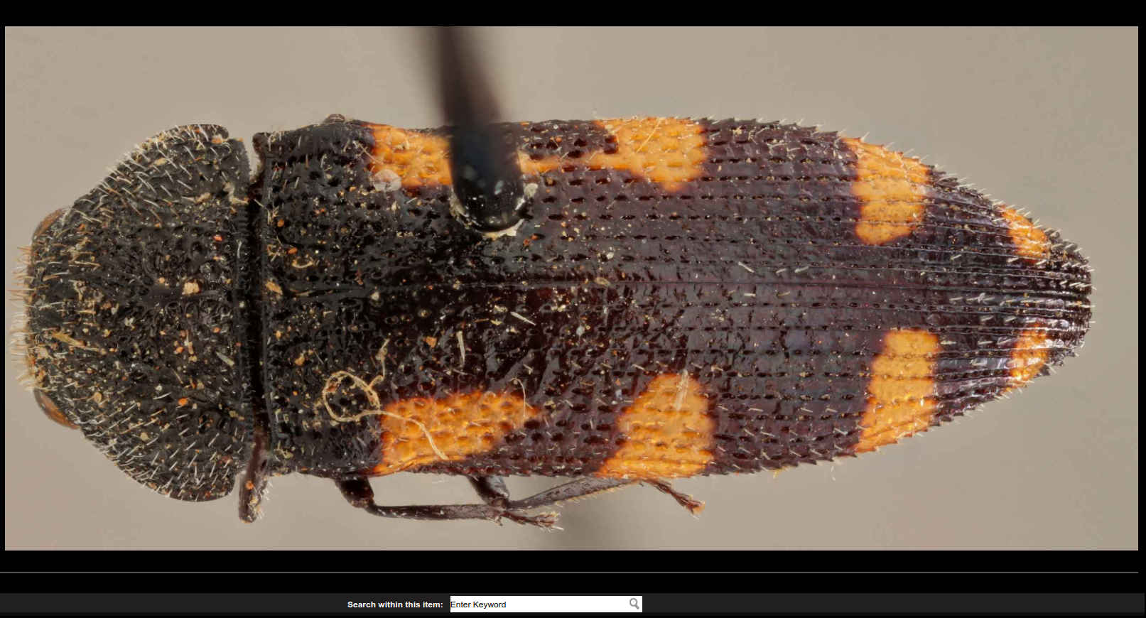
Figure 64. Virtual Coll IIIF image of Acmaeodera exasperans octoplagiata - RMCA ENT 000014124
Several tools facilitating the quality of the data were developed using web services and backbones (Taxonomy and geographic coordinates).
- Access: Natural Heritage is supported by CETAF as a pilot of a National Hub. We already evaluate technologies to combine structured, rich text and multimedia information from several sources and how to connect these indexes to the international aggregators (e.g. GBIF and DiSSCo).

Task 5.2 Collaboration with other FSI and regional scientific institutions
Establish a strategic plan and use existing service for non partner FSI and other institutions in Belgium and abroad to make use of and/or contribute to the maintenance of the digitisation platform(s). APM is already housing herbariums of third parties, notably of regional botanical collections, which are digitised within their programs. APM also assists institutions, which opted to keep their collections locally with management and digitization best practices and services. RBINS/RMCA will also offer their digitization lines and competencies to regional/communities institutions like universities in order to cover the Belgian collections as large as possible in DiSSCo. All digitization infrastructures - except the 2 micro CT scanners - are mobile and can be moved to the collection.
RBINS and RMCA collaborate also with APM using the Citizen Science platform developed by the APM (DOEDAT) in the framework of DiSSCo Flanders. Preliminary tests demonstrate the potential of CS in the digitisation workflows.

5. DISSEMINATION AND VALORISATION

Task 5.1 Valorisation
Valorisation is an important task which follows the digitization processes of the collections. RBINS, RMCA and APM collaborate already in several national and european projects aiming to improve the access and the valorisation of digital scientific collections.

5.1.1 NaturalHeritage
RBINS and RMCA use the same specimens database (DaRWIN) and the 3 major Belgian collections will use Naturalheritage.be portal to guarantee the cross search and the access through DiSSCo or GBIF search engines. The goal of the project was to develop a search portal combining the different collections and the different categories of data (Specimens data, bibliography, archives, multimedia).
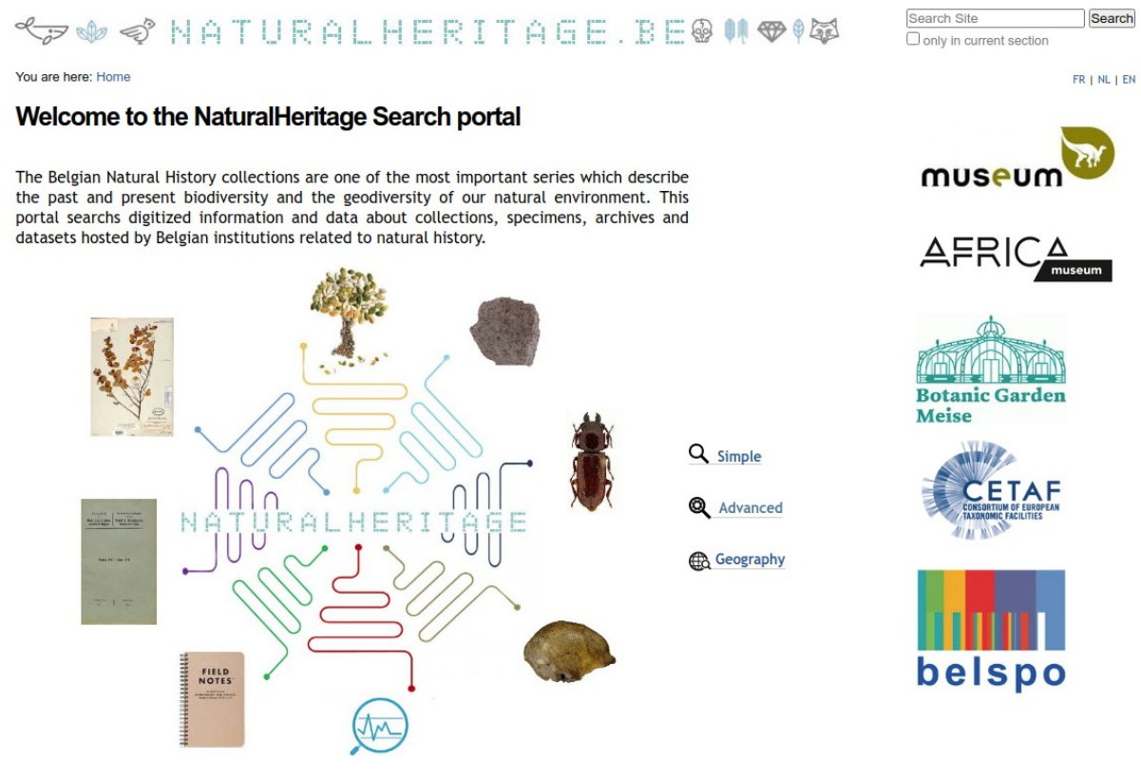
Figure 65. NaturalHeritage Homepage
The Naturalheritage project is based on a re-indexation of the different sources with a link to the original resource which is the owner of the rights on these (meta)data. The import of the specimens data are achieved using the GBIF IPT, the bibliography data are imported with script or using OAI-PMH protocol and the access of the multimedia files is provided using links to the original resource.

At the Institution level, different strategies were adopted by RBINS and RMCA.

5.1.2 virtualcollections.naturalsciences.be (RBINS)
At RBINS, a Plone 4.3 platform is used to combine the DaRWIN CMS data and the multimedia files (images, 3D, files).
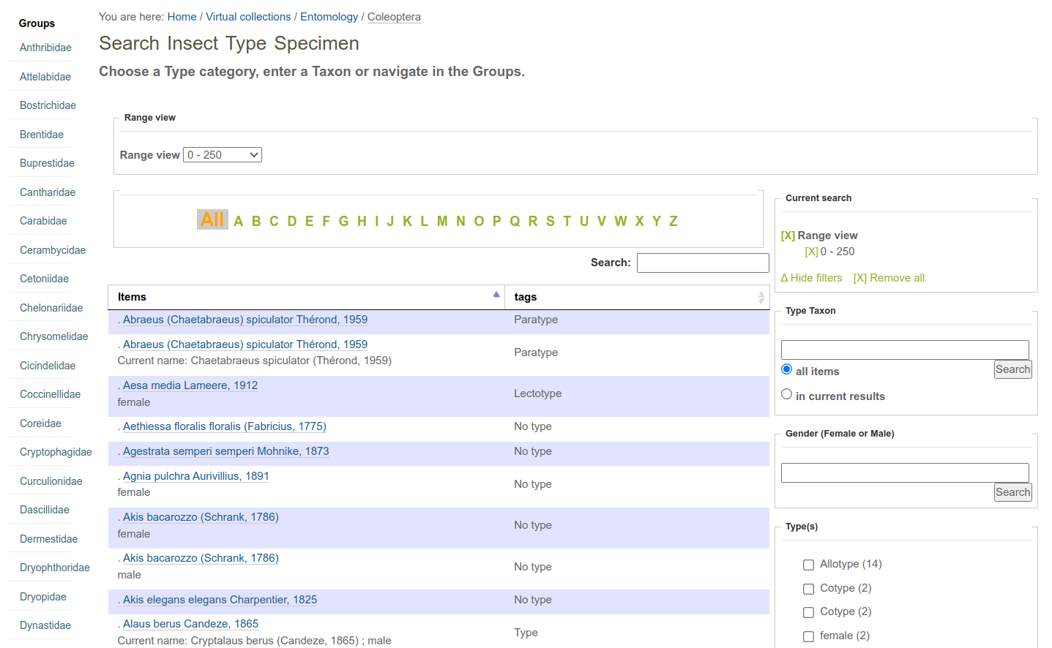
Figure 66. Search view based on the taxonomy
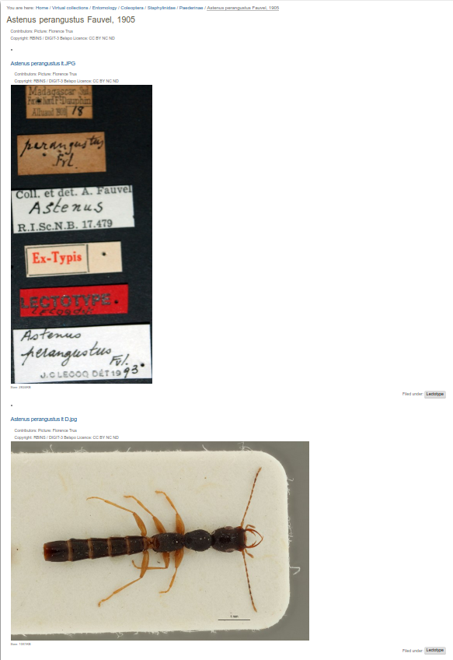 | 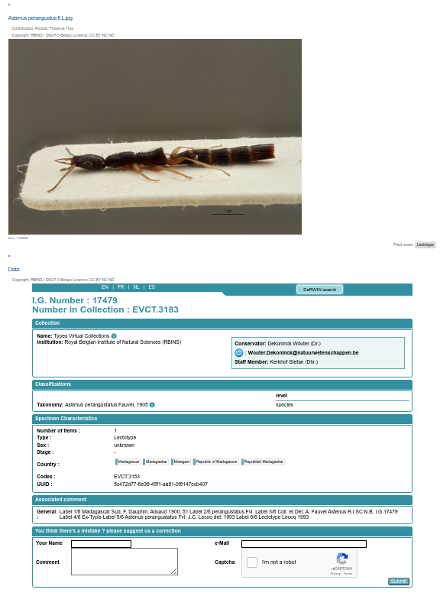

Figure 67. Specimen view in virtualcollections.naturalsciences.be
The image viewer is not compatible with IIIF which is now required by the setup of DiSSCo. A new version is in preparation to include the IIIF compatibility and the direct display of 3D files. It will be available in 2024.
At the end of the DiSSCo fed project, more than 31.000 specimens are available through the Virtualcollections portal with more than 93.000 images.

5.1.3 Virtual collections RMCA
The Virtual Coll platform is used by the RMCA to share 2D images obtained during the DiSSCo-Fed project.
In the frame of a brain project (naturalheritage.be) it was decided to create a new website for media, easier to maintain and technically up to date, to be readable on various platforms (pc, tablet, smartphone). The system is fast and versatile and can link to the DaRWIN collection management system. The image viewer is compatible with IIIF which is now required by the setup of DiSSCo.

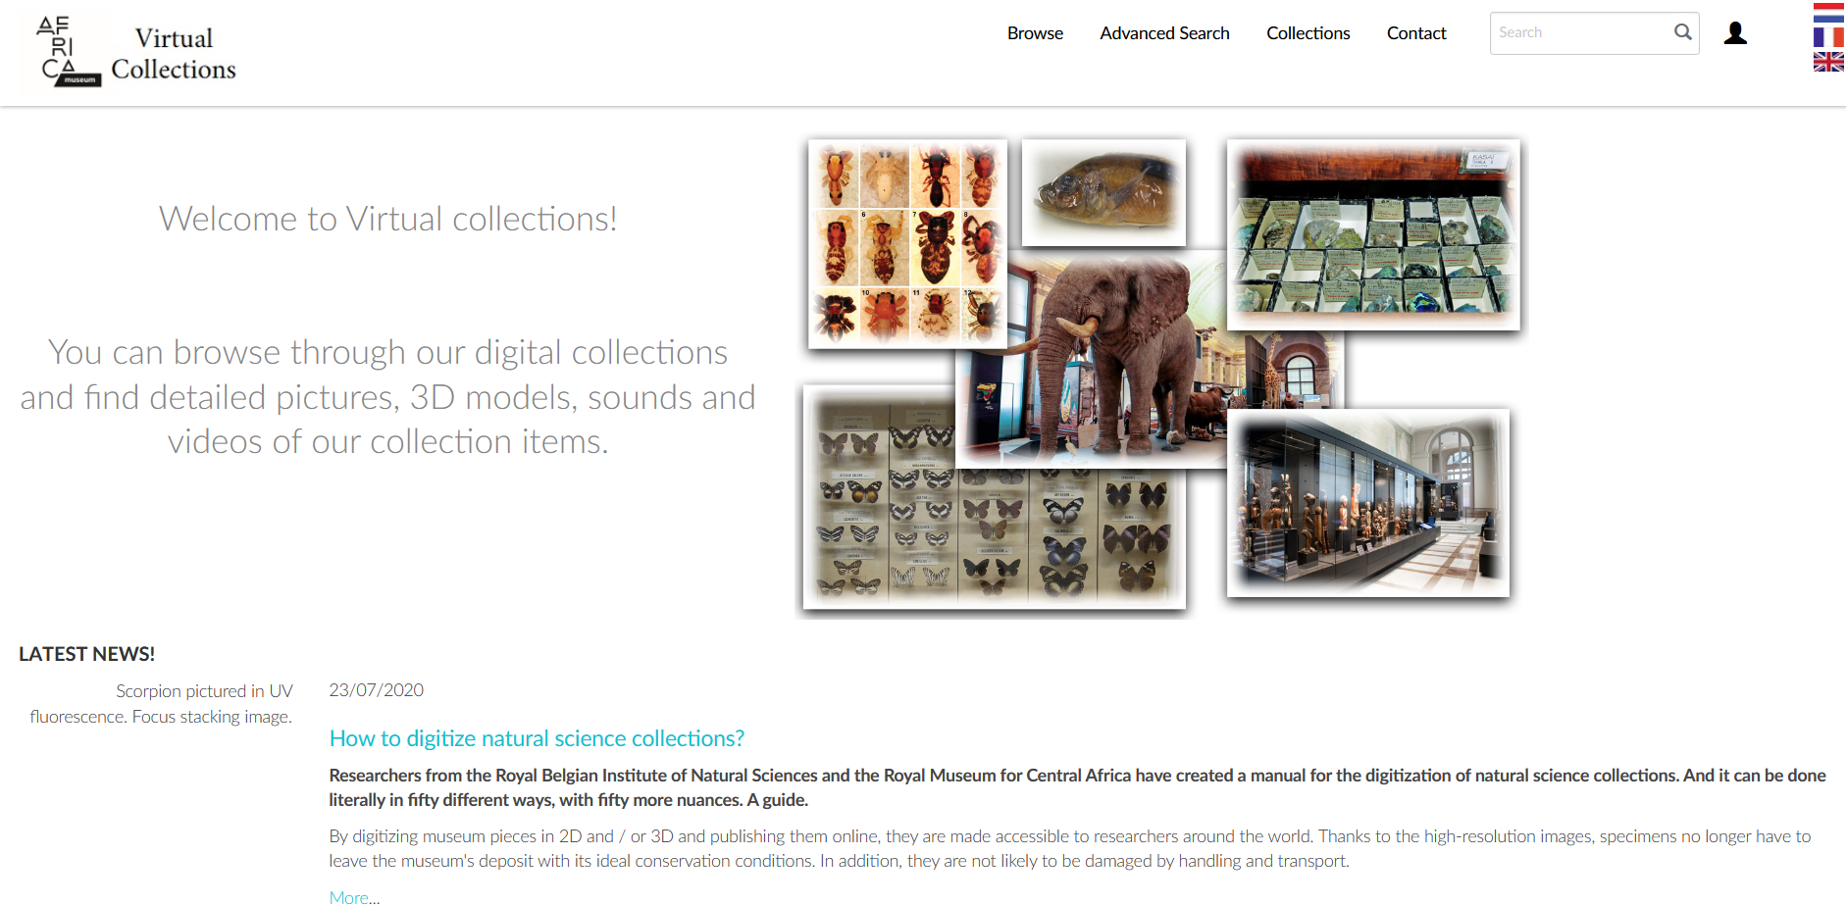
Figure 68. AfricaMuseum Virtual collections Homepage

5.1.4 Printing from 3D-models for educational purposes
The high resolution 3D files allow the production of 3D models using 3D printing technologies. It is therefore possible to produce scaled or magnified models and use them for educational or exhibition purposes. Here are some examples produced from the digital models resulting from the DiSSCo fed activities.
Spider palp
Furthermore, these images and the possibility to produce printed 3D models (Figure 69-C) can also be used as tools in an academic context, e.g. as part of a course in zoology or evolution. In this context, 3D models of male spider palp can highlight their complex ultrastructure and link them to their mechanical-hydraulic function during mating. It also brings light on how evolution drove the key-lock systems allowing species to reproduce among themselves and diminishing the possibilities of hybridizations.
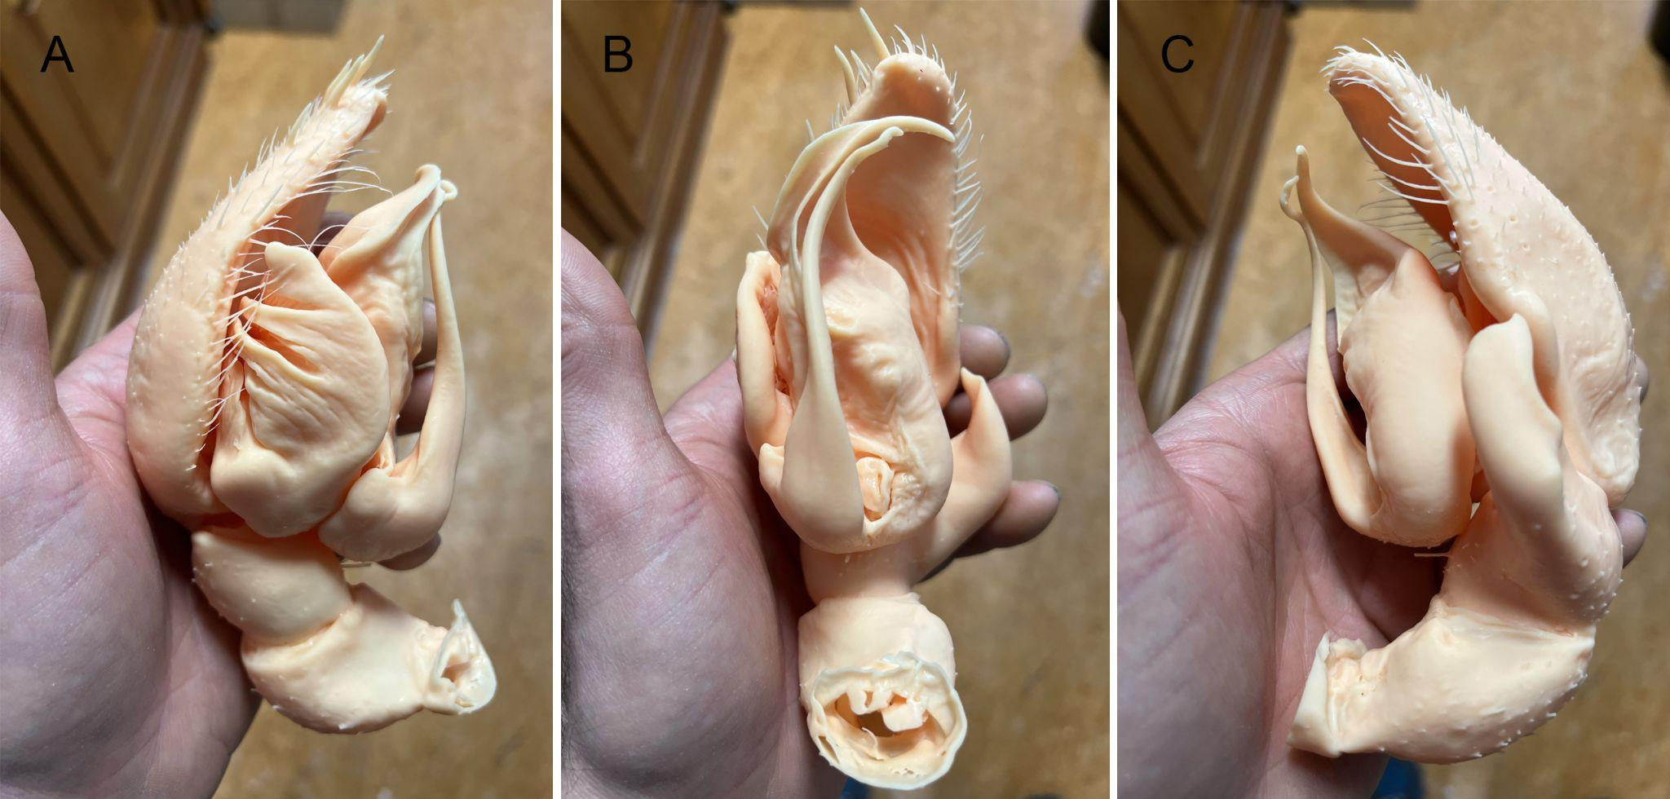Figure 69 A-C. Different views of a 3D printed model of a spider male palp.
(Arnaud Henrard and Jonathan Brecko).

Stomach flukes
Previously, stomach flukes – a group of trematode parasites found in the stomach of ruminants – could only be identified by sectioning and thus destroying the specimen. Through microCT scanning, in collaboration with Ruben Schols (PhD Student at RMCA), we created digital 3D models of valuable museum specimens, enabling us to make these sections on the computer without destroying the original specimen. Moreover, these models allowed us to 3D-print physical copies of these specimens (thanks to Jonathan Brecko), visualizing these elusive parasites for the broader public (Figure 70 A-C). These models have since travelled to Zimbabwe for awareness raising in the field with the local populace and to Chicago (USA) to promote our work with scientists at an international conference of the American Society of Tropical Medicine and Hygiene (2023). The innovative approach, thereby, not only provides benefits for the scientific community, but also for scientific outreach activities.
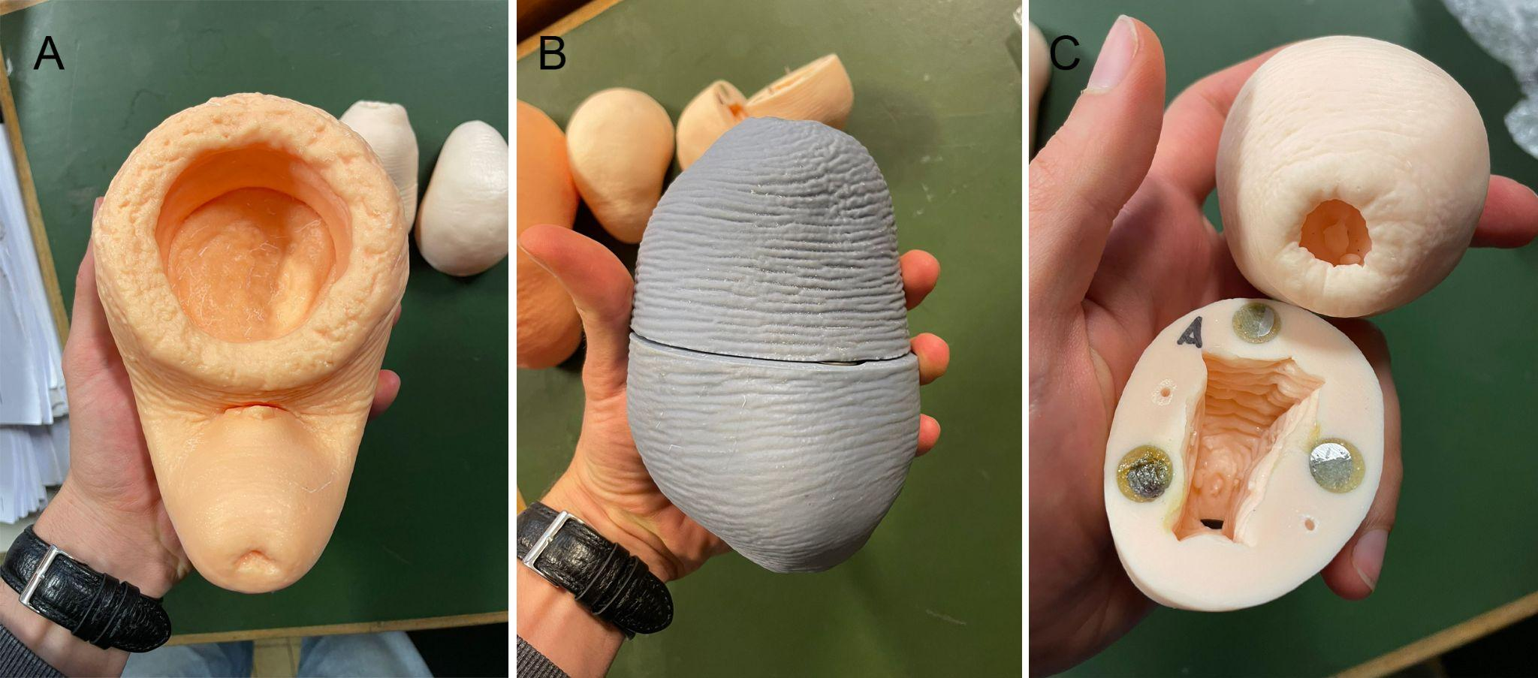
Figure 70 A-C. Different printed stomach flukes species, with the possibility to visualise the internal structure (Ruben Schols, Arnaud Henrard and Jonathan Brecko).

The high resolution 3D models allow the preparation of full size replicas of large specimens for exhibition purposes. In 2022, a nearly complete skeleton of a cave lion discovered in Goyet cave was digitised by Aurore Mathys using the Artec Spider scanner and printed in 3D to replace the original in the Musée du Malgré-tout during the Giant exhibition at RBINS. The replica will later be used for the tour exhibition.
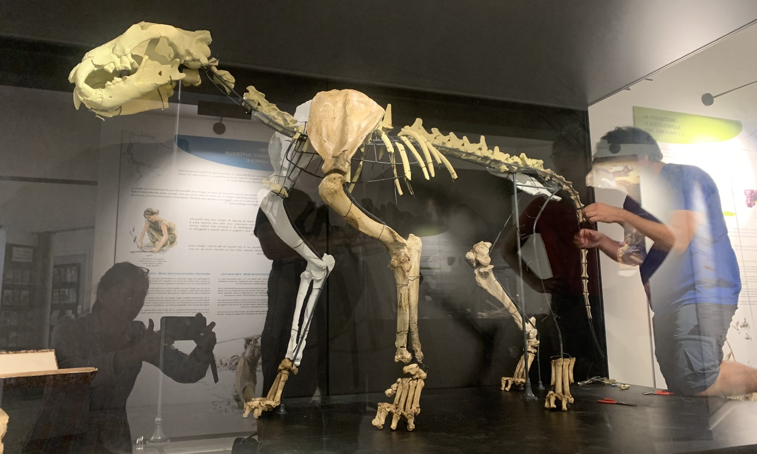
Figure 71. 3D printed replica of a Panthera Leo from Goyet Cave at the Musée du Malgré-Tout (Treignes)

5.2 Dissemination
- Goolaerts, S., Locatelli, C., Brecko, J., D’Udekem D’Acoz, C., Folie, A., Henrard, A., Mathys, A., Van De Gehuchte, E., 2021. X-ploring new tools for paleontologists: the RBINS-RMCA micro-CT lab at your service! In Delvaux, D., Dewitte, O., Fernandez-Alonso, M., Hubert-Ferrari, A., Elsen, J. (eds), 7th International Geologica Belgica Meeting 15-17 September 2021 - AfricaMuseum Tervuren (Belgium), Geosciences Made in Belgium, Conference Program and abstract book, Geologica Belgica Conference Proceedings 4 (2021), 197-198. https://doi.org/10.20341/gbcp.vol4. [Open Access]
- Semal, P., Presentation of the DaRWIN Collection Management System. DiSSCo Flanders Meeting. 02-12-2021.(PDF)
- Goolaerts, S., d’Udekem d’Acoz, C., Folie, A., Locatelli, C., Mathys, A., Mottequin, B., Samyn, Y., Semal, P., 2022. Into the digital cephalopod world: tales from digitizing the Cephalopoda from the RBINS type-and-figured collections. 11th International Symposium Cephalopods Present and Past (ISCPP11), NHM London, UK, Sep 12-16th 2022. Abstract book, p. 5-6. [Abstract for talk]
- Goolaerts, S., 2023. 'Ammoniet en nautilusfossielen in de CT-scanner'. Talk on Sunday November 12th 13h00-13h30, PaleoTime Lectures, VTC De Mixx in Herselt, Belgium
- Henrard A. & Jocqué R. 2022. "The genus Mallinella (Araneae, Zodariidae) in Africa: a lesson in biodiversity". Science day – 2022, AfricaMuseum, Tervuren (Belgium), 17th–18th of October 2022.
- Henrard A. 2022. "Spider taxonomy in the era of digitization programs and technologies". PRIZE D4D EDITION 2022. AfricaMuseum, Tervuren (Belgium), 24th of November 2022.
- Henrard A. 2019. "Modélisation 3D des palpes d'araignées". Rencontres nationales d’Arachnologie (AsFrA) – octobre 2019, Val-Joly, (France) le 12/10/2019
- Henrard A. 2018. Communication orale. "La Micro-tomographie (µCT = Micro-computed tomography) dévoile la structure interne des palpes mâles". Réunion d’ARABEL à l’IRSNB, Bruxelles, (Belgique) le 28/09/2018.

6. PUBLICATIONS
- d’Udekem d’Acoz, C., submitted (referees comments: minor modifications). On a new species of Thia Leach, 1815 from the tropical Eastern Atlantic (Decapoda, Brachyura, Portunoidea, Carcinidae). Crustaceana. [Open Access]
- García-Raso J.E., d'Udekem d'Acoz C., Moukrim A., Schubart C., Cuesta J.A., submitted. A new species of the genus Polybius (Crustacea: Decapoda: Portunoidea: Polybiidae) from the East Atlantic. European Journal of Taxonomy. [Open Access]
- Goolaerts, S., 2023. On the first Belgian record of the Eifelian (Middle Devonian) ammonoid cephalopod Subanarcestes (Suborder Anarcestina). Geologica Belgica, 26(1-2), 93-100. https://doi.org/10.20341/gb.2023.004 [Open Access]
- Goolaerts, S., Christiaens, Y., Mollen, F., Mottequin, B., Steurbaut, E., 2022. Applying micro-CT imaging in the study of historically and newly collected specimens of Belosaepia (Sepiida, Coleoidea, Cephalopoda) from the Early Eocene (Ypresian) of Belgium. Riviste Italiana Di Paleontologia E Stratigrafia 128(3): 585-606 https://doi.org/10.54103/2039-4942/16617 [Open access]
- Goolaerts, S., Mottequin, B., 2023. A Santonian record of the nautilid cephalopod Angulithes westphalicus (Schlüter, 1872) from the subsurface of the Campine, north-east Belgium, with comments on regional lithostratigraphic problems. Geologica Belgica 26(1-2), 101-113. https://doi.org/10.20341/gb.2023.007 [Open Access]
- Henrard, A., Cazanove, G., & Zonstein, S. (in prep.). On the Mygalomorphae (Araneae) of Mayotte (Comoros), with description of new taxa.
- Henrard, A. & Brecko, J. (in prep.). Spider taxonomy in a new era: on a protocol to prepare spider samples for reconstructing 3D models using Micro-CT scans.
- Henrard, A., Griswold, C., Jocque, M. & Jocqué, R. (in prep.). On new genera and species of crack-leg spiders (Araneae, Udubidae) from Madagascar.
- Mathys, A., Cammaert, L., Jadin, I., & Semal, P. (2022). Un autre regard sur l’art mobilier paléolithique belge au travers des nouvelles technologies. In Archéologues Malgré-Tout Apporter sa pierre pour y voir clair. Treignes, Belgium: Cerdac. https://hdl.handle.net/2268/295862
- Mottequin, B., Goolaerts, S., Hunt, A.P, Olive, S., 2021. The erroneous chondrichthyan egg case assignments from the Devonian: implications for the knowledge on the evolution of the reproductive strategy within chondrichthyans. The Science of Nature 108, 36. https://doi.org/10.1007/s00114-021-01751-z
- Pauwels O.S.G., Théleste E., Carlino P., Chirio L., De Bruyne G., d'Udekem d'Acoz C., Gindorff L., Van Steenberge M., Zipper D. & White L.J.T. 2023. Miscellanea Herpetologica Gabonica XVIII. Bulletin of the Chicago Herpetological Society 58(9): 141-149.
- Pauwels O.S.G., Das S., Camara L.B., Chirio L., Doumbia J., d'Udekem d'Acoz C., Dufour S., Margraf N. & Sonet G. 2023. Rediscovery, range extension, phylogenetic relationships and updated diagnosis of the Ornate Long-tailed Lizard Latastia ornata Monard, 1940 (Squamata: Lacertidae). Zootaxa 5296 (4): 501–524. https://doi.org/10.11646/zootaxa.5296.4.1
- Samyn Y., Sonet G., d'Udekem d'Acoz C. 2021. Exploring the use of micro-computed tomography (micro-CT) in the taxonomy of sea cucumbers: a case-study on the gravel sea cucumber Neopentadactyla mixta (Östergren, 1898) (Echinodermata, Holothuroidea, ]]Phyllophoridae). ZooKeys, 1054:173-184. https://doi.org/10.3897/zookeys.1054.6708
- Schols, R., Henrard, A., Brecko, J., Mudavanhu, A., Goossens, E., Steffanie, N., Vanhove, M., Clegg, S., Huyse, T. (in prep.) Micro-CT scanning as a non-destructive solution for the identification of parasites of the superfamily Paramphistomoidea (Plagiorchiida; Pronocephalata).
- Sherwood, D., Henrard, A., Logunov, D. V. & Fowler, L. (2023d). Saint Helenian wolf spiders, with description of two new genera and three new species (Araneae: Lycosidae). Arachnology 19(5): 816-851. doi:10.13156/arac.2023.19.5.816
- Tripathi, R., Henrard, A., Jangid, A. K., Dutta, S. & Sudhikumar, A. V. (2022). First documentation of Plexippus minor Wesołowska & van Harten, 2010 (Araneae: Salticidae) from India. Arachnology 19(1): 66-71. doi:10.13156/arac.2022.19.1.66
- Verheye, M. L.; D'Udekem D'Acoz, C. (2020). Integrative taxonomy of giant crested Eusirus in the Southern Ocean, including the description of a new species (Crustacea: Amphipoda: Eusiridae). Zoological Journal of the Linnean Society. 193(1): 31-77, https://doi.org/10.1093/zoolinnean/zlaa141
[PHOTO STACKING]

7. ACKNOWLEDGEMENTS
We would like to thank all our collaborators (DiSSCo Fed, DIGIT-4, RBINS, MRAC) and students/volunteers who worked hard during a difficult and anxiety-provoking period. Thanks to their work, the effort to digitise the collections was never blocked by the COVID crisis.
We would like to thank Camille PISANI and Guido GRYSEELS for their support in preparing this project during their terms of office as Director General of IRSNB and the RMCA.
We would also like to thank the DiSSCo infrastructure management team for their conviction and support.
Our thanks also to the non funded partners for their input in the project: Ana CASINO and the members of the CETAF secretariat for the regular exchanges, and to Patricia MERGEN from the Meise Botanic Garden for monitoring DiSSCO Flanders and associated tasks.
Thanks to Anna CALDERONE for her full and persistent support in coordinating the DIGIT-4 program.
Finally, we would like to thank Aline VAN DER WERF and Aurore DELIS (BELSPO) for their support and patience.

ANNEXES

Scripts Long Term Preservation

- find_candidates.sh.pdf
- dataset_prezip.param.pdf
- ltp_preingest.py.pdf
- create_packets.sh.pdf
- digit03ltp.sh.pdf
- upload_packets.sh.pdf
- dataset.param.pdf

